AI Principal Architect – Interview Preparation Guide

Contents
Expectation 1: Lead architecture for strategic AI initiatives across products, platforms, and shared enterprise capabilities 1
Expectation: Partner with business units, product leaders, and engineering teams to shape scalable, secure, and practical AI solution architectures 11
Expectation: Define and evolve architecture standards, reference patterns, and guardrails for AI solutions and AI-enabled software development 29
Expectation: Define and evolve architecture standards, reference patterns, and guardrails for AI solutions and AI-enabled software development 50
Expectation: Provide architectural leadership for capabilities, agentic workflows, AI orchestration, evaluations, AI observability, and AI governance 80
Expectation: Help engineering teams leverage AI-powered PDLC capabilities across coding, testing, documentation, analysis, and delivery workflows 124
Guide architecture decisions across application, data, integration, platform, and operational concerns to avoid fragmented or duplicative solutions 156
Participate in architecture reviews, technical strategy discussions, and investment decisions related to AI and platform modernization 179

Expectation 1: Lead architecture for strategic AI initiatives across products, platforms, and shared enterprise capabilities
This expectation focuses on your ability to translate enterprise AI strategy into architectural direction, scalable technology capabilities, and measurable business outcomes. As an AI Principal Architect, you are expected to work closely with business executives, product leaders, engineering teams, data architects, and technology leadership to identify strategic AI opportunities and define the architecture required to deliver them. This includes establishing AI architecture principles, defining target-state architectures and transformation roadmaps, evaluating technology choices, and ensuring that individual AI initiatives align with the broader enterprise technology strategy. You are not simply designing individual AI applications; you are establishing the architectural foundation that enables the enterprise to adopt AI consistently, securely, and at scale.
You are also expected to establish reusable AI capabilities across the organization, reducing duplication and accelerating innovation across multiple products and business domains. This involves defining shared AI platforms, reference architectures, integration patterns, reusable components, and architectural governance mechanisms. You must balance innovation with enterprise considerations such as security, scalability, interoperability, responsible AI, operational resilience, and cost optimization. Your success is measured not only by the technical quality of individual AI solutions but also by your ability to accelerate AI adoption, improve delivery efficiency, reduce architectural complexity, and demonstrate measurable business value across the enterprise.
2. Expand each significant point with examples
A. Translate business strategy into AI architecture
What it means: Understand enterprise priorities and identify where AI can create tangible business value. Convert business problems into AI capabilities, architecture decisions, and investment priorities.
Example 1 – Banking: AI-powered customer cross-selling
A bank wants to increase cross-sell revenue by 15%. I would collaborate with business and data teams to define an AI architecture that combines customer profiles, transaction history, behavioural segmentation, product eligibility, and recommendation models.
- Integrate customer data from CRM, core banking, and digital channels.
- Use ML models to identify cross-sell opportunities.
- Use GenAI to generate personalized campaign recommendations.
- Integrate AI recommendations into CRM and customer engagement workflows.
- Establish metrics such as conversion rate, revenue per customer, and campaign ROI.
Example 2 – Insurance: Intelligent claims processing
An insurance organization wants to reduce claims processing time and operational costs.
- Introduce document AI for extracting information from claim documents.
- Use RAG to retrieve relevant policy clauses and claim guidelines.
- Use AI agents to coordinate claim validation and workflow activities.
- Retain deterministic business rules for eligibility and financial approvals.
- Measure claims cycle time, processing cost, accuracy, and exception rates.
How to explain this in an interview:
I start with the business outcome rather than the AI technology. I work with business stakeholders to identify high-value opportunities, assess feasibility and risk, and translate those opportunities into architecture capabilities and measurable outcomes.
B. Define target-state AI architecture and transformation roadmaps
What it means: Establish how the organization should evolve from its current technology landscape to an AI-enabled enterprise architecture.
This includes:
- Current-state architecture assessment.
- Target-state AI architecture.
- Capability gap analysis.
- Technology and platform selection.
- Migration and modernization strategy.
- Phased implementation roadmap.
- Architecture decision records and governance.
Example 1 – Enterprise RAG platform
An organization wants to introduce AI-powered knowledge assistants across HR, legal, customer service, and technology operations.
Rather than building four separate RAG solutions, I would define a shared enterprise RAG architecture.
The architecture would include:
- Enterprise document ingestion and processing.
- Embedding and vector search capabilities.
- Enterprise identity and access management.
- Permission-aware retrieval.
- Model access and orchestration.
- Evaluation, monitoring, and feedback mechanisms.
The roadmap could begin with a controlled HR knowledge assistant, followed by legal and technology use cases, and eventually expand into enterprise-wide knowledge services.
Example 2 – Legacy application modernization with AI
A large enterprise operates multiple legacy applications and wants to introduce AI-assisted business processes.
I would define a roadmap that separates modernization into phases:
- Expose existing business capabilities through APIs.
- Introduce AI-assisted decision support.
- Integrate AI into workflow orchestration.
- Gradually modernize selected legacy components.
- Establish reusable AI integration patterns.
This allows the organization to introduce AI without undertaking a high-risk, large-scale replacement of its existing applications.
C. Lead architecture across products, platforms, and shared capabilities
What it means: Design AI solutions at multiple architectural levels while ensuring that product-specific implementations leverage common enterprise capabilities.
Architectural level | Principal Architect responsibility | Example
Product architecture | Design AI capabilities within individual products | AI assistant embedded in a banking application
Platform architecture | Build reusable AI services | Enterprise model gateway and RAG platform
Shared enterprise capabilities | Standardize capabilities used across business units | AI identity, evaluation, monitoring, governance
Integration architecture | Connect AI to existing systems | AI agents accessing CRM, ERP, and BPM APIs
Example 1 – Shared AI platform for multiple products
Imagine three product teams independently developing AI assistants.
Without architectural leadership, each team may implement its own model integration, prompt management, security controls, and monitoring.
I would establish a shared AI platform offering:
- Centralized model access.
- Reusable prompt and orchestration services.
- Standardized RAG capabilities.
- Common AI evaluation and observability.
- Shared security and governance controls.
Each product team retains flexibility in its business logic while leveraging enterprise capabilities.
Example 2 – AI integration across enterprise workflows
A customer onboarding product, loan processing application, and customer service platform all need AI-based document processing.
Instead of building separate document intelligence implementations, I would establish a shared document AI capability that provides:
- Document classification.
- Information extraction.
- Confidence scoring.
- Human review for uncertain results.
- API-based integration with business workflows.
This improves consistency and reduces implementation effort across products.
D. Establish enterprise AI architecture standards and governance
What it means: Ensure that AI initiatives follow consistent architectural principles and enterprise controls without unnecessarily restricting innovation.
Key areas include:
- AI architecture principles.
- Reference architectures and design patterns.
- Model selection and approval criteria.
- Responsible AI and risk assessment.
- Security and privacy requirements.
- AI evaluation and acceptance criteria.
- Architecture review and decision governance.
- Lifecycle management and operational controls.
Example 1 – Standardized AI model access
Different teams want to use different LLM providers.
I would establish a model gateway architecture that centralizes model access and applies:
- Authentication and authorization.
- Model selection and routing.
- Rate limits and cost controls.
- Safety policies.
- Usage logging and monitoring.
This allows teams to innovate while maintaining enterprise control.
Example 2 – Responsible AI architecture for loan approval
A bank wants to introduce AI-assisted loan underwriting.
I would ensure that the architecture incorporates:
- Data privacy and access controls.
- Model performance and fairness evaluation.
- Explainability and decision traceability.
- Human approval for consequential decisions.
- Monitoring for model drift and bias.
- Audit evidence and regulatory compliance.
The architecture should distinguish AI-generated recommendations from final lending decisions and retain appropriate human accountability.
E. Drive cross-functional architecture leadership
What it means: Work across business, product, data, AI engineering, security, infrastructure, and operations teams to ensure AI initiatives are architecturally coherent.
Example 1 – AI architecture design authority
For a strategic AI program, I would establish an architecture working group involving:
- Enterprise architecture.
- AI/ML engineering.
- Data architecture.
- Cloud and infrastructure.
- Security and compliance.
- Product and business stakeholders.
The group would review architecture decisions, resolve technical dependencies, evaluate risks, and ensure alignment with enterprise standards.
Example 2 – Reusable AI capability development
Suppose multiple teams are building agentic AI applications.
I would work with engineering leads to define common patterns for:
- Agent orchestration.
- Tool calling and API integration.
- Context and memory management.
- Human-in-the-loop approval.
- Agent evaluation and observability.
I would also promote reusable implementation assets and support architecture knowledge-sharing across teams.
F. Demonstrate measurable business value
What it means: Architecture must support measurable business outcomes, not simply technology adoption.
Business outcome | AI architecture contribution | Example measurement
Revenue growth | Recommendation and personalization capabilities | Cross-sell conversion
Cost reduction | Automation and AI-assisted operations | Cost per transaction
Customer experience | AI assistants and intelligent service | Customer satisfaction
Productivity | Enterprise knowledge assistants | Time saved per employee
Operational efficiency | Intelligent workflow orchestration | Process cycle time
Risk reduction | AI monitoring and decision controls | Error rates and compliance incidents
Example 1 – Enterprise customer service
Introduce a shared AI customer support capability that combines RAG, CRM integration, and workflow automation.
Measure:
- First-contact resolution.
- Average handling time.
- Customer satisfaction.
- Escalation rates.
- Cost per interaction.
Example 2 – Enterprise knowledge management
Implement a knowledge assistant across technology and operations teams.
Measure:
- Search success rate.
- Time to retrieve information.
- Reduction in repetitive support requests.
- Employee productivity.
- Answer accuracy and citation quality.
The principal architect should define the architecture and measurement framework together so that business value can be evaluated after implementation.
3. Preparation guide: Topics to study and reference links
For an AI Principal Architect interview, focus on architecture decisions, enterprise-scale design, strategic alignment, governance, and the ability to explain trade-offs.
A. Enterprise AI architecture and reference architectures
Topic | What to prepare | Reference
Enterprise AI architecture | AI architecture layers, capabilities, interoperability, reusable services | AI Reference Architecture – Australian Government
Agentic AI architecture | Agent orchestration, model access, tools, knowledge, observability | AWS Enterprise Agentic AI Architecture
AI-native enterprise architecture | AI agents, business processes, enterprise platforms | SAP AI-Native North Star Architecture
Multi-agent architecture | Multi-tenancy, security, centralized governance, business-unit isolation | Google Cloud Multi-Tenant Agentic AI Architecture
Interview preparation questions:
- How would you define an enterprise AI reference architecture?
- How would you prevent individual business units from developing isolated AI solutions?
- What capabilities should be centralized versus decentralized?
- How would you design an enterprise AI platform that supports multiple products?
B. AI platform architecture and reusable capabilities
Prepare the following topics:
- Enterprise AI platform architecture.
- LLM gateway and model routing.
- RAG architecture and enterprise search.
- Agent orchestration and tool calling.
- AI integration with BPM and legacy applications.
- Model lifecycle management.
- AI evaluation and observability.
- Cloud AI services and infrastructure.
Recommended resources:
- AWS – Building an Enterprise-Ready Generative AI Platform
- AWS – Enterprise Agentic AI Architecture
Interview preparation questions:
- How would you design a shared AI platform for 20 business applications?
- How would you design an enterprise RAG capability that respects document-level access permissions?
- How would you integrate AI agents with existing enterprise workflow systems?
- How would you balance centralized AI governance with product-team autonomy?
C. AI governance, security, and responsible AI
Prepare:
- Responsible AI principles.
- AI risk classification.
- Model evaluation and validation.
- Data privacy and security.
- Explainability and traceability.
- Human-in-the-loop controls.
- AI lifecycle governance.
- Production monitoring and incident management.
Recommended resource:
AI Reference Architecture – Governance, Assurance and Human Oversight
The reference architecture includes trustworthiness and assurance capabilities such as security, privacy, fairness, explainability, traceability, and resilience.
digital.gov.au+1
Interview preparation questions:
- How would you govern AI initiatives across multiple business units?
- How would you architect a responsible AI solution for a regulated industry?
- What architectural controls would you introduce to prevent unauthorized agent actions?
- How would you balance innovation, compliance, and speed of delivery?
D. Enterprise architecture and strategic leadership
Since this is a Principal Architect position, prepare the broader enterprise architecture discipline alongside AI technology.
Topic | Preparation focus
Enterprise architecture | Business, application, data, and technology architecture
Architecture strategy | Business alignment, strategic capabilities, investment priorities
Architecture governance | Design authority, architecture reviews, decision records
Transformation roadmaps | Current state, target state, capability gaps, phased implementation
Technology strategy | Build vs. buy, vendor evaluation, platform selection
Architecture leadership | Stakeholder alignment, team enablement, conflict resolution
Recommended resources:
- AI Reference Architecture – Enterprise Architecture Perspective
- AI4EA – Artificial Intelligence for Enterprise Adoption
The AI4EA framework is particularly useful for connecting AI strategy, architecture, governance, scaling, and business value measurement.
Artificial Intelligence for Enterprise Adoption+1
4. Suggested interview preparation exercise
Prepare one architecture case study that you can use across multiple interview questions.
Scenario: A large bank wants to establish an enterprise AI platform supporting customer onboarding, cross-selling, loan underwriting, and customer service.
Be prepared to explain:
- Business objectives and strategic alignment.
- Current-state architecture and challenges.
- Target-state enterprise AI architecture.
- Shared AI capabilities and product-specific components.
- Integration with existing CRM, BPM, and core banking systems.
- AI governance, security, and compliance.
- Architecture roadmap and implementation phases.
- Business KPIs and expected outcomes.
This scenario is particularly useful because it connects enterprise architecture, AI platform strategy, intelligent automation, integration architecture, and business transformation.
The key interview positioning: Present yourself as an architect who can move beyond designing individual AI solutions to establishing enterprise-wide AI capabilities, architecture standards, and strategic roadmaps that enable multiple products and business units to adopt AI successfully.

Expectation: Partner with business units, product leaders, and engineering teams to shape scalable, secure, and practical AI solution architectures
1. Two-paragraph interview narrative
As an AI Principal Architect, I partner closely with business units, product leaders, enterprise architects, data teams, and engineering organizations to translate business objectives into practical, scalable, and secure AI solution architectures. I begin by understanding business challenges, operational constraints, customer expectations, and strategic priorities, and then identify where AI, Generative AI, agentic AI, machine learning, and intelligent automation can deliver measurable value. I facilitate cross-functional discovery workshops, challenge assumptions, evaluate technical feasibility, and define solution architectures that balance business value, technical complexity, integration requirements, and enterprise standards. My focus is on ensuring that AI solutions are not developed as isolated technology experiments but are embedded into business products, processes, and enterprise platforms.
I also work collaboratively with product and engineering teams to translate architectural vision into implementable designs, defining system boundaries, API contracts, data flows, integration patterns, model selection, security controls, and non-functional requirements. I promote reusable architecture patterns, modular design, and shared AI capabilities while allowing product teams sufficient flexibility to innovate. I ensure that AI solutions address enterprise requirements for scalability, security, privacy, reliability, explainability, and operational readiness. By facilitating architecture reviews, resolving cross-team dependencies, and guiding engineering teams through implementation trade-offs, I help organizations move from AI experimentation to production-grade solutions that deliver sustainable business outcomes.
2. Expand each significant point with industry examples
A. Partner with business units to understand business problems and strategic priorities
What this means
An AI Principal Architect must understand the business context before selecting AI technologies or defining solution architecture.
The objective is to translate business challenges into:
- Business capabilities and AI opportunities.
- Functional and non-functional requirements.
- Business process improvements.
- AI feasibility and value assessments.
- Architecture options and trade-offs.
- Business KPIs and success criteria.
This requires working with business stakeholders, operations leaders, domain experts, and enterprise architecture teams.
Example 1: Banking – Improve customer cross-selling
Business problem: The bank wants to increase cross-sell revenue by identifying customers who are likely to purchase additional financial products.
Business stakeholder collaboration:
- Meet retail banking and marketing leaders.
- Understand customer segmentation and campaign processes.
- Identify limitations in current CRM-based recommendations.
- Define expected revenue and customer engagement improvements.
Architecture direction:
- Integrate CRM, customer transaction history, and product eligibility data.
- Use ML models for customer propensity scoring.
- Use GenAI to generate personalized campaign suggestions.
- Integrate recommendations into CRM and customer engagement workflows.
Business metrics: Cross-sell conversion, revenue per customer, campaign ROI.
Example 2: Insurance – Reduce claims processing time
Business problem: Claims processing involves manual document verification, policy interpretation, and multiple approval steps.
Business stakeholder collaboration:
- Work with claims operations and underwriting leaders.
- Understand claims lifecycle and exception handling.
- Identify bottlenecks and regulatory constraints.
- Determine which decisions can be automated and which require human review.
Architecture direction:
- Document AI for claims document extraction.
- RAG for retrieving relevant policy clauses.
- Workflow orchestration for claims processing.
- Human-in-the-loop review for exceptions.
Business metrics: Claims cycle time, processing cost, accuracy, customer satisfaction.
Example 3: Healthcare – Improve clinical documentation
Business problem: Clinicians spend excessive time preparing clinical notes and reviewing patient information.
Business stakeholder collaboration:
- Engage clinicians, hospital operations, and medical information teams.
- Understand documentation workflows.
- Identify patient safety and privacy requirements.
- Establish acceptable levels of AI assistance.
Architecture direction:
- Clinical document summarization.
- Retrieval of patient history from authorized systems.
- Integration with electronic health records.
- Clinician review before information is finalized.
Business metrics: Documentation time, clinician productivity, completeness of clinical records.
Example 4: Telecommunications – Reduce customer churn
Business problem: Telecom customers frequently leave because of poor service experience, pricing issues, or competing offers.
Business stakeholder collaboration:
- Engage customer experience, marketing, and customer service leaders.
- Understand churn drivers and retention strategies.
- Identify data availability and campaign limitations.
Architecture direction:
- ML-based churn prediction.
- Customer behavioural segmentation.
- GenAI-powered retention recommendations.
- Integration with CRM and campaign management systems.
Business metrics: Churn rate, retention rate, customer lifetime value.
Example 5: Government – Improve citizen service delivery
Business problem: Citizens experience delays when accessing public services due to fragmented systems and manual document processing.
Business stakeholder collaboration:
- Engage department administrators and service delivery teams.
- Understand citizen journeys and service bottlenecks.
- Identify accessibility, privacy, and regulatory requirements.
Architecture direction:
- AI-powered citizen service assistant.
- RAG over approved government information.
- Document processing for application submissions.
- Integration with existing government service workflows.
Business metrics: Service turnaround time, citizen satisfaction, application processing cost.
B. Collaborate with product leaders to translate business requirements into AI product architecture
What this means
Product leaders focus on customer value, product capabilities, prioritization, and time-to-market.
The AI Principal Architect works with product managers and product owners to ensure that AI capabilities are technically feasible, strategically aligned, and integrated into the product roadmap.
Key responsibilities include:
- Defining AI product capabilities.
- Prioritizing AI features.
- Establishing product architecture boundaries.
- Defining API and integration requirements.
- Evaluating build-versus-buy options.
- Managing technical dependencies.
- Establishing AI quality and acceptance criteria.
Example 1: Banking – AI-powered financial advisor
Product objective: Introduce a personalized financial assistant into the bank's mobile application.
Product collaboration:
- Define customer journeys and use cases.
- Identify personalization requirements.
- Establish acceptable recommendation boundaries.
- Prioritize initial product features.
Architecture decisions:
- Integrate customer financial information through secure APIs.
- Use RAG to retrieve approved banking products and policies.
- Use an LLM for conversational interaction.
- Apply deterministic rules for product eligibility.
- Require customer confirmation for financial transactions.
Product outcome: Personalized financial guidance within the mobile banking experience.
Example 2: Insurance – Intelligent insurance quotation product
Product objective: Enable customers to obtain insurance quotations with minimal manual input.
Product collaboration:
- Define customer onboarding and quotation journeys.
- Identify document submission requirements.
- Agree on acceptable quotation accuracy.
- Define human intervention for complex cases.
Architecture decisions:
- Document AI for extracting customer information.
- Product eligibility APIs.
- Pricing engine integration.
- Workflow orchestration.
- AI-assisted customer communication.
Product outcome: Faster quotation generation and improved digital conversion.
Example 3: Healthcare – Patient engagement assistant
Product objective: Develop an AI assistant for appointment scheduling and patient information.
Product collaboration:
- Define patient interaction scenarios.
- Establish boundaries between administrative and clinical assistance.
- Determine escalation requirements.
- Define patient experience metrics.
Architecture decisions:
- Integrate appointment scheduling APIs.
- Use approved knowledge sources for administrative information.
- Apply identity verification.
- Establish escalation to healthcare staff when appropriate.
Product outcome: Improved patient engagement and reduced administrative workload.
Example 4: Telecommunications – AI customer support application
Product objective: Introduce an AI assistant into the telecom customer service application.
Product collaboration:
- Identify high-volume customer queries.
- Define supported customer journeys.
- Prioritize self-service capabilities.
- Establish escalation rules.
Architecture decisions:
- RAG over approved service documentation.
- CRM integration for customer-specific context.
- API integration for billing and service requests.
- Agent orchestration for multi-step operations.
Product outcome: Improved self-service and reduced customer support workload.
Example 5: Government – Digital citizen services assistant
Product objective: Create an AI assistant that helps citizens navigate government services.
Product collaboration:
- Identify frequently requested services.
- Define accessibility and language requirements.
- Establish information accuracy requirements.
- Define supported transactions and escalation scenarios.
Architecture decisions:
- RAG over official government information.
- Integration with service application APIs.
- Identity verification for protected information.
- Human support for complex or sensitive requests.
Product outcome: Easier access to public services and improved citizen experience.
C. Partner with engineering teams to convert architecture into implementable solutions
What this means
The AI Principal Architect must bridge strategic architecture and engineering execution. The role involves working with AI engineers, application developers, data engineers, cloud architects, security teams, and DevOps engineers to convert architectural decisions into implementation-ready designs.
The architect should ensure that engineering teams understand:
- Application and AI component boundaries.
- API contracts and integration patterns.
- Data ingestion and processing requirements.
- Model selection and deployment approaches.
- AI orchestration and tool-calling patterns.
- Security and infrastructure constraints.
- Performance, scalability, and availability requirements.
- Testing, evaluation, deployment, and monitoring strategies.
The architect should remain engaged throughout implementation, reviewing critical decisions, resolving dependencies, and helping teams address technical challenges without unnecessarily imposing rigid design constraints.
Example 1: Banking – AI-powered loan underwriting
Engineering challenge: Integrate an AI underwriting assistant with legacy banking systems.
Architecture collaboration:
- Work with AI engineers to design the document extraction and RAG components.
- Work with backend engineers to expose loan application APIs.
- Work with data engineers to establish secure access to customer financial information.
- Work with security engineers to implement access controls.
- Work with QA teams to test AI-generated recommendations and business rules.
Architectural outcome: A modular underwriting solution integrated with existing banking systems, with human approval for consequential lending decisions.
Example 2: Insurance – Claims automation
Engineering challenge: Implement an AI-assisted claims processing workflow across multiple systems.
Architecture collaboration:
- Define document processing service contracts.
- Establish integration patterns with policy and claims systems.
- Design asynchronous processing for large document volumes.
- Define exception handling and human review.
- Establish audit logging and traceability.
Architectural outcome: An extensible claims automation architecture supporting multiple insurance products.
Example 3: Healthcare – Clinical knowledge assistant
Engineering challenge: Implement an AI assistant that retrieves clinical information securely.
Architecture collaboration:
- Define secure integration with electronic health records.
- Establish patient-context retrieval boundaries.
- Work with AI engineers on retrieval quality and hallucination mitigation.
- Work with security teams on access control and privacy.
- Define clinical validation and human oversight.
Architectural outcome: A secure clinical knowledge assistant that supports healthcare professionals without replacing clinical judgment.
Example 4: Telecommunications – Network operations AI agent
Engineering challenge: Build an AI agent that investigates network incidents and recommends remediation.
Architecture collaboration:
- Integrate network monitoring and observability systems.
- Define APIs for incident retrieval and diagnostics.
- Establish agent tool permissions.
- Implement approval controls for network-changing operations.
- Define monitoring and incident evaluation.
Architectural outcome: An AI-assisted network operations capability with controlled access to operational systems.
Example 5: Government – Intelligent document processing
Engineering challenge: Automate government application processing across multiple departments.
Architecture collaboration:
- Define reusable document extraction APIs.
- Integrate departmental case management systems.
- Establish secure document storage and retention.
- Design exception handling and human review.
- Implement audit trails for administrative decisions.
Architectural outcome: A reusable document intelligence platform that supports multiple government services.
D. Shape scalable AI solution architectures
What this means
Scalability means designing AI systems that can accommodate increasing workloads, users, data volumes, business domains, and model complexity without requiring substantial architectural redesign.
As an AI Principal Architect, I evaluate scalability across several dimensions:
- Application scalability.
- Model inference scalability.
- Data and retrieval scalability.
- Integration scalability.
- Multi-tenancy.
- Availability and resilience.
- Cost efficiency.
- Reusability across business domains.
A scalable architecture should support horizontal growth, modular components, asynchronous processing where appropriate, and clear separation between shared capabilities and business-specific logic.
Five industry examples
Industry | Scenario | Architectural approach
Banking | Millions of customer interactions with an AI assistant | Stateless application services, scalable model gateway, caching, rate limiting, and retrieval optimization
Insurance | Processing large volumes of claims documents | Event-driven ingestion, asynchronous document processing, scalable extraction services, and workflow queues
Healthcare | Clinical knowledge assistant across multiple hospitals | Shared AI services, hospital-level tenancy, authorization-aware retrieval, and controlled regional data access
Telecommunications | AI-based network incident analysis | Event-driven architecture, streaming telemetry, scalable inference, and distributed incident processing
Government | Citizen AI services across multiple departments | Multi-tenant platform, shared identity and security services, departmental data isolation, and reusable APIs
Interview talking point:
I design for scalability from the beginning by separating business capabilities from shared AI services, establishing clear component boundaries, and selecting architectural patterns based on workload characteristics. I also consider model inference capacity, retrieval performance, data growth, concurrency, and cost rather than treating scalability as a simple infrastructure problem.
E. Shape secure AI solution architectures
What this means
Security must be embedded into the AI architecture from the initial design phase rather than added after implementation.
AI introduces additional security considerations beyond conventional application security, including sensitive prompt data, model access, retrieval permissions, prompt injection, unauthorized tool execution, and AI-generated content risks.
The architect should work with security, privacy, compliance, and engineering teams to define:
- Identity and access management.
- Data classification and protection.
- Encryption and secure connectivity.
- Model and API access controls.
- Retrieval-level authorization.
- Prompt injection and output validation.
- Agent tool permissions.
- Auditability and traceability.
- Responsible AI and human oversight.
Five industry examples
These are illustrative architecture scenarios, not claims about specific deployed systems.
1. Banking – Secure AI financial advisor
A banking AI assistant accesses customer account information and provides financial recommendations.
Security architecture:
- Authenticate customers through enterprise identity services.
- Authorize access to customer-specific financial information.
- Apply data masking to sensitive information.
- Prevent unauthorized transactions.
- Maintain audit records of recommendations and actions.
2. Insurance – Secure claims processing
An AI claims assistant processes confidential policyholder documents.
Security architecture:
- Encrypt claims documents and extracted information.
- Enforce access based on claims roles and responsibilities.
- Apply retention policies to documents and AI-generated outputs.
- Prevent one policyholder's information from appearing in another customer's results.
- Maintain traceability for claims decisions.
3. Healthcare – Patient information assistant
A healthcare assistant retrieves patient information from clinical systems.
Security architecture:
- Enforce clinician-specific permissions.
- Restrict retrieval to authorized patient records.
- Apply privacy controls to prompts and logs.
- Maintain audit trails of information access.
- Require appropriate clinical oversight.
4. Telecommunications – Network operations agent
An AI agent investigates network issues and may interact with network management tools.
Security architecture:
- Use least-privilege access for each tool.
- Separate diagnostic permissions from configuration-changing permissions.
- Require human approval for high-impact network changes.
- Validate tool arguments and commands.
- Record agent actions and outcomes.
5. Government – Citizen services assistant
An AI assistant provides information about public services and accesses citizen application records.
Security architecture:
- Authenticate citizens before accessing personal records.
- Enforce departmental data access boundaries.
- Protect sensitive information in prompts and responses.
- Maintain auditability of access and actions.
- Apply approved information sources and appropriate human escalation.
Interview talking point:
I treat AI security as a layered architecture concern encompassing identity, data, models, retrieval, application integration, and agent execution. I work with security and compliance teams to establish controls appropriate to the risk level of each AI use case, with particular attention to sensitive data, unauthorized actions, and auditability.
F. Shape practical AI solution architectures
What this means
A practical AI architecture is one that can be implemented, operated, maintained, and justified economically within the organization's existing technology ecosystem.
The architect must avoid unnecessary complexity and choose technology based on business value, technical feasibility, organizational capability, and operational readiness.
Important considerations include:
- Build versus buy.
- Existing enterprise technology investments.
- AI model selection.
- Integration complexity.
- Data readiness.
- Implementation effort.
- Operational support.
- Total cost of ownership.
- Time-to-market.
- Incremental modernization.
Five industry examples
1. Banking – AI-powered customer service
Instead of replacing the entire customer service platform, introduce an AI assistant that integrates with existing CRM and banking APIs.
Practical architecture: RAG, existing CRM APIs, an LLM gateway, and workflow integration.
This minimizes disruption and enables incremental adoption.
2. Insurance – AI-assisted underwriting
Rather than developing a custom ML platform from scratch, use existing enterprise document processing, workflow, and model services where appropriate.
Practical architecture: Document AI, policy retrieval, underwriting APIs, and existing workflow capabilities.
This accelerates implementation while retaining established business controls.
3. Healthcare – Clinical documentation assistant
Rather than introducing a separate clinical data platform, integrate the AI capability with existing electronic health record systems.
Practical architecture: Secure EHR integration, speech-to-text, clinical summarization, and clinician review.
This reduces system duplication and improves workflow adoption.
4. Telecommunications – AI network support
Rather than building a new network monitoring platform, integrate AI capabilities into existing monitoring and incident management tools.
Practical architecture: Existing observability tools, incident APIs, an AI diagnostic assistant, and controlled remediation workflows.
This improves operational efficiency without replacing established infrastructure.
5. Government – AI citizen services
Rather than creating a separate system for every department, develop a shared AI capability that integrates with existing departmental applications.
Practical architecture: Shared AI services, official knowledge sources, identity integration, and departmental APIs.
This improves reuse and reduces implementation cost.
Interview talking point:
My architecture philosophy is to solve the business problem with the simplest architecture that satisfies functional and non-functional requirements. I evaluate whether existing enterprise capabilities can be reused, where custom development provides differentiation, and how to deliver the solution incrementally without compromising security, scalability, or maintainability.
3. Preparation guide with learning resources
For interview preparation, focus on being able to explain how you collaborate, what architectural decisions you make, why you make them, and how you balance business and technical constraints.
A. Business and product collaboration
Topic | What to prepare | Reference
Business capability mapping | Map business objectives to AI capabilities | TOGAF Enterprise Architecture
AI use-case identification | Business value, feasibility, risk, and prioritization | Google Cloud Architecture Center
Product architecture | Product boundaries, APIs, capabilities, and integration | Azure Architecture Center
AI product lifecycle | AI product discovery, implementation, evaluation, and monitoring | Azure AI Architecture Patterns
Questions to prepare:
- How do you identify AI opportunities with business stakeholders?
- How do you translate business requirements into an AI solution architecture?
- How do you resolve disagreements between product priorities and architecture constraints?
- How do you prioritize AI use cases based on business value and feasibility?
B. Scalable AI architecture
Topic | What to prepare | Reference
AI architecture patterns | AI application layers, model access, retrieval, and orchestration | Microsoft Azure AI Architecture Patterns
Enterprise AI platforms | Shared AI capabilities and reusable services | AWS Enterprise-Ready GenAI Platform
Cloud scalability | Reliability, performance, availability, and cost | Azure Well-Architected Framework
AI and ML architecture | AI workload scalability and operational design | Google Cloud AI/ML Well-Architected Perspective
Questions to prepare:
- How would you design an AI platform that supports multiple business units?
- How would you scale a RAG application to support millions of users?
- How would you design an AI architecture that supports multiple models and providers?
- How would you manage performance, latency, and inference costs?
C. Secure AI architecture
Topic | What to prepare | Reference
AI risk management | AI risk identification, assessment, and mitigation | NIST AI Risk Management Framework
Secure AI workloads | Identity, data protection, network security, and model security | Azure AI Security Design Principles
Responsible AI | Fairness, transparency, explainability, and accountability | NIST AI RMF
Agent security | Tool permissions, human approval, and action validation | Azure AI Architecture and Security
Questions to prepare:
- How would you secure an enterprise RAG application?
- How would you prevent an AI agent from performing unauthorized business transactions?
- How would you protect sensitive data in prompts, embeddings, and logs?
- How would you implement responsible AI governance across business units?
D. Engineering collaboration and implementation
Topic | What to prepare | Reference
API architecture | REST APIs, API contracts, integration patterns | Microsoft API Design Best Practices
Distributed architecture | Microservices, event-driven systems, asynchronous processing | Azure Architecture Styles
AI application design | RAG, model integration, orchestration, and AI application components | Google Cloud Generative AI Architecture Guides
Production readiness | Reliability, deployment, observability, and operational excellence | AWS Enterprise GenAI Architecture
Questions to prepare:
- How do you ensure that architecture decisions are implementable by engineering teams?
- How do you handle disagreements between architects and developers?
- How do you manage technical debt while delivering AI initiatives?
- How do you move an AI prototype into production?
4. Practical interview preparation exercise
Prepare one reusable architecture case study that demonstrates collaboration across business, product, engineering, security, and enterprise architecture.
Case study: Enterprise AI platform for a banking organization
The bank wants to introduce AI capabilities across customer service, loan underwriting, cross-selling, and fraud monitoring.
Prepare to explain:
Area | What you should demonstrate
Business collaboration | How you identify business problems and define measurable outcomes
Product collaboration | How you prioritize AI capabilities and define product boundaries
Engineering collaboration | How you translate architecture into implementation-ready designs
Scalability | How shared AI capabilities support multiple business applications
Security | How identity, data protection, and AI risk controls are implemented
Practicality | How you reuse existing banking systems and avoid unnecessary complexity
Governance | How you establish standards, architecture reviews, and decision processes
Business outcomes | How you measure revenue, productivity, customer experience, and operational efficiency
5. Final interview positioning
A strong way to summarize this expectation during an interview is:
I see the AI Principal Architect role as a bridge between business strategy, product innovation, and engineering execution. My approach is to work collaboratively with business units and product leaders to identify high-value AI opportunities, translate them into practical architecture designs, and partner with engineering teams to deliver scalable, secure, and maintainable solutions. I focus on building reusable enterprise AI capabilities while respecting business-specific requirements, existing technology investments, and operational constraints. Ultimately, my responsibility is to ensure that AI architecture enables measurable business outcomes while maintaining enterprise standards for security, reliability, governance, and long-term sustainability.

Expectation: Define and evolve architecture standards, reference patterns, and guardrails for AI solutions and AI-enabled software development
1. Two-paragraph interview narrative
As an AI Principal Architect, I establish and continuously evolve enterprise architecture standards, reference architectures, reusable design patterns, and technical guardrails that enable teams to build AI solutions consistently, securely, and at scale. I collaborate with enterprise architecture, AI engineering, application development, data, security, and business stakeholders to define architectural principles covering AI application design, LLM integration, RAG, agentic AI, model selection, data management, API integration, and responsible AI. I translate emerging AI technologies and enterprise requirements into practical architectural guidance that engineering teams can adopt across products, platforms, and business domains. My objective is to accelerate AI innovation while minimizing architectural fragmentation, duplicated investments, technology risks, and unnecessary complexity.
I also treat architecture standards as evolving assets rather than static documentation. I establish governance mechanisms to validate architectural patterns through implementation experience, AI evaluation results, operational feedback, and changes in technology or regulatory requirements. I define guardrails that guide engineering teams toward approved technologies, secure development practices, reusable components, and appropriate AI risk controls while preserving flexibility for experimentation and innovation. Through architecture reviews, reference implementations, reusable blueprints, developer enablement, and continuous improvement, I ensure that AI-enabled software development follows consistent enterprise principles and that architectural standards remain practical, measurable, and aligned with business objectives.
2. Expand each significant point with industry examples
A. Define enterprise AI architecture standards
What this means
Architecture standards establish the common principles, technology choices, engineering practices, and quality requirements that AI solutions must follow across the enterprise.
As an AI Principal Architect, you define standards that provide consistency without forcing every AI solution into an identical implementation.
Typical standards include:
- AI application architecture principles.
- Approved model integration approaches.
- API and service integration standards.
- Data management and information security standards.
- RAG and knowledge retrieval standards.
- AI agent design standards.
- AI evaluation and testing requirements.
- Model lifecycle and operational standards.
- Documentation and architecture decision requirements.
- Responsible AI and compliance requirements.
The objective is to reduce architectural fragmentation, promote reuse, improve quality, and make AI solutions easier to maintain and govern.
Example 1: Banking – Standardize AI-powered customer assistants
Business scenario: Multiple banking divisions want to introduce customer-facing AI assistants.
Without standards, each team might independently select an LLM, implement customer data access, and establish its own security mechanisms.
Standards I would establish:
- Approved enterprise LLM access through a model gateway.
- Standard integration with customer and product APIs.
- Customer identity and authorization requirements.
- Standard RAG architecture for approved banking knowledge.
- Evaluation requirements for accuracy and financial misinformation.
- Audit logging and human escalation requirements.
Result: Multiple banking products can use a consistent architecture while retaining their own business-specific capabilities.
Example 2: Insurance – Standardize document intelligence
Business scenario: Claims, underwriting, policy servicing, and customer onboarding teams all need document extraction capabilities.
Standards I would establish:
- Common document ingestion and classification patterns.
- Standard extraction APIs and data schemas.
- Confidence scoring and validation requirements.
- Standard exception handling.
- Secure document storage and retention.
- Reusable integration with insurance workflow systems.
Result: Teams reuse document intelligence capabilities rather than developing separate extraction solutions.
Example 3: Healthcare – Standardize clinical AI applications
Business scenario: Multiple hospitals want to introduce clinical summarization and knowledge assistants.
Standards I would establish:
- Approved clinical data integration patterns.
- Patient-level access control.
- Clinical data privacy requirements.
- Standard evaluation of clinical accuracy.
- Human review requirements.
- Clinical auditability and traceability.
Result: Healthcare AI applications follow consistent safety and privacy requirements while supporting different clinical workflows.
Example 4: Telecommunications – Standardize network AI capabilities
Business scenario: Network operations, customer service, and predictive maintenance teams are introducing AI.
Standards I would establish:
- Common model integration and API standards.
- Standard event-driven integration patterns.
- Reusable network telemetry ingestion.
- Agent tool permission standards.
- Operational observability and monitoring requirements.
Result: AI capabilities can be reused across network operations and customer service platforms.
Example 5: Government – Standardize citizen service AI
Business scenario: Multiple departments want to introduce AI assistants for citizen services.
Standards I would establish:
- Approved knowledge source requirements.
- Standard identity and access management.
- API integration with departmental systems.
- Accessibility and multilingual support requirements.
- Data retention and audit requirements.
- Human escalation for sensitive administrative decisions.
Result: Departments can implement AI services consistently while preserving departmental data boundaries.
B. Establish reusable AI reference architectures and design patterns
What this means
A reference architecture provides a reusable architectural blueprint for a particular class of AI solution.
A design pattern provides a repeatable solution to a recurring architectural problem.
The principal architect identifies common AI use cases and establishes patterns that engineering teams can reuse rather than designing each application from scratch.
Examples of reusable AI patterns include:
Pattern | Purpose
Enterprise RAG pattern | Ground AI responses in enterprise knowledge
AI model gateway | Centralize model access and control
AI agent with tool calling | Enable controlled interaction with business APIs
Human-in-the-loop pattern | Introduce human review for consequential decisions
Document intelligence pattern | Standardize document extraction and processing
AI workflow orchestration | Coordinate AI and deterministic business processes
AI evaluation pattern | Establish reusable quality and performance evaluation
Event-driven AI pattern | Support asynchronous AI processing
AI observability pattern | Monitor AI quality, performance, cost, and behavior
Microsoft's AI architecture guidance provides useful baseline patterns for intelligent applications, orchestration, knowledge retrieval, and tools integration.
Microsoft Learn+1
Example 1: Banking – Enterprise RAG reference architecture
Business scenario: Banking teams want AI assistants for credit policy, customer servicing, compliance, and product information.
Reference architecture:
- Document ingestion and processing.
- Enterprise knowledge repository.
- Embedding and retrieval services.
- Permission-aware retrieval.
- LLM orchestration.
- Response generation with citations.
- Evaluation and monitoring.
Reusable pattern: A common enterprise RAG architecture that supports multiple banking use cases while enforcing data access and knowledge source controls.
Example 2: Insurance – Document intelligence pattern
Business scenario: Insurance teams need to extract information from claims forms, medical reports, policy documents, and customer submissions.
Reference architecture:
- Document ingestion.
- Classification.
- OCR and document extraction.
- Validation and confidence scoring.
- Human review.
- Workflow integration.
Reusable pattern: A document intelligence service that can be reused across claims, underwriting, and policy servicing.
Example 3: Healthcare – Clinical knowledge assistant pattern
Business scenario: Healthcare professionals need an assistant that retrieves clinical guidelines and authorized patient information.
Reference architecture:
- Identity and authorization.
- Clinical knowledge retrieval.
- Patient context integration.
- LLM-based summarization.
- Source citation.
- Clinician review.
Reusable pattern: A clinical knowledge assistant architecture with strong patient data protection and human oversight.
Example 4: Telecommunications – Network operations agent pattern
Business scenario: Telecom operators want AI agents to investigate incidents and recommend remediation.
Reference architecture:
- Event ingestion.
- Network telemetry retrieval.
- Incident analysis.
- Tool calling to monitoring systems.
- Diagnostic recommendations.
- Approval-controlled remediation.
- Audit logging.
Reusable pattern: A controlled AI agent architecture that supports multiple network operations workflows.
Example 5: Government – Citizen services assistant pattern
Business scenario: Government departments want AI assistants for citizen information and service navigation.
Reference architecture:
- Approved public knowledge sources.
- Retrieval and grounding.
- Citizen authentication where required.
- Departmental API integration.
- Response validation.
- Human escalation.
Reusable pattern: A citizen services architecture that can be adapted across departments without duplicating core AI capabilities.
C. Define guardrails for AI solutions and AI-enabled software development
What this means
Guardrails are architectural constraints, controls, and engineering practices that guide teams toward safe, secure, reliable, and maintainable AI implementations.
They are not intended to prevent innovation. They establish the boundaries within which teams can innovate responsibly.
A mature enterprise AI guardrail framework should cover the following areas:
AI solution guardrails
- Approved models, providers, and deployment environments.
- Data classification and privacy.
- AI risk classification and responsible AI.
- Retrieval quality and source grounding.
- Model evaluation and validation.
- AI-specific security controls.
- Human oversight and approval.
- Production monitoring and incident management.
AI-enabled software development guardrails
- Approved AI development frameworks and libraries.
- Secure coding practices for AI applications.
- API contracts and integration standards.
- Prompt and configuration versioning.
- Automated testing and AI evaluation.
- CI/CD and deployment controls.
- Dependency and vulnerability scanning.
- Observability and operational readiness.
The distinction is important: AI solution guardrails govern the behavior and risk of AI capabilities, while AI-enabled software development guardrails govern how engineering teams design, build, test, deploy, and maintain those capabilities.
Example 1: Banking – Guardrails for AI loan underwriting
Business scenario: A bank introduces AI-assisted loan underwriting.
Guardrails:
- AI-generated recommendations must not bypass established lending policies.
- Approved models and data sources must be used.
- Sensitive customer information must be protected.
- Model fairness and performance must be evaluated.
- High-impact lending decisions must retain appropriate human accountability.
- All relevant recommendations and decisions must be traceable.
Engineering guardrails:
- Use approved APIs for accessing customer information.
- Enforce deterministic eligibility and policy rules.
- Test model outputs against predefined evaluation datasets.
- Apply mandatory approval workflows before consequential actions.
Architectural outcome: AI improves underwriting efficiency without compromising lending controls.
Example 2: Insurance – Guardrails for AI claims processing
Business scenario: An insurer introduces AI-assisted claims assessment.
Guardrails:
- Claims information must be retrieved only from authorized sources.
- AI must not invent policy clauses or coverage conditions.
- Low-confidence extraction must trigger human review.
- Claims decisions must remain traceable.
- Customer data must be protected throughout processing.
Engineering guardrails:
- Standard document extraction schemas.
- Confidence thresholds for automated processing.
- Validation against policy and claims systems.
- Mandatory exception handling.
- Automated testing of document extraction accuracy.
Architectural outcome: AI-assisted claims processing becomes more consistent, controlled, and auditable.
Example 3: Healthcare – Guardrails for clinical AI
Business scenario: A hospital introduces AI-generated clinical summaries.
Guardrails:
- Clinical information must come from approved and authorized sources.
- AI-generated clinical content must be clearly distinguishable from verified clinical records.
- Clinical accuracy must be evaluated.
- Sensitive patient information must be protected.
- Clinicians must retain appropriate oversight.
Engineering guardrails:
- Secure EHR integration.
- Clinical terminology validation.
- Version-controlled prompts and model configurations.
- Evaluation datasets representing relevant clinical scenarios.
- Logging and traceability of AI-generated outputs.
Architectural outcome: Clinical AI supports healthcare professionals while preserving clinical responsibility and patient safety.
Example 4: Telecommunications – Guardrails for autonomous network agents
Business scenario: A telecom operator introduces AI agents for network incident remediation.
Guardrails:
- Agents must use approved operational tools.
- Tool permissions must follow least privilege.
- Network-changing actions must have appropriate approval.
- Agent actions must be logged and monitored.
- High-risk actions must have rollback mechanisms.
Engineering guardrails:
- Standardized tool contracts.
- Input validation for tool calls.
- Controlled execution environments.
- Integration testing against simulated network scenarios.
- Monitoring for unexpected agent behavior.
Architectural outcome: Network automation becomes more intelligent without introducing uncontrolled operational risk.
Example 5: Government – Guardrails for AI-enabled citizen services
Business scenario: Government departments deploy AI assistants that help citizens access public services.
Guardrails:
- Responses must use approved information sources.
- Sensitive citizen information must be protected.
- Department-specific access boundaries must be enforced.
- AI must not independently make unauthorized administrative decisions.
- Human escalation must be available for complex or sensitive cases.
Engineering guardrails:
- Approved knowledge repositories.
- Standard API authentication and authorization.
- Content validation and response evaluation.
- Accessibility and multilingual testing.
- Audit logging and retention controls.
Architectural outcome: Citizen services become more accessible while maintaining transparency, security, and public accountability.
D. Embed architecture guardrails into the software development lifecycle
What this means
A Principal Architect should ensure that architecture standards are embedded into the development process rather than relying solely on documentation or architecture review meetings.
This is where architecture governance becomes engineering enablement.
The goal is to make the correct architectural approach the easiest approach for engineering teams to follow.
Recommended implementation approach
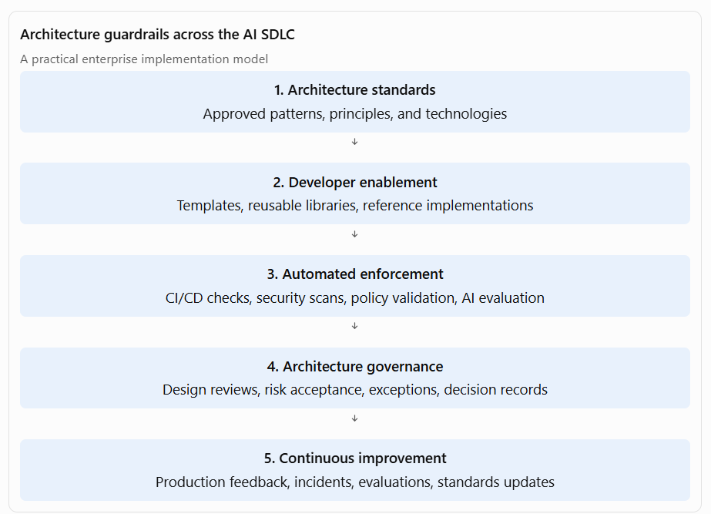
Example 1: Banking – Standardized AI application development
Develop a reusable AI application starter kit containing:
- Approved LLM integration.
- Authentication and authorization.
- Prompt management.
- Logging and monitoring.
- Standard API integration.
- Automated security checks.
Engineering teams use the starter kit instead of building these components independently.
Example 2: Insurance – Automated AI quality checks
Introduce CI/CD pipeline checks for AI claims applications.
The pipeline validates:
- Approved model versions.
- Prompt and configuration changes.
- Document extraction accuracy.
- RAG retrieval quality.
- Security and privacy requirements.
- Regression evaluation results.
This makes architecture and AI quality standards part of the delivery process.
Example 3: Healthcare – AI development governance
Establish a controlled development process for clinical AI applications.
The pipeline includes:
- Clinical evaluation datasets.
- Model and prompt version tracking.
- Privacy and security checks.
- Clinical review requirements.
- Release approval.
- Production monitoring.
This ensures that clinical AI changes receive appropriate validation before deployment.
Example 4: Telecommunications – Agent development guardrails
Provide standardized agent development templates with:
- Approved tool registration.
- Tool permission definitions.
- Agent execution limits.
- Input and output validation.
- Human approval mechanisms.
- Audit logging.
This allows different teams to develop agents while maintaining consistent controls.
Example 5: Government – Architecture compliance automation
Develop reusable compliance checks for citizen-facing AI applications.
Automated checks validate:
- Approved knowledge sources.
- API authentication.
- Data access permissions.
- Logging and retention requirements.
- Accessibility requirements.
- Deployment configuration.
Architecture reviews can then focus on complex design decisions rather than repetitive compliance checks.
E. Continuously evolve architecture standards based on technology, business, and operational feedback
What this means
AI architecture standards cannot remain static because models, frameworks, security threats, business requirements, and regulatory expectations change rapidly.
The Principal Architect must establish a structured process to review, validate, and evolve standards based on:
- New AI technologies and capabilities.
- Emerging architectural patterns.
- Production incidents and operational feedback.
- Model evaluation results.
- Security vulnerabilities.
- Business requirements.
- Cloud and platform changes.
- Regulatory and compliance requirements.
- Engineering feedback and implementation challenges.
The goal is to maintain architectural consistency without creating outdated standards that constrain innovation.
Example 1: Banking – Evolve model selection standards
Initially, the organization may standardize on a single LLM provider.
Over time, new models may offer better reasoning, lower latency, improved cost efficiency, or stronger privacy capabilities.
I would establish a model evaluation framework that assesses:
- Accuracy and reasoning quality.
- Security and data protection.
- Latency and throughput.
- Cost per interaction.
- Business suitability.
- Operational reliability.
Based on evaluation results, I would evolve the model standards to support approved multi-model routing rather than relying on a single provider.
Example 2: Insurance – Evolve document processing patterns
Production feedback reveals that document extraction performs well for standard claims but struggles with handwritten forms and complex attachments.
I would evolve the reference pattern to include:
- Improved document classification.
- Specialized extraction models.
- Confidence-based routing.
- Human review for uncertain results.
- Continuous evaluation of extraction quality.
The architecture evolves based on operational evidence rather than theoretical assumptions.
Example 3: Healthcare – Evolve clinical AI evaluation standards
New clinical AI use cases introduce additional safety and accuracy considerations.
I would update standards to include:
- Domain-specific evaluation datasets.
- Clinical validation requirements.
- Improved source grounding.
- Human review requirements.
- More comprehensive error and risk monitoring.
This ensures that architectural standards reflect the increasing risk and complexity of clinical AI applications.
Example 4: Telecommunications – Evolve AI agent standards
Initially, AI agents may only provide diagnostic recommendations.
Later, business teams may want agents to execute operational actions.
I would evolve agent architecture standards to introduce:
- Tool permission tiers.
- Action risk classification.
- Human approval for high-impact operations.
- Execution limits.
- Rollback mechanisms.
- Enhanced monitoring and auditability.
This allows agent capabilities to expand without compromising operational safety.
Example 5: Government – Evolve AI governance standards
As AI services expand across government departments, new requirements may emerge around privacy, transparency, accessibility, and accountability.
I would review architecture standards and update:
- AI risk classification.
- Approved data handling patterns.
- Knowledge source validation.
- Audit and traceability requirements.
- Human oversight requirements.
- Accessibility and multilingual design standards.
The architecture governance process ensures that new requirements are incorporated consistently across departmental solutions.
F. Promote architecture standards through developer enablement and governance
What this means
Defining architecture standards is only one part of the role. A Principal Architect must ensure that teams understand, adopt, and consistently apply those standards.
This involves creating an architecture enablement ecosystem comprising:
- Architecture playbooks.
- Reference implementations.
- Reusable code templates.
- AI engineering guidelines.
- Architecture decision records.
- Developer training.
- Design review forums.
- Exception management.
- Architecture compliance dashboards.
The objective is to make architecture guidance accessible, actionable, and measurable.
Five industry examples
Industry | Architecture enablement approach | Expected benefit
Banking | Reusable AI application templates with secure model gateway integration | Faster delivery and consistent security
Insurance | Shared document intelligence libraries and claims integration patterns | Reduced duplication and implementation effort
Healthcare | Clinical AI reference implementations and evaluation templates | Consistent clinical validation and privacy controls
Telecommunications | Standard agent development framework and tool integration templates | Faster agent development and controlled operations
Government | AI architecture playbooks, compliance checklists, and departmental reference patterns | Consistent governance across departments
Interview talking point:
I view architecture standards as a product for engineering teams. I focus on making them easy to understand, easy to adopt, and measurable through automated controls. Rather than relying exclusively on governance meetings, I promote reusable templates, reference implementations, and automated compliance checks that help teams build the right solutions from the beginning.
3. Preparation guide with links
For an AI Principal Architect interview, prepare to explain not only what standards and patterns you would establish, but also how you would implement, govern, and evolve them across enterprise teams.
A. AI architecture standards and reference architectures
Topic | What to study | Preparation resource
AI reference architecture | AI application layers, model access, orchestration, knowledge, tools | Microsoft AI Architecture Patterns
Enterprise AI architecture | Shared platforms, AI services, reusable architecture | AWS Enterprise-Ready GenAI Platform
AI design patterns | RAG, model gateway, agents, event-driven AI, human-in-the-loop | Microsoft AI Application Design Patterns
AI architecture principles | Security, reliability, performance, cost, operational excellence | Azure AI Design Principles
Microsoft's AI architecture guidance is a useful starting point for understanding how to structure reusable AI architecture patterns across application, orchestration, knowledge, and tools layers.
Microsoft Learn+1
Interview questions to prepare:
- How would you establish enterprise AI architecture standards?
- How do you decide which AI capabilities should be standardized?
- How would you define an AI reference architecture for a large organization?
- How would you prevent different teams from creating incompatible AI architectures?
- How would you balance architectural consistency with innovation?
B. AI security and architecture guardrails
Topic | What to study | Preparation resource
AI risk management | Risk classification, risk assessment, mitigation, lifecycle governance | NIST AI Risk Management Framework
AI security verification | Security requirements for AI systems and lifecycle controls | OWASP AI Security Verification Standard
AI security architecture | AI security, privacy, responsible AI, operational controls | Microsoft AI Design Principles
Zero Trust for AI | Identity, access control, trust boundaries, agent security | Microsoft Zero Trust for AI
NIST AI RMF provides a lifecycle-oriented framework for managing AI risks, while OWASP AISVS offers testable security requirements for AI-enabled systems.
NIST+1
Interview questions to prepare:
- How would you define guardrails for enterprise AI development?
- How would you prevent sensitive data from being exposed through RAG?
- How would you govern AI agent tool access?
- How would you incorporate AI security into CI/CD?
- How would you enforce guardrails without slowing down delivery?
C. AI-enabled software development and engineering governance
Topic | What to study | Preparation resource
Architecture governance | Architecture reviews, standards, decision records, exceptions | TOGAF Enterprise Architecture
API design | API contracts, versioning, integration standards | Microsoft API Design Best Practices
Cloud architecture governance | Reliability, security, performance, operational excellence | Azure Well-Architected Framework
AI application engineering | Application patterns, RAG, orchestration, deployment | AI Application Design
The Azure Well-Architected Framework is particularly useful for explaining how standards can be translated into engineering practices for reliability, security, cost optimization, operational excellence, and performance.
Microsoft Learn+1
Interview questions to prepare:
- How would you embed architecture standards into the software development lifecycle?
- How would you automate architecture compliance?
- How do you handle exceptions to enterprise architecture standards?
- How would you measure architecture adoption across teams?
- How would you manage architecture technical debt?
4. Practical interview case study
Prepare a case study that demonstrates how you would establish architecture standards for a large enterprise AI program.
Scenario: Enterprise AI architecture standards for a banking organization
A bank plans to introduce AI applications across:
- Customer service.
- Loan underwriting.
- Fraud monitoring.
- Cross-selling.
- Compliance monitoring.
- Employee knowledge management.
The bank currently has multiple development teams independently building AI applications.
Your architectural responsibilities
Step | What you should explain
1. Assess current state | Identify existing AI solutions, duplicated capabilities, security gaps, and technology fragmentation
2. Define architecture principles | Establish principles for security, reuse, scalability, interoperability, and responsible AI
3. Develop reference architectures | Define standard RAG, agentic AI, document intelligence, and AI integration patterns
4. Establish guardrails | Define model approval, data security, AI evaluation, and agent permission controls
5. Enable engineering teams | Provide reusable templates, libraries, APIs, and reference implementations
6. Automate governance | Introduce CI/CD architecture checks, AI evaluations, and security validation
7. Establish governance | Define architecture review forums, decision records, and exception management
8. Evolve standards | Incorporate production feedback, incidents, new technologies, and changing requirements
5. Metrics to demonstrate architecture effectiveness
A Principal Architect should demonstrate that architecture standards improve enterprise delivery and quality.
Metric | What it measures
Architecture adoption rate | Percentage of AI projects using approved patterns
Reuse rate | Percentage of solutions leveraging shared AI capabilities
Time-to-market | Reduction in AI application delivery time
Architecture compliance | Compliance with mandatory standards and guardrails
Security findings | AI-related security issues identified and resolved
AI quality | Accuracy, retrieval quality, and evaluation results
Operational reliability | Availability, failure rates, and incident frequency
Cost efficiency | Reduction in duplicated infrastructure and AI service costs
Exception rate | Frequency of architecture deviations and waivers
These metrics help demonstrate that architecture governance is an enabler of innovation rather than simply a control mechanism.
6. Strong interview closing statement
Use this as your final summary when discussing the expectation:
My approach to AI architecture standards is to establish a strong but flexible architectural foundation that enables enterprise-wide AI adoption without restricting innovation. I define reusable reference architectures, design patterns, and engineering guardrails covering AI applications, RAG, agentic AI, model integration, security, governance, and operational excellence. I work closely with enterprise architecture, AI engineering, security, and product teams to ensure these standards are practical, implementable, and aligned with business priorities. I embed architecture controls into the software development lifecycle through reusable templates, automated validation, architecture reviews, and continuous evaluation. Most importantly, I continuously evolve these standards based on emerging technologies, engineering feedback, production experience, and business requirements to ensure the enterprise can scale AI adoption securely, consistently, and sustainably.

Expectation: Define and evolve architecture standards, reference patterns, and guardrails for AI solutions and AI-enabled software development
1. Two-paragraph interview narrative
As an AI Principal Architect, I establish and continuously evolve enterprise architecture standards, reference architectures, reusable design patterns, and technical guardrails that enable teams to build AI solutions consistently, securely, and at scale. I collaborate with enterprise architecture, AI engineering, application development, data, security, and business stakeholders to define architectural principles covering AI application design, LLM integration, RAG, agentic AI, model selection, data management, API integration, and responsible AI. I translate emerging AI technologies and enterprise requirements into practical architectural guidance that engineering teams can adopt across products, platforms, and business domains. My objective is to accelerate AI innovation while minimizing architectural fragmentation, duplicated investments, technology risks, and unnecessary complexity.
I also treat architecture standards as evolving assets rather than static documentation. I establish governance mechanisms to validate architectural patterns through implementation experience, AI evaluation results, operational feedback, and changes in technology or regulatory requirements. I define guardrails that guide engineering teams toward approved technologies, secure development practices, reusable components, and appropriate AI risk controls while preserving flexibility for experimentation and innovation. Through architecture reviews, reference implementations, reusable blueprints, developer enablement, and continuous improvement, I ensure that AI-enabled software development follows consistent enterprise principles and that architectural standards remain practical, measurable, and aligned with business objectives.
2. Expand each significant point with industry examples
A. Define enterprise AI architecture standards
What this means
Architecture standards establish the common principles, technology choices, engineering practices, and quality requirements that AI solutions must follow across the enterprise.
As an AI Principal Architect, you define standards that provide consistency without forcing every AI solution into an identical implementation.
Typical standards include:
- AI application architecture principles.
- Approved model integration approaches.
- API and service integration standards.
- Data management and information security standards.
- RAG and knowledge retrieval standards.
- AI agent design standards.
- AI evaluation and testing requirements.
- Model lifecycle and operational standards.
- Documentation and architecture decision requirements.
- Responsible AI and compliance requirements.
The objective is to reduce architectural fragmentation, promote reuse, improve quality, and make AI solutions easier to maintain and govern.
Example 1: Banking – Standardize AI-powered customer assistants
Business scenario: Multiple banking divisions want to introduce customer-facing AI assistants.
Without standards, each team might independently select an LLM, implement customer data access, and establish its own security mechanisms.
Standards I would establish:
- Approved enterprise LLM access through a model gateway.
- Standard integration with customer and product APIs.
- Customer identity and authorization requirements.
- Standard RAG architecture for approved banking knowledge.
- Evaluation requirements for accuracy and financial misinformation.
- Audit logging and human escalation requirements.
Result: Multiple banking products can use a consistent architecture while retaining their own business-specific capabilities.
Example 2: Insurance – Standardize document intelligence
Business scenario: Claims, underwriting, policy servicing, and customer onboarding teams all need document extraction capabilities.
Standards I would establish:
- Common document ingestion and classification patterns.
- Standard extraction APIs and data schemas.
- Confidence scoring and validation requirements.
- Standard exception handling.
- Secure document storage and retention.
- Reusable integration with insurance workflow systems.
Result: Teams reuse document intelligence capabilities rather than developing separate extraction solutions.
Example 3: Healthcare – Standardize clinical AI applications
Business scenario: Multiple hospitals want to introduce clinical summarization and knowledge assistants.
Standards I would establish:
- Approved clinical data integration patterns.
- Patient-level access control.
- Clinical data privacy requirements.
- Standard evaluation of clinical accuracy.
- Human review requirements.
- Clinical auditability and traceability.
Result: Healthcare AI applications follow consistent safety and privacy requirements while supporting different clinical workflows.
Example 4: Telecommunications – Standardize network AI capabilities
Business scenario: Network operations, customer service, and predictive maintenance teams are introducing AI.
Standards I would establish:
- Common model integration and API standards.
- Standard event-driven integration patterns.
- Reusable network telemetry ingestion.
- Agent tool permission standards.
- Operational observability and monitoring requirements.
Result: AI capabilities can be reused across network operations and customer service platforms.
Example 5: Government – Standardize citizen service AI
Business scenario: Multiple departments want to introduce AI assistants for citizen services.
Standards I would establish:
- Approved knowledge source requirements.
- Standard identity and access management.
- API integration with departmental systems.
- Accessibility and multilingual support requirements.
- Data retention and audit requirements.
- Human escalation for sensitive administrative decisions.
Result: Departments can implement AI services consistently while preserving departmental data boundaries.
B. Establish reusable AI reference architectures and design patterns
What this means
A reference architecture provides a reusable architectural blueprint for a particular class of AI solution.
A design pattern provides a repeatable solution to a recurring architectural problem.
The principal architect identifies common AI use cases and establishes patterns that engineering teams can reuse rather than designing each application from scratch.
Examples of reusable AI patterns include:
Pattern | Purpose
Enterprise RAG pattern | Ground AI responses in enterprise knowledge
AI model gateway | Centralize model access and control
AI agent with tool calling | Enable controlled interaction with business APIs
Human-in-the-loop pattern | Introduce human review for consequential decisions
Document intelligence pattern | Standardize document extraction and processing
AI workflow orchestration | Coordinate AI and deterministic business processes
AI evaluation pattern | Establish reusable quality and performance evaluation
Event-driven AI pattern | Support asynchronous AI processing
AI observability pattern | Monitor AI quality, performance, cost, and behavior
Microsoft's AI architecture guidance provides useful baseline patterns for intelligent applications, orchestration, knowledge retrieval, and tools integration.
Microsoft Learn+1
Example 1: Banking – Enterprise RAG reference architecture
Business scenario: Banking teams want AI assistants for credit policy, customer servicing, compliance, and product information.
Reference architecture:
- Document ingestion and processing.
- Enterprise knowledge repository.
- Embedding and retrieval services.
- Permission-aware retrieval.
- LLM orchestration.
- Response generation with citations.
- Evaluation and monitoring.
Reusable pattern: A common enterprise RAG architecture that supports multiple banking use cases while enforcing data access and knowledge source controls.
Example 2: Insurance – Document intelligence pattern
Business scenario: Insurance teams need to extract information from claims forms, medical reports, policy documents, and customer submissions.
Reference architecture:
- Document ingestion.
- Classification.
- OCR and document extraction.
- Validation and confidence scoring.
- Human review.
- Workflow integration.
Reusable pattern: A document intelligence service that can be reused across claims, underwriting, and policy servicing.
Example 3: Healthcare – Clinical knowledge assistant pattern
Business scenario: Healthcare professionals need an assistant that retrieves clinical guidelines and authorized patient information.
Reference architecture:
- Identity and authorization.
- Clinical knowledge retrieval.
- Patient context integration.
- LLM-based summarization.
- Source citation.
- Clinician review.
Reusable pattern: A clinical knowledge assistant architecture with strong patient data protection and human oversight.
Example 4: Telecommunications – Network operations agent pattern
Business scenario: Telecom operators want AI agents to investigate incidents and recommend remediation.
Reference architecture:
- Event ingestion.
- Network telemetry retrieval.
- Incident analysis.
- Tool calling to monitoring systems.
- Diagnostic recommendations.
- Approval-controlled remediation.
- Audit logging.
Reusable pattern: A controlled AI agent architecture that supports multiple network operations workflows.
Example 5: Government – Citizen services assistant pattern
Business scenario: Government departments want AI assistants for citizen information and service navigation.
Reference architecture:
- Approved public knowledge sources.
- Retrieval and grounding.
- Citizen authentication where required.
- Departmental API integration.
- Response validation.
- Human escalation.
Reusable pattern: A citizen services architecture that can be adapted across departments without duplicating core AI capabilities.
C. Define guardrails for AI solutions and AI-enabled software development
What this means
Guardrails are architectural constraints, controls, and engineering practices that guide teams toward safe, secure, reliable, and maintainable AI implementations.
They are not intended to prevent innovation. They establish the boundaries within which teams can innovate responsibly.
A mature enterprise AI guardrail framework should cover the following areas:
AI solution guardrails
- Approved models, providers, and deployment environments.
- Data classification and privacy.
- AI risk classification and responsible AI.
- Retrieval quality and source grounding.
- Model evaluation and validation.
- AI-specific security controls.
- Human oversight and approval.
- Production monitoring and incident management.
AI-enabled software development guardrails
- Approved AI development frameworks and libraries.
- Secure coding practices for AI applications.
- API contracts and integration standards.
- Prompt and configuration versioning.
- Automated testing and AI evaluation.
- CI/CD and deployment controls.
- Dependency and vulnerability scanning.
- Observability and operational readiness.
The distinction is important: AI solution guardrails govern the behavior and risk of AI capabilities, while AI-enabled software development guardrails govern how engineering teams design, build, test, deploy, and maintain those capabilities.
Example 1: Banking – Guardrails for AI loan underwriting
Business scenario: A bank introduces AI-assisted loan underwriting.
Guardrails:
- AI-generated recommendations must not bypass established lending policies.
- Approved models and data sources must be used.
- Sensitive customer information must be protected.
- Model fairness and performance must be evaluated.
- High-impact lending decisions must retain appropriate human accountability.
- All relevant recommendations and decisions must be traceable.
Engineering guardrails:
- Use approved APIs for accessing customer information.
- Enforce deterministic eligibility and policy rules.
- Test model outputs against predefined evaluation datasets.
- Apply mandatory approval workflows before consequential actions.
Architectural outcome: AI improves underwriting efficiency without compromising lending controls.
Example 2: Insurance – Guardrails for AI claims processing
Business scenario: An insurer introduces AI-assisted claims assessment.
Guardrails:
- Claims information must be retrieved only from authorized sources.
- AI must not invent policy clauses or coverage conditions.
- Low-confidence extraction must trigger human review.
- Claims decisions must remain traceable.
- Customer data must be protected throughout processing.
Engineering guardrails:
- Standard document extraction schemas.
- Confidence thresholds for automated processing.
- Validation against policy and claims systems.
- Mandatory exception handling.
- Automated testing of document extraction accuracy.
Architectural outcome: AI-assisted claims processing becomes more consistent, controlled, and auditable.
Example 3: Healthcare – Guardrails for clinical AI
Business scenario: A hospital introduces AI-generated clinical summaries.
Guardrails:
- Clinical information must come from approved and authorized sources.
- AI-generated clinical content must be clearly distinguishable from verified clinical records.
- Clinical accuracy must be evaluated.
- Sensitive patient information must be protected.
- Clinicians must retain appropriate oversight.
Engineering guardrails:
- Secure EHR integration.
- Clinical terminology validation.
- Version-controlled prompts and model configurations.
- Evaluation datasets representing relevant clinical scenarios.
- Logging and traceability of AI-generated outputs.
Architectural outcome: Clinical AI supports healthcare professionals while preserving clinical responsibility and patient safety.
Example 4: Telecommunications – Guardrails for autonomous network agents
Business scenario: A telecom operator introduces AI agents for network incident remediation.
Guardrails:
- Agents must use approved operational tools.
- Tool permissions must follow least privilege.
- Network-changing actions must have appropriate approval.
- Agent actions must be logged and monitored.
- High-risk actions must have rollback mechanisms.
Engineering guardrails:
- Standardized tool contracts.
- Input validation for tool calls.
- Controlled execution environments.
- Integration testing against simulated network scenarios.
- Monitoring for unexpected agent behavior.
Architectural outcome: Network automation becomes more intelligent without introducing uncontrolled operational risk.
Example 5: Government – Guardrails for AI-enabled citizen services
Business scenario: Government departments deploy AI assistants that help citizens access public services.
Guardrails:
- Responses must use approved information sources.
- Sensitive citizen information must be protected.
- Department-specific access boundaries must be enforced.
- AI must not independently make unauthorized administrative decisions.
- Human escalation must be available for complex or sensitive cases.
Engineering guardrails:
- Approved knowledge repositories.
- Standard API authentication and authorization.
- Content validation and response evaluation.
- Accessibility and multilingual testing.
- Audit logging and retention controls.
Architectural outcome: Citizen services become more accessible while maintaining transparency, security, and public accountability.
D. Embed architecture guardrails into the software development lifecycle
What this means
A Principal Architect should ensure that architecture standards are embedded into the development process rather than relying solely on documentation or architecture review meetings.
This is where architecture governance becomes engineering enablement.
The goal is to make the correct architectural approach the easiest approach for engineering teams to follow.
Recommended implementation approach
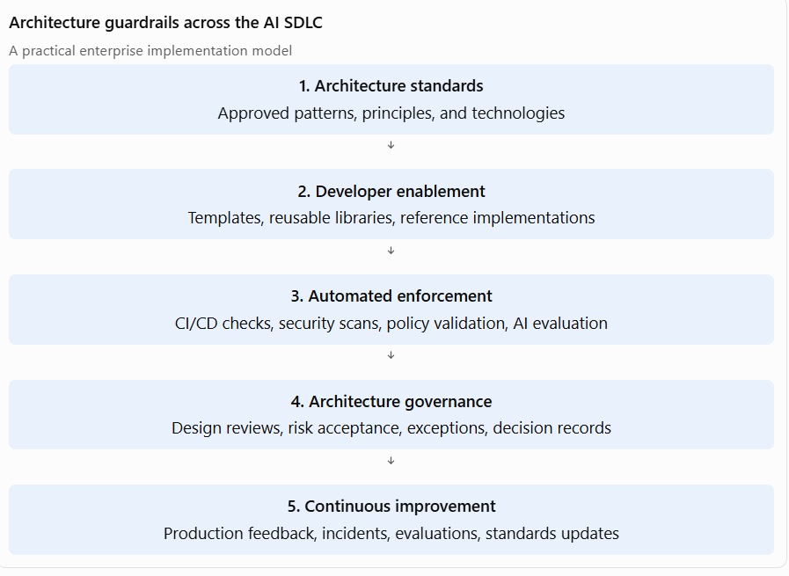
Example 1: Banking – Standardized AI application development
Develop a reusable AI application starter kit containing:
- Approved LLM integration.
- Authentication and authorization.
- Prompt management.
- Logging and monitoring.
- Standard API integration.
- Automated security checks.
Engineering teams use the starter kit instead of building these components independently.
Example 2: Insurance – Automated AI quality checks
Introduce CI/CD pipeline checks for AI claims applications.
The pipeline validates:
- Approved model versions.
- Prompt and configuration changes.
- Document extraction accuracy.
- RAG retrieval quality.
- Security and privacy requirements.
- Regression evaluation results.
This makes architecture and AI quality standards part of the delivery process.
Example 3: Healthcare – AI development governance
Establish a controlled development process for clinical AI applications.
The pipeline includes:
- Clinical evaluation datasets.
- Model and prompt version tracking.
- Privacy and security checks.
- Clinical review requirements.
- Release approval.
- Production monitoring.
This ensures that clinical AI changes receive appropriate validation before deployment.
Example 4: Telecommunications – Agent development guardrails
Provide standardized agent development templates with:
- Approved tool registration.
- Tool permission definitions.
- Agent execution limits.
- Input and output validation.
- Human approval mechanisms.
- Audit logging.
This allows different teams to develop agents while maintaining consistent controls.
Example 5: Government – Architecture compliance automation
Develop reusable compliance checks for citizen-facing AI applications.
Automated checks validate:
- Approved knowledge sources.
- API authentication.
- Data access permissions.
- Logging and retention requirements.
- Accessibility requirements.
- Deployment configuration.
Architecture reviews can then focus on complex design decisions rather than repetitive compliance checks.
E. Continuously evolve architecture standards based on technology, business, and operational feedback
What this means
AI architecture standards cannot remain static because models, frameworks, security threats, business requirements, and regulatory expectations change rapidly.
The Principal Architect must establish a structured process to review, validate, and evolve standards based on:
- New AI technologies and capabilities.
- Emerging architectural patterns.
- Production incidents and operational feedback.
- Model evaluation results.
- Security vulnerabilities.
- Business requirements.
- Cloud and platform changes.
- Regulatory and compliance requirements.
- Engineering feedback and implementation challenges.
The goal is to maintain architectural consistency without creating outdated standards that constrain innovation.
Example 1: Banking – Evolve model selection standards
Initially, the organization may standardize on a single LLM provider.
Over time, new models may offer better reasoning, lower latency, improved cost efficiency, or stronger privacy capabilities.
I would establish a model evaluation framework that assesses:
- Accuracy and reasoning quality.
- Security and data protection.
- Latency and throughput.
- Cost per interaction.
- Business suitability.
- Operational reliability.
Based on evaluation results, I would evolve the model standards to support approved multi-model routing rather than relying on a single provider.
Example 2: Insurance – Evolve document processing patterns
Production feedback reveals that document extraction performs well for standard claims but struggles with handwritten forms and complex attachments.
I would evolve the reference pattern to include:
- Improved document classification.
- Specialized extraction models.
- Confidence-based routing.
- Human review for uncertain results.
- Continuous evaluation of extraction quality.
The architecture evolves based on operational evidence rather than theoretical assumptions.
Example 3: Healthcare – Evolve clinical AI evaluation standards
New clinical AI use cases introduce additional safety and accuracy considerations.
I would update standards to include:
- Domain-specific evaluation datasets.
- Clinical validation requirements.
- Improved source grounding.
- Human review requirements.
- More comprehensive error and risk monitoring.
This ensures that architectural standards reflect the increasing risk and complexity of clinical AI applications.
Example 4: Telecommunications – Evolve AI agent standards
Initially, AI agents may only provide diagnostic recommendations.
Later, business teams may want agents to execute operational actions.
I would evolve agent architecture standards to introduce:
- Tool permission tiers.
- Action risk classification.
- Human approval for high-impact operations.
- Execution limits.
- Rollback mechanisms.
- Enhanced monitoring and auditability.
This allows agent capabilities to expand without compromising operational safety.
Example 5: Government – Evolve AI governance standards
As AI services expand across government departments, new requirements may emerge around privacy, transparency, accessibility, and accountability.
I would review architecture standards and update:
- AI risk classification.
- Approved data handling patterns.
- Knowledge source validation.
- Audit and traceability requirements.
- Human oversight requirements.
- Accessibility and multilingual design standards.
The architecture governance process ensures that new requirements are incorporated consistently across departmental solutions.
F. Promote architecture standards through developer enablement and governance
What this means
Defining architecture standards is only one part of the role. A Principal Architect must ensure that teams understand, adopt, and consistently apply those standards.
This involves creating an architecture enablement ecosystem comprising:
- Architecture playbooks.
- Reference implementations.
- Reusable code templates.
- AI engineering guidelines.
- Architecture decision records.
- Developer training.
- Design review forums.
- Exception management.
- Architecture compliance dashboards.
The objective is to make architecture guidance accessible, actionable, and measurable.
Five industry examples
Industry | Architecture enablement approach | Expected benefit
Banking | Reusable AI application templates with secure model gateway integration | Faster delivery and consistent security
Insurance | Shared document intelligence libraries and claims integration patterns | Reduced duplication and implementation effort
Healthcare | Clinical AI reference implementations and evaluation templates | Consistent clinical validation and privacy controls
Telecommunications | Standard agent development framework and tool integration templates | Faster agent development and controlled operations
Government | AI architecture playbooks, compliance checklists, and departmental reference patterns | Consistent governance across departments
Interview talking point:
I view architecture standards as a product for engineering teams. I focus on making them easy to understand, easy to adopt, and measurable through automated controls. Rather than relying exclusively on governance meetings, I promote reusable templates, reference implementations, and automated compliance checks that help teams build the right solutions from the beginning.
3. Preparation guide with links
For an AI Principal Architect interview, prepare to explain not only what standards and patterns you would establish, but also how you would implement, govern, and evolve them across enterprise teams.
A. AI architecture standards and reference architectures
Topic | What to study | Preparation resource
AI reference architecture | AI application layers, model access, orchestration, knowledge, tools | Microsoft AI Architecture Patterns
Enterprise AI architecture | Shared platforms, AI services, reusable architecture | AWS Enterprise-Ready GenAI Platform
AI design patterns | RAG, model gateway, agents, event-driven AI, human-in-the-loop | Microsoft AI Application Design Patterns
AI architecture principles | Security, reliability, performance, cost, operational excellence | Azure AI Design Principles
Microsoft's AI architecture guidance is a useful starting point for understanding how to structure reusable AI architecture patterns across application, orchestration, knowledge, and tools layers.
Microsoft Learn+1
Interview questions to prepare:
- How would you establish enterprise AI architecture standards?
- How do you decide which AI capabilities should be standardized?
- How would you define an AI reference architecture for a large organization?
- How would you prevent different teams from creating incompatible AI architectures?
- How would you balance architectural consistency with innovation?
B. AI security and architecture guardrails
Topic | What to study | Preparation resource
AI risk management | Risk classification, risk assessment, mitigation, lifecycle governance | NIST AI Risk Management Framework
AI security verification | Security requirements for AI systems and lifecycle controls | OWASP AI Security Verification Standard
AI security architecture | AI security, privacy, responsible AI, operational controls | Microsoft AI Design Principles
Zero Trust for AI | Identity, access control, trust boundaries, agent security | Microsoft Zero Trust for AI
NIST AI RMF provides a lifecycle-oriented framework for managing AI risks, while OWASP AISVS offers testable security requirements for AI-enabled systems.
NIST+1
Interview questions to prepare:
- How would you define guardrails for enterprise AI development?
- How would you prevent sensitive data from being exposed through RAG?
- How would you govern AI agent tool access?
- How would you incorporate AI security into CI/CD?
- How would you enforce guardrails without slowing down delivery?
C. AI-enabled software development and engineering governance
Topic | What to study | Preparation resource
Architecture governance | Architecture reviews, standards, decision records, exceptions | TOGAF Enterprise Architecture
API design | API contracts, versioning, integration standards | Microsoft API Design Best Practices
Cloud architecture governance | Reliability, security, performance, operational excellence | Azure Well-Architected Framework
AI application engineering | Application patterns, RAG, orchestration, deployment | AI Application Design
The Azure Well-Architected Framework is particularly useful for explaining how standards can be translated into engineering practices for reliability, security, cost optimization, operational excellence, and performance.
Microsoft Learn+1
Interview questions to prepare:
- How would you embed architecture standards into the software development lifecycle?
- How would you automate architecture compliance?
- How do you handle exceptions to enterprise architecture standards?
- How would you measure architecture adoption across teams?
- How would you manage architecture technical debt?
4. Practical interview case study
Prepare a case study that demonstrates how you would establish architecture standards for a large enterprise AI program.
Scenario: Enterprise AI architecture standards for a banking organization
A bank plans to introduce AI applications across:
- Customer service.
- Loan underwriting.
- Fraud monitoring.
- Cross-selling.
- Compliance monitoring.
- Employee knowledge management.
The bank currently has multiple development teams independently building AI applications.
Your architectural responsibilities
Step | What you should explain
1. Assess current state | Identify existing AI solutions, duplicated capabilities, security gaps, and technology fragmentation
2. Define architecture principles | Establish principles for security, reuse, scalability, interoperability, and responsible AI
3. Develop reference architectures | Define standard RAG, agentic AI, document intelligence, and AI integration patterns
4. Establish guardrails | Define model approval, data security, AI evaluation, and agent permission controls
5. Enable engineering teams | Provide reusable templates, libraries, APIs, and reference implementations
6. Automate governance | Introduce CI/CD architecture checks, AI evaluations, and security validation
7. Establish governance | Define architecture review forums, decision records, and exception management
8. Evolve standards | Incorporate production feedback, incidents, new technologies, and changing requirements
5. Metrics to demonstrate architecture effectiveness
A Principal Architect should demonstrate that architecture standards improve enterprise delivery and quality.
Metric | What it measures
Architecture adoption rate | Percentage of AI projects using approved patterns
Reuse rate | Percentage of solutions leveraging shared AI capabilities
Time-to-market | Reduction in AI application delivery time
Architecture compliance | Compliance with mandatory standards and guardrails
Security findings | AI-related security issues identified and resolved
AI quality | Accuracy, retrieval quality, and evaluation results
Operational reliability | Availability, failure rates, and incident frequency
Cost efficiency | Reduction in duplicated infrastructure and AI service costs
Exception rate | Frequency of architecture deviations and waivers
These metrics help demonstrate that architecture governance is an enabler of innovation rather than simply a control mechanism.
6. Strong interview closing statement
Use this as your final summary when discussing the expectation:
Example 1: Banking – Standardized AI application development
Develop a reusable AI application starter kit containing:
- Approved LLM integration.
- Authentication and authorization.
- Prompt management.
- Logging and monitoring.
- Standard API integration.
- Automated security checks.
Engineering teams use the starter kit instead of building these components independently.
Example 2: Insurance – Automated AI quality checks
Introduce CI/CD pipeline checks for AI claims applications.
The pipeline validates:
- Approved model versions.
- Prompt and configuration changes.
- Document extraction accuracy.
- RAG retrieval quality.
- Security and privacy requirements.
- Regression evaluation results.
This makes architecture and AI quality standards part of the delivery process.
Example 3: Healthcare – AI development governance
Establish a controlled development process for clinical AI applications.
The pipeline includes:
- Clinical evaluation datasets.
- Model and prompt version tracking.
- Privacy and security checks.
- Clinical review requirements.
- Release approval.
- Production monitoring.
This ensures that clinical AI changes receive appropriate validation before deployment.
Example 4: Telecommunications – Agent development guardrails
Provide standardized agent development templates with:
- Approved tool registration.
- Tool permission definitions.
- Agent execution limits.
- Input and output validation.
- Human approval mechanisms.
- Audit logging.
This allows different teams to develop agents while maintaining consistent controls.
Example 5: Government – Architecture compliance automation
Develop reusable compliance checks for citizen-facing AI applications.
Automated checks validate:
- Approved knowledge sources.
- API authentication.
- Data access permissions.
- Logging and retention requirements.
- Accessibility requirements.
- Deployment configuration.
Architecture reviews can then focus on complex design decisions rather than repetitive compliance checks.
E. Continuously evolve architecture standards based on technology, business, and operational feedback
What this means
AI architecture standards cannot remain static because models, frameworks, security threats, business requirements, and regulatory expectations change rapidly.
The Principal Architect must establish a structured process to review, validate, and evolve standards based on:
- New AI technologies and capabilities.
- Emerging architectural patterns.
- Production incidents and operational feedback.
- Model evaluation results.
- Security vulnerabilities.
- Business requirements.
- Cloud and platform changes.
- Regulatory and compliance requirements.
- Engineering feedback and implementation challenges.
The goal is to maintain architectural consistency without creating outdated standards that constrain innovation.
Example 1: Banking – Evolve model selection standards
Initially, the organization may standardize on a single LLM provider.
Over time, new models may offer better reasoning, lower latency, improved cost efficiency, or stronger privacy capabilities.
I would establish a model evaluation framework that assesses:
- Accuracy and reasoning quality.
- Security and data protection.
- Latency and throughput.
- Cost per interaction.
- Business suitability.
- Operational reliability.
Based on evaluation results, I would evolve the model standards to support approved multi-model routing rather than relying on a single provider.
Example 2: Insurance – Evolve document processing patterns
Production feedback reveals that document extraction performs well for standard claims but struggles with handwritten forms and complex attachments.
I would evolve the reference pattern to include:
- Improved document classification.
- Specialized extraction models.
- Confidence-based routing.
- Human review for uncertain results.
- Continuous evaluation of extraction quality.
The architecture evolves based on operational evidence rather than theoretical assumptions.
Example 3: Healthcare – Evolve clinical AI evaluation standards
New clinical AI use cases introduce additional safety and accuracy considerations.
I would update standards to include:
- Domain-specific evaluation datasets.
- Clinical validation requirements.
- Improved source grounding.
- Human review requirements.
- More comprehensive error and risk monitoring.
This ensures that architectural standards reflect the increasing risk and complexity of clinical AI applications.
Example 4: Telecommunications – Evolve AI agent standards
Initially, AI agents may only provide diagnostic recommendations.
Later, business teams may want agents to execute operational actions.
I would evolve agent architecture standards to introduce:
- Tool permission tiers.
- Action risk classification.
- Human approval for high-impact operations.
- Execution limits.
- Rollback mechanisms.
- Enhanced monitoring and auditability.
This allows agent capabilities to expand without compromising operational safety.
Example 5: Government – Evolve AI governance standards
As AI services expand across government departments, new requirements may emerge around privacy, transparency, accessibility, and accountability.
I would review architecture standards and update:
- AI risk classification.
- Approved data handling patterns.
- Knowledge source validation.
- Audit and traceability requirements.
- Human oversight requirements.
- Accessibility and multilingual design standards.
The architecture governance process ensures that new requirements are incorporated consistently across departmental solutions.
F. Promote architecture standards through developer enablement and governance
What this means
Defining architecture standards is only one part of the role. A Principal Architect must ensure that teams understand, adopt, and consistently apply those standards.
This involves creating an architecture enablement ecosystem comprising:
- Architecture playbooks.
- Reference implementations.
- Reusable code templates.
- AI engineering guidelines.
- Architecture decision records.
- Developer training.
- Design review forums.
- Exception management.
- Architecture compliance dashboards.
The objective is to make architecture guidance accessible, actionable, and measurable.
Five industry examples
Industry | Architecture enablement approach | Expected benefit
Banking | Reusable AI application templates with secure model gateway integration | Faster delivery and consistent security
Insurance | Shared document intelligence libraries and claims integration patterns | Reduced duplication and implementation effort
Healthcare | Clinical AI reference implementations and evaluation templates | Consistent clinical validation and privacy controls
Telecommunications | Standard agent development framework and tool integration templates | Faster agent development and controlled operations
Government | AI architecture playbooks, compliance checklists, and departmental reference patterns | Consistent governance across departments
Interview talking point:
I view architecture standards as a product for engineering teams. I focus on making them easy to understand, easy to adopt, and measurable through automated controls. Rather than relying exclusively on governance meetings, I promote reusable templates, reference implementations, and automated compliance checks that help teams build the right solutions from the beginning.
3. Preparation guide with links
For an AI Principal Architect interview, prepare to explain not only what standards and patterns you would establish, but also how you would implement, govern, and evolve them across enterprise teams.
A. AI architecture standards and reference architectures
Topic | What to study | Preparation resource
AI reference architecture | AI application layers, model access, orchestration, knowledge, tools | Microsoft AI Architecture Patterns
Enterprise AI architecture | Shared platforms, AI services, reusable architecture | AWS Enterprise-Ready GenAI Platform
AI design patterns | RAG, model gateway, agents, event-driven AI, human-in-the-loop | Microsoft AI Application Design Patterns
AI architecture principles | Security, reliability, performance, cost, operational excellence | Azure AI Design Principles
Microsoft's AI architecture guidance is a useful starting point for understanding how to structure reusable AI architecture patterns across application, orchestration, knowledge, and tools layers.
Microsoft Learn+1
Interview questions to prepare:
- How would you establish enterprise AI architecture standards?
- How do you decide which AI capabilities should be standardized?
- How would you define an AI reference architecture for a large organization?
- How would you prevent different teams from creating incompatible AI architectures?
- How would you balance architectural consistency with innovation?
B. AI security and architecture guardrails
Topic | What to study | Preparation resource
AI risk management | Risk classification, risk assessment, mitigation, lifecycle governance | NIST AI Risk Management Framework
AI security verification | Security requirements for AI systems and lifecycle controls | OWASP AI Security Verification Standard
AI security architecture | AI security, privacy, responsible AI, operational controls | Microsoft AI Design Principles
Zero Trust for AI | Identity, access control, trust boundaries, agent security | Microsoft Zero Trust for AI
NIST AI RMF provides a lifecycle-oriented framework for managing AI risks, while OWASP AISVS offers testable security requirements for AI-enabled systems.
NIST+1
Interview questions to prepare:
- How would you define guardrails for enterprise AI development?
- How would you prevent sensitive data from being exposed through RAG?
- How would you govern AI agent tool access?
- How would you incorporate AI security into CI/CD?
- How would you enforce guardrails without slowing down delivery?
C. AI-enabled software development and engineering governance
Topic | What to study | Preparation resource
Architecture governance | Architecture reviews, standards, decision records, exceptions | TOGAF Enterprise Architecture
API design | API contracts, versioning, integration standards | Microsoft API Design Best Practices
Cloud architecture governance | Reliability, security, performance, operational excellence | Azure Well-Architected Framework
AI application engineering | Application patterns, RAG, orchestration, deployment | AI Application Design
The Azure Well-Architected Framework is particularly useful for explaining how standards can be translated into engineering practices for reliability, security, cost optimization, operational excellence, and performance.
Microsoft Learn+1
Interview questions to prepare:
- How would you embed architecture standards into the software development lifecycle?
- How would you automate architecture compliance?
- How do you handle exceptions to enterprise architecture standards?
- How would you measure architecture adoption across teams?
- How would you manage architecture technical debt?
4. Practical interview case study
Prepare a case study that demonstrates how you would establish architecture standards for a large enterprise AI program.
Scenario: Enterprise AI architecture standards for a banking organization
A bank plans to introduce AI applications across:
- Customer service.
- Loan underwriting.
- Fraud monitoring.
- Cross-selling.
- Compliance monitoring.
- Employee knowledge management.
The bank currently has multiple development teams independently building AI applications.
Your architectural responsibilities
Step | What you should explain
1. Assess current state | Identify existing AI solutions, duplicated capabilities, security gaps, and technology fragmentation
2. Define architecture principles | Establish principles for security, reuse, scalability, interoperability, and responsible AI
3. Develop reference architectures | Define standard RAG, agentic AI, document intelligence, and AI integration patterns
4. Establish guardrails | Define model approval, data security, AI evaluation, and agent permission controls
5. Enable engineering teams | Provide reusable templates, libraries, APIs, and reference implementations
6. Automate governance | Introduce CI/CD architecture checks, AI evaluations, and security validation
7. Establish governance | Define architecture review forums, decision records, and exception management
8. Evolve standards | Incorporate production feedback, incidents, new technologies, and changing requirements
5. Metrics to demonstrate architecture effectiveness
A Principal Architect should demonstrate that architecture standards improve enterprise delivery and quality.
Metric | What it measures
Architecture adoption rate | Percentage of AI projects using approved patterns
Reuse rate | Percentage of solutions leveraging shared AI capabilities
Time-to-market | Reduction in AI application delivery time
Architecture compliance | Compliance with mandatory standards and guardrails
Security findings | AI-related security issues identified and resolved
AI quality | Accuracy, retrieval quality, and evaluation results
Operational reliability | Availability, failure rates, and incident frequency
Cost efficiency | Reduction in duplicated infrastructure and AI service costs
Exception rate | Frequency of architecture deviations and waivers
These metrics help demonstrate that architecture governance is an enabler of innovation rather than simply a control mechanism.
6. Strong interview closing statement
Use this as your final summary when discussing the expectation:
My role as an AI Principal Architect is to act as a strategic technology advisor, helping the organization make informed decisions about emerging AI technologies, platforms, and architectural patterns. I evaluate innovations based on business value, technical maturity, scalability, security, integration complexity, cost, and long-term enterprise fit. I work closely with business leaders, product teams, and engineering stakeholders to identify where AI can deliver meaningful outcomes and determine the most appropriate adoption approach. Through structured technology assessments, proof-of-concepts, reference architectures, and phased adoption roadmaps, I help the organization move from experimentation to production in a controlled and scalable manner. My objective is to ensure that AI investments create sustainable business value while maintaining architectural integrity, responsible AI practices, and enterprise readiness.

Expectation: Provide architectural leadership for capabilities, agentic workflows, AI orchestration, evaluations, AI observability, and AI governance

This expectation is about leading the architecture of an enterprise AI ecosystem—not simply designing individual LLM applications. A Principal Architect must define how reusable AI capabilities are built and exposed, how AI agents interact with enterprise systems, how multi-step workflows are orchestrated, how AI quality is evaluated, how production behaviour is monitored, and how governance is embedded throughout the AI lifecycle.
The key is to establish an architecture in which AI solutions can be developed and scaled consistently across business units, while remaining secure, reliable, explainable, cost-effective, and aligned with business outcomes. I would approach this by defining enterprise reference architectures, reusable services, orchestration patterns, evaluation frameworks, observability standards, and governance controls. I would also work closely with business, product, data, security, platform, and engineering teams to ensure that AI capabilities move from experimentation into production with measurable value and controlled risk.
1. Expand the key responsibilities
A. Establish reusable enterprise AI capabilities
What this means
Rather than allowing every product team to independently implement LLM integration, prompt management, retrieval, document processing, model access, and agent functionality, establish a common set of enterprise AI capabilities.
These capabilities become shared building blocks that product and engineering teams can consume through APIs, SDKs, and approved architectural patterns.
Key capabilities to define include:
1. Model access and management
- Centralised access to approved foundation models.
- Model selection based on capability, latency, cost, and risk.
- Model version management and controlled upgrades.
- Support for cloud-hosted and privately deployed models.
2. Prompt management
- Centralised prompt templates and versioning.
- Prompt testing and approval workflows.
- Environment-specific prompt configuration.
- Protection against prompt injection and unsafe instructions.
3. Enterprise retrieval services
- Document ingestion and preprocessing.
- Chunking, embedding generation, and vector indexing.
- Hybrid search and reranking.
- Metadata filtering and document-level access control.
4. Enterprise AI APIs
- Standard APIs for summarisation, classification, extraction, translation, and question answering.
- Consistent authentication, authorisation, rate limiting, and audit logging.
- Reusable interfaces for application teams.
5. Agent and tool services
- Standard interfaces for agents to access enterprise APIs.
- Tool registration, discovery, and authorisation.
- Approved tools for customer lookup, payment status, claims, loan applications, and workflow execution.
Industry examples
Industry | Reusable AI capability | Business application
Banking | Document intelligence, RAG, model gateway | Loan processing, customer support, compliance
Insurance | Claims document extraction, image analysis | Claims assessment, underwriting
Healthcare | Clinical document retrieval, summarisation | Clinical assistance, patient engagement
Telecommunications | Knowledge retrieval, network-event analysis | Customer support, network operations
Government | Multilingual document processing, citizen-service APIs | Application processing, citizen support
Principal Architect perspective: I would establish a shared AI capability platform with clear service boundaries, ownership, SLAs, security controls, consumption models, and adoption guidelines. This reduces duplication and allows teams to focus on business-specific innovation.
B. Architect agentic workflows
What this means
An agentic workflow uses one or more AI agents to interpret objectives, decide which actions are required, invoke approved tools, maintain context, and coordinate work toward a defined outcome.
The important architectural distinction is that an agent should not be treated as an unrestricted autonomous application. Its authority, tools, data access, decision boundaries, and escalation conditions must be explicitly designed.
Key architectural decisions include:
1. Agent responsibility and boundaries
- Define the business objective of each agent.
- Separate reasoning from deterministic business rules.
- Define what the agent can decide and what requires human approval.
2. Tool integration
- Expose enterprise functionality through controlled APIs or tool interfaces.
- Define input/output schemas and validation.
- Apply authentication, authorisation, and transaction controls.
3. Workflow state management
- Maintain the state of long-running tasks.
- Support retries, timeouts, resumability, and exception handling.
- Persist decisions and execution history.
4. Human-in-the-loop controls
- Introduce approval checkpoints for high-impact actions.
- Escalate low-confidence or exceptional cases.
- Allow authorised users to review and override decisions.
5. Agent collaboration
- Use specialised agents only when separation of responsibility creates a clear benefit.
- Define communication protocols and hand-off conditions.
- Avoid unnecessary multi-agent complexity.
Industry examples
Industry | Agentic workflow | Example execution
Banking | Loan processing agent | Collect documents → verify information → retrieve credit data → assess eligibility → route for approval
Insurance | Claims processing agent | Register claim → analyse documents and images → check policy → identify discrepancies → recommend settlement
Healthcare | Patient coordination agent | Review appointment request → check availability → retrieve relevant records → coordinate scheduling → escalate clinical decisions
Telecommunications | Service resolution agent | Identify issue → inspect network status → run diagnostics → execute permitted remediation → escalate unresolved incidents
Government | Citizen application agent | Receive application → validate documents → check eligibility rules → identify missing information → route for authorised decision
Example: Banking loan approval agentic workflow
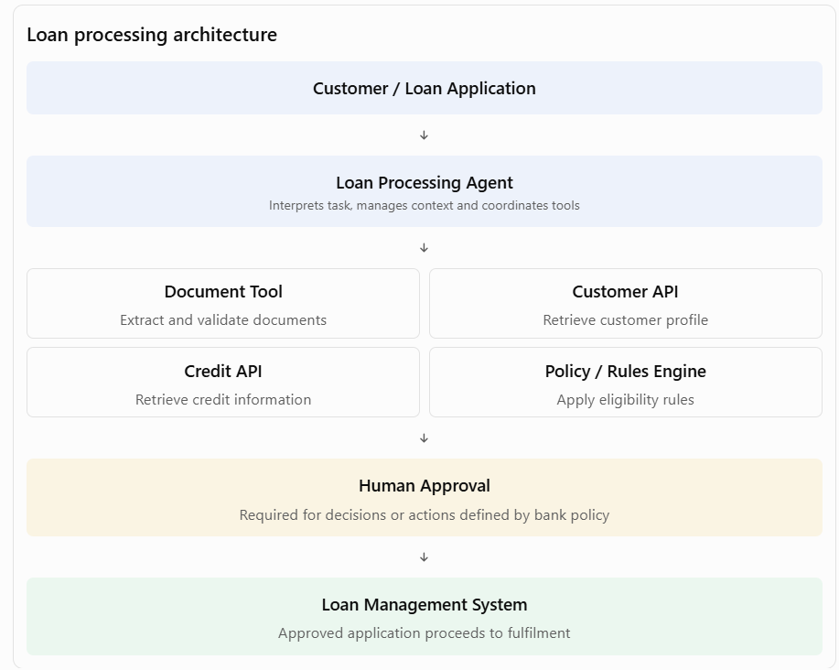
The agent coordinates the process, but authoritative eligibility rules, credit decisions, and financial transactions remain subject to approved business controls. This separation is critical in regulated environments.
C. Define enterprise AI orchestration architecture
What this means
AI orchestration coordinates models, agents, retrieval systems, enterprise APIs, business workflows, and human approvals to complete an end-to-end business process.
The Principal Architect must decide which orchestration approach is appropriate for each use case.
Important architectural patterns include:
- Sequential orchestration: Tasks execute in a predefined sequence.
- Parallel orchestration: Independent tasks execute concurrently.
- Conditional orchestration: Workflow branches based on rules or model outputs.
- Supervisor-worker pattern: A supervisor agent delegates work to specialised agents.
- Human-in-the-loop orchestration: A human decision or approval is required before proceeding.
- Event-driven orchestration: Events trigger agent or workflow execution.
- Durable orchestration: Long-running workflows persist state and recover from failures.
Industry examples
Industry | Orchestration pattern | Example
Banking | Sequential + human approval | Loan application assessment
Insurance | Parallel + conditional | Concurrent policy, document, and fraud checks
Healthcare | Human-in-the-loop | Clinical documentation and review
Telecommunications | Event-driven | Network incident detection and remediation
Government | Durable workflow | Multi-stage citizen application processing
Architectural decision: Agent versus workflow engine
A common interview question is: Should an agent control the entire process, or should a workflow engine orchestrate the process?
My approach would be:
- Use a workflow engine for deterministic steps, approvals, SLAs, retries, and process state.
- Use an AI agent for interpretation, reasoning, unstructured information processing, and selecting among permitted tools.
- Use enterprise APIs for authoritative business operations.
- Use human approval for decisions requiring accountability or judgement.
This is particularly relevant to your low-code and BPM architecture background: an Appian-style process layer can manage predictable business orchestration, while agents provide bounded intelligence within selected process steps.
D. Establish AI evaluation frameworks
What this means
AI evaluation is the systematic measurement of whether an AI application produces accurate, relevant, safe, consistent, and useful outcomes.
A Principal Architect should ensure that evaluation is designed into the AI lifecycle rather than introduced only after deployment.
Key evaluation dimensions:
Evaluation area | What to measure | Example
Accuracy | Correctness of responses | Correct loan document extraction
Relevance | Whether retrieved information answers the query | Relevant policy clauses retrieved
Faithfulness | Whether output is grounded in source evidence | No unsupported claims in RAG responses
Completeness | Whether important information is included | All mandatory claim fields extracted
Safety | Whether harmful or prohibited output is generated | No unauthorised financial advice
Bias and fairness | Whether outcomes differ unfairly across groups | Loan approval fairness
Tool-use accuracy | Whether the correct tool is selected and invoked | Correct customer record retrieved
Workflow success | Whether the task reaches its intended outcome | Claim processed without avoidable rework
Performance | Latency and throughput | Response within agreed SLA
Cost | Cost per task or successful outcome | Cost per resolved customer query
Industry examples
- Banking: Evaluate the accuracy of loan-document extraction, retrieval quality, decision-support recommendations, and fairness.
- Insurance: Evaluate claims classification, damage assessment, policy interpretation, and settlement recommendations.
- Healthcare: Evaluate clinical summarisation, source attribution, completeness, and safety.
- Telecommunications: Evaluate troubleshooting recommendations, tool selection, and first-contact resolution.
- Government: Evaluate eligibility information, multilingual response quality, accessibility, and consistency with policy.
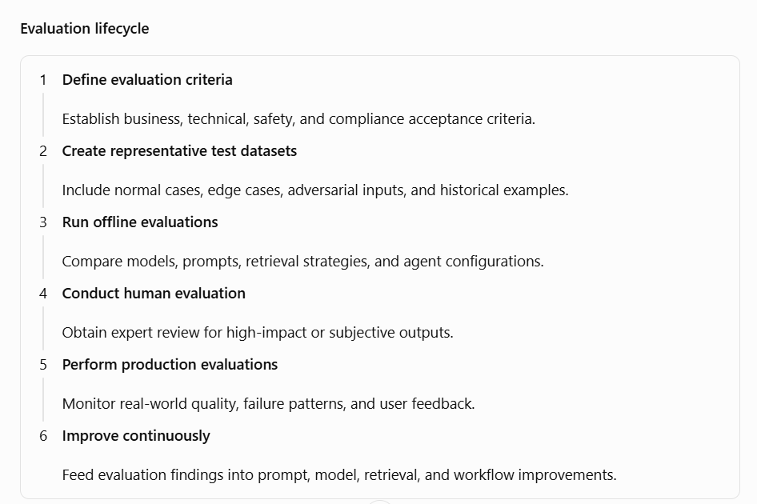A strong architecture should support evaluation datasets, test harnesses, versioned evaluation results, release gates, and regression testing.
E. Establish AI observability architecture
What this means
Traditional application monitoring tells us whether an application is running. AI observability must also explain what happened inside an AI request: which model was called, what context was retrieved, which tools were invoked, how long each step took, what it cost, and whether the result met quality expectations.
Key observability capabilities:
1. Request tracing
- Trace a user request across application, orchestration, retrieval, model, and tool layers.
- Maintain correlation IDs across distributed services.
2. LLM monitoring
- Track model latency, token consumption, throughput, error rates, and cost.
- Monitor model availability and fallback behaviour.
3. RAG observability
- Track retrieved documents, retrieval scores, ranking, and citation quality.
- Identify missing, stale, or unauthorised information.
4. Agent observability
- Record agent decisions, tool calls, hand-offs, retries, and execution paths.
- Detect loops, unnecessary tool calls, and failed tasks.
5. Quality and safety monitoring
- Monitor hallucination indicators, policy violations, unsafe outputs, and user feedback.
- Track quality trends across model and prompt versions.
6. Operational monitoring
- Monitor service availability, throughput, queue depth, workflow completion, and SLA breaches.
Industry examples
Industry | What to observe | Business value
Banking | Loan-agent tool calls, decision evidence, latency, audit trail | Operational control and regulatory traceability
Insurance | Claim extraction confidence, document retrieval, exception rates | Reduced claim-processing errors
Healthcare | Source references, response quality, clinical review and overrides | Safer clinical assistance
Telecommunications | Agent execution, network API calls, remediation success | Faster incident resolution
Government | Application decisions, source policy, access logs, escalation | Accountability and transparency
Example: AI observability dashboard
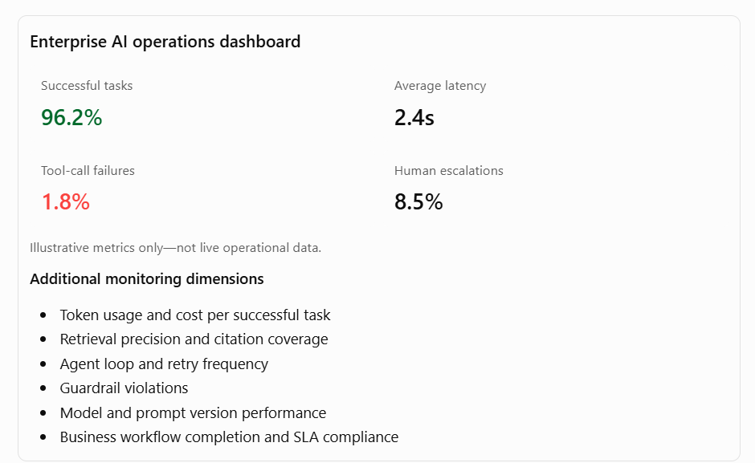The architecture should also address privacy: prompts, retrieved content, and model responses may contain sensitive information. Logging must therefore be designed with data minimisation, masking, access control, retention, and audit requirements.
F. Establish enterprise AI governance
What this means
AI governance ensures that AI solutions are designed, developed, deployed, and operated within defined organisational policies, regulatory requirements, risk tolerances, and accountability structures.
Governance must be embedded in architecture and delivery processes—not treated as a separate approval exercise at the end.
Key governance dimensions:
1. AI use-case governance
- Maintain an inventory of AI use cases.
- Classify use cases by business impact and risk.
- Define approval requirements for high-risk applications.
2. Model governance
- Maintain approved model inventories.
- Track model versions, provenance, limitations, and intended use.
- Define model validation and change-management requirements.
3. Data governance
- Enforce data classification and access controls.
- Protect personal, confidential, and regulated information.
- Apply retention and residency requirements.
4. Agent governance
- Maintain an inventory of agents and their permitted tools.
- Apply least-privilege access.
- Define approval boundaries for consequential actions.
- Maintain execution and decision audit trails.
5. Responsible AI
- Assess fairness, transparency, explainability, safety, and accountability.
- Define human oversight for high-impact decisions.
- Establish complaint, escalation, and remediation mechanisms.
6. Lifecycle governance
- Apply controls during design, development, testing, deployment, and operations.
- Require evaluation evidence before production release.
- Reassess risk when models, prompts, tools, data, or workflows change.
Industry examples
Industry | Governance requirement | Example control
Banking | Model risk, privacy, fair lending, auditability | Human review and evidence for credit decisions
Insurance | Fairness, claims accountability, policy compliance | Auditable settlement recommendations
Healthcare | Patient safety, privacy, clinical oversight | Clinician approval of consequential recommendations
Telecommunications | Customer privacy, operational safety | Restricted network remediation permissions
Government | Transparency, accountability, public-sector policy | Documented eligibility rules and appeal processes
2. How the six capabilities fit together
At Principal Architect level, the interviewer will expect you to explain how these capabilities form one coherent enterprise architecture.
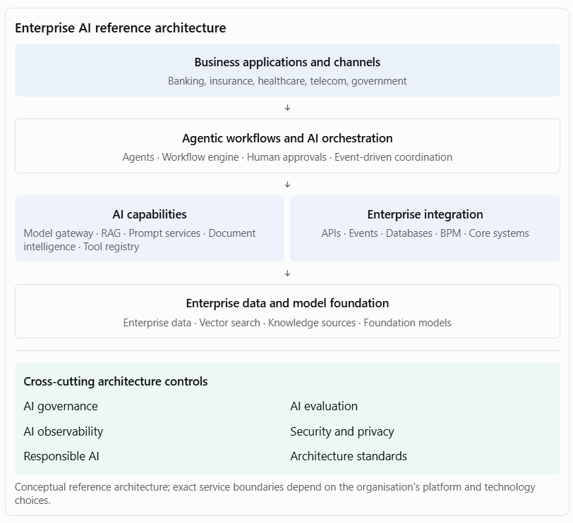
The important architectural principle is that evaluation, observability, and governance are not isolated components at the bottom of the stack. They apply across the entire lifecycle and every layer.
For example, when a loan-processing agent invokes a credit API:
- Orchestration controls the sequence of activities.
- AI capabilities provide extraction, retrieval, and reasoning.
- Enterprise integration invokes the credit API.
- Evaluation measures extraction and recommendation quality.
- Observability records the execution path, latency, failures, and cost.
- Governance enforces permissions, approval requirements, and auditability.
3. Architectural decisions you should be ready to defend
A Principal Architect is expected to make trade-offs, not simply list technologies.
Decision | Architectural position
Agent vs. deterministic workflow | Use agents for bounded reasoning; workflow engines for predictable process control
Single agent vs. multi-agent | Start with one agent; introduce multiple agents only where specialisation or isolation justifies the overhead
Centralised vs. distributed AI capabilities | Centralise shared platform services and standards; allow domain teams controlled autonomy
RAG vs. fine-tuning | Use RAG for frequently changing or access-controlled knowledge; fine-tune for suitable behavioural or task adaptation
Model selection | Select against quality, latency, security, cost, availability, and deployment constraints
Synchronous vs. asynchronous execution | Use synchronous interaction for short tasks; durable asynchronous execution for long-running workflows
Full autonomy vs. human oversight | Set autonomy according to risk, reversibility, impact, and accountability
Centralised vs. embedded evaluation | Provide shared evaluation infrastructure, with domain-specific acceptance criteria owned by business teams
Detailed logging vs. data minimisation | Capture sufficient diagnostic evidence while masking sensitive information and enforcing retention controls
A useful architecture principle to articulate: AI should augment enterprise processes without weakening established controls around identity, transaction integrity, data access, business rules, and accountability.
4. Practical interview case study: Enterprise AI platform for a bank
Assume a bank wants to introduce AI across five areas:
- Customer service assistant
- Loan application processing
- Fraud investigation support
- Compliance knowledge assistant
- Employee productivity assistant
As Principal Architect, I would propose the following approach.
Step 1 — Establish shared capabilities
Create an enterprise AI platform with:
- Approved model gateway and model catalogue.
- Prompt management and version control.
- Enterprise RAG and document intelligence.
- Agent tool registry and API integration.
- Shared identity, secrets, and access management.
Step 2 — Define agentic workflow patterns
Start with three bounded use cases:
Use case | Agent responsibility | Controlled business execution
Customer service | Understand queries and retrieve relevant information | CRM updates through authorised APIs
Loan processing | Extract and validate information; identify missing documents | Credit checks and approval through governed services
Fraud investigation | Correlate evidence and summarise suspicious activity | Case creation and escalation through existing systems
Step 3 — Implement evaluation
Define acceptance thresholds for each use case. For example:
- Customer assistant: answer relevance, groundedness, policy compliance, escalation accuracy.
- Loan processing: extraction accuracy, completeness, fairness, exception detection.
- Fraud support: evidence coverage, false-positive review, investigator usefulness.
Use a combination of automated test sets, domain-expert review, adversarial testing, and production feedback.
Step 4 — Implement observability
Provide a central AI operations dashboard showing:
- Model and agent execution traces.
- Token consumption and cost per task.
- Tool invocation success and failure.
- Retrieval quality and citation coverage.
- Workflow completion and exception rates.
- Human overrides and escalations.
- Security and policy violations.
Step 5 — Implement governance
Establish:
- AI use-case and agent inventory.
- Risk classification and approval process.
- Model and prompt change control.
- Agent permissions and tool access policies.
- Human approval for consequential actions.
- Audit trails and periodic risk reviews.
Step 6 — Scale through architecture governance
Introduce architecture review checkpoints, reusable reference patterns, platform onboarding standards, and a clear ownership model between central AI platform teams and business-domain teams.
5. Preparation guide and recommended resources
I recommend preparing these topics in the following order.
A. Agentic architecture and orchestration
Topic to study | What you should understand | Resource
Agent architecture | Agent runtime, tools, memory, context, identity, lifecycle | Microsoft Foundry Agent Service
Enterprise agent adoption | Agent charters, boundaries, orchestration strategy, enterprise governance | Microsoft: Build agents across your organisation
Stateful agent orchestration | Graph-based workflows, state management, retries, persistence, human approval | LangGraph documentation
Enterprise agent architecture | Scaling, evaluation, agent operations and governance | Microsoft AI Landing Zones – Agent Operations
B. AI evaluation and quality engineering
Topic to study | What you should understand | Resource
RAG evaluation | Retrieval relevance, groundedness, answer relevance, citation quality | Microsoft Foundry evaluation resources
Agent evaluation | Task completion, tool selection accuracy, agent behaviour | Evaluating AI agents at scale
Continuous evaluation | Evaluation datasets, regression testing, production evaluation | Microsoft Foundry Control Plane
Evaluation strategy | Component-level and end-to-end testing | Enterprise agents: evaluation and operations series
C. AI observability and operations
Topic to study | What you should understand | Resource
Distributed tracing | Trace IDs, spans, parent-child relationships, cross-service correlation | OpenTelemetry trace conventions
AI observability | Model calls, token usage, tool calls, latency, failures and cost | OpenTelemetry GenAI spans
AI metrics | Token usage, model duration and inference metrics | GenAI metrics conventions
Production monitoring | Logs, alerts, cost anomalies, output drift and operational impact | AWS agentic AI observability guidance
D. AI governance and responsible AI
Topic to study | What you should understand | Resource
AI risk management | Govern, map, measure and manage AI risks | NIST AI Risk Management Framework
Generative AI risks | Hallucination, privacy, information integrity, security and governance | NIST Generative AI Profile
Agent governance | Agent inventory, access controls, boundaries and monitoring | Microsoft enterprise agent governance guidance
Enterprise AI control plane | Centralised observability, evaluation, guardrails and security | Microsoft Foundry Control Plane
6. Interview questions you should prepare
These questions are particularly relevant to a Principal AI Architect interview.
Enterprise AI capabilities
- How would you design a shared enterprise AI platform for multiple business units?
- Which AI capabilities should be centralised, and which should remain within individual product teams?
- How would you prevent duplication of AI services across the organisation?
- How would you design a model gateway supporting multiple foundation models?
Agentic workflows and orchestration
5. How do you decide between an AI agent and a traditional workflow engine?
6. When would you use a single-agent architecture versus a multi-agent architecture?
7. How would you manage agent permissions when agents interact with enterprise systems?
8. How would you design a long-running agentic workflow with retries, failures, and human approvals?
Evaluation
9. How do you evaluate the quality of an agent beyond measuring the quality of its final response?
10. How would you implement an evaluation framework for an enterprise RAG solution?
11. How would you prevent a new model or prompt version from degrading production quality?
Observability
12. What should be captured in an AI execution trace?
13. How would you troubleshoot an agent that repeatedly invokes the wrong tools?
14. How would you monitor hallucination, latency, token consumption, and cost in production?
Governance
15. How would you establish enterprise-wide AI governance?
16. How would you govern autonomous agents that can initiate business transactions?
17. How would you ensure traceability and accountability for AI-generated decisions?
7. Metrics you should discuss in the interview
A Principal Architect should connect architecture performance to business and operational outcomes.
Dimension | Example metrics
Platform adoption | Number of applications using shared AI capabilities; reuse percentage
Engineering productivity | Time to onboard a new AI application; development lead time
Agent performance | Task completion rate; tool-call accuracy; successful hand-off rate
Workflow efficiency | Process cycle-time reduction; straight-through processing rate
AI quality | Groundedness; retrieval precision; extraction accuracy; evaluation pass rate
Observability | Mean time to detect; mean time to resolve; trace coverage
Reliability | Availability; failure rate; retry rate; recovery time
Cost efficiency | Cost per successful task; tokens per transaction; cost per application
Governance | Percentage of registered AI systems; policy compliance; unresolved risk exceptions
Human oversight | Escalation rate; human override rate; unauthorised action prevention
Avoid treating metrics such as a 95% accuracy rate as universal targets. Establish baselines and acceptance thresholds based on the use case, risk classification, and business impact.
8. A suggested 10-day preparation plan
Days | Preparation focus | Practical exercise
1–2 | Enterprise AI capabilities | Design a shared enterprise AI platform
3–4 | Agentic workflows | Design a loan-processing agent with controlled tools
5 | AI orchestration | Compare workflow, sequential, parallel, and supervisor-worker patterns
6–7 | AI evaluation | Create an evaluation scorecard for a RAG application and an agent
8 | AI observability | Design an end-to-end trace and AI operations dashboard
9 | AI governance | Define an AI governance framework and agent control policies
10 | Architecture leadership | Present the complete enterprise AI reference architecture
9. Your interview-ready closing statement
My approach to AI architecture leadership is to build an enterprise AI ecosystem that is reusable, scalable, observable, and governed by design.
I would establish common AI capabilities such as model access, retrieval, prompt management, document intelligence, and agent tooling. I would define standard patterns for agentic workflows and orchestration, ensuring that AI reasoning is combined with deterministic business processes, enterprise APIs, and human approval wherever necessary.
I would also make evaluation and observability first-class architectural capabilities. Every AI solution should have measurable quality criteria, traceable execution, operational monitoring, cost visibility, and continuous improvement mechanisms.
Finally, I would embed AI governance across the lifecycle, covering data protection, model risk, agent permissions, responsible AI, auditability, and human accountability.
The objective is not simply to introduce more AI solutions. It is to establish an enterprise architecture that enables business units to adopt AI faster while maintaining consistency, operational reliability, security, and measurable business value.
10. How to position your existing architecture experience
Your application architecture and Appian/BPM background gives you a useful way to explain this responsibility.
The strongest connection is combining intelligent decision-making with controlled enterprise process execution.
You can explain the relationship this way:
- Your application architecture experience is relevant to defining application boundaries, integration contracts, reusable services, and non-functional requirements.
- Your BPM experience is relevant to deterministic orchestration, process state, human approvals, exception handling, and audit trails.
- Your enterprise architecture experience is relevant to reference architectures, governance, reusable patterns, and cross-team adoption.
- Your AI architecture development should demonstrate how you extend these foundations with model integration, RAG, agent orchestration, AI evaluation, and observability.
The distinction to emphasise is that agentic AI does not replace enterprise architecture or BPM. It introduces an intelligent reasoning capability into an enterprise architecture that still needs to preserve process control, security, accountability, and operational discipline.
My recommendation: Be particularly strong on the distinction between an AI agent, an orchestration framework, and a BPM/workflow engine. It is one of the most important architectural discussions behind this job expectation.
Expectation: Ensure AI solutions align with enterprise requirements for security, privacy, compliance, resiliency, observability, and maintainability

This expectation assesses whether you can design AI solutions that meet the same enterprise-grade architectural standards as mission-critical business applications. It is not sufficient to demonstrate that an AI solution works or produces accurate responses. A Principal AI Architect must ensure that the solution protects enterprise data, enforces identity and access controls, meets regulatory obligations, remains available under failure conditions, provides operational transparency, and can be maintained and evolved over time.
My approach would be to establish a set of enterprise non-functional requirements (NFRs), architecture principles, reference patterns, and technical controls that apply across the AI lifecycle—from data ingestion and model selection through application development, deployment, and production operations. I would work with security, privacy, legal, compliance, infrastructure, data, and engineering teams to translate enterprise policies into enforceable architecture controls. I would also ensure that these controls are measurable through security testing, compliance evidence, resilience testing, observability dashboards, and operational service-level objectives.
1. Expand the key responsibilities
A. Ensure AI security
What this means
AI security extends beyond traditional application security. An AI solution introduces additional attack surfaces through prompts, retrieved documents, model interactions, agent tools, training or fine-tuning data, and generated outputs.
As Principal Architect, you must ensure that security is designed into every layer of the AI solution.
Key architectural responsibilities
1. Identity and access management
- Integrate enterprise identity providers and single sign-on.
- Apply role-based access control (RBAC) and attribute-based access control (ABAC).
- Use least-privilege permissions for applications, agents, and tools.
- Enforce service-to-service authentication using managed identities or equivalent mechanisms.
- Ensure that an agent cannot inherit unrestricted access simply because its user has broad permissions.
2. Data and information security
- Encrypt data at rest and in transit.
- Protect prompts, embeddings, retrieved documents, model inputs, and outputs.
- Apply data classification and handling policies.
- Mask or redact sensitive information where appropriate.
- Protect secrets, API keys, credentials, and model endpoints.
3. LLM-specific security
- Protect against direct and indirect prompt injection.
- Prevent sensitive information disclosure.
- Validate model outputs before using them in downstream systems.
- Protect against insecure tool invocation and excessive agent autonomy.
- Defend against malicious documents and poisoned knowledge sources.
4. API and integration security
- Secure enterprise APIs using OAuth 2.0, managed identities, or equivalent mechanisms.
- Apply API gateways, rate limiting, schema validation, and request controls.
- Validate tool arguments before execution.
- Separate read operations from high-impact write operations.
- Apply approval controls to sensitive transactions.
5. AI supply-chain security
- Assess foundation models, third-party libraries, plugins, and orchestration frameworks.
- Validate model provenance and deployment configurations.
- Scan containers and dependencies.
- Control model and package versions.
- Maintain approved technology inventories.
Industry examples
Industry | Security concern | Architectural control
Banking | Customer data exposed through a RAG assistant | Document-level authorisation, identity propagation, encryption
Insurance | Agent accesses claims beyond its assigned portfolio | Claims-level permissions and scoped agent tools
Healthcare | Patient records disclosed to unauthorised users | Patient-context access checks, masking, audit logging
Telecommunications | AI agent invokes unauthorised network operations | Tool allowlists, least privilege, approval for sensitive changes
Government | Confidential citizen information exposed through an AI assistant | Data classification, restricted retrieval, identity-based access
Example: Securing an enterprise RAG application
Suppose a bank has an AI assistant that retrieves information from customer documents, loan policies, and internal operational manuals.
A critical security requirement is that the assistant must not retrieve documents merely because they exist in the vector database.
The architecture must enforce:
- User authentication before retrieval.
- User and group permissions propagated into the retrieval layer.
- Document-level access filtering before content is provided to the LLM.
- Metadata-based filtering for business unit, customer, and document classification.
- Output checks to reduce the risk of sensitive information disclosure.
- Audit records of the user, retrieved sources, model invocation, and response.
Principal Architect perspective: I would treat the LLM as an untrusted reasoning component operating within a controlled enterprise security boundary. Authorisation decisions and business permissions must be enforced by trusted application and data services, not delegated to the model.
B. Ensure AI privacy
What this means
Privacy focuses on how personal and sensitive information is collected, processed, stored, retrieved, shared, and deleted throughout the AI lifecycle.
An important architectural concern is that sensitive data can appear in places that traditional applications may not normally expose, such as prompts, embeddings, conversation history, model logs, evaluation datasets, and third-party model requests.
Key architectural responsibilities
1. Data minimisation
- Send only the information necessary for the AI task.
- Avoid including entire customer records when selected attributes are sufficient.
- Remove unnecessary personal identifiers before model processing.
2. Consent and lawful processing
- Identify the purpose for which personal data is processed.
- Ensure appropriate legal basis and consent where required.
- Respect purpose limitations and data-subject rights.
3. Sensitive data protection
- Detect and classify personally identifiable information (PII).
- Mask, redact, or tokenise sensitive fields.
- Protect financial, health, identity, and confidential business information.
4. Data residency and third-party processing
- Understand where data is processed and stored.
- Assess third-party model-provider data handling.
- Verify contractual commitments concerning retention, training use, and subprocessors.
- Apply regional processing requirements where applicable.
5. Retention and deletion
- Define retention periods for prompts, responses, conversation histories, and logs.
- Support deletion and correction workflows where applicable.
- Understand how deletion requirements apply to derived data such as embeddings and cached content.
6. Privacy impact assessments
- Conduct privacy impact assessments for sensitive use cases.
- Identify risks before production deployment.
- Document mitigations and residual risks.
Industry examples
Industry | Privacy scenario | Architectural approach
Banking | Customer asks questions about financial accounts | Restrict model context to authorised account data and minimise personal information
Insurance | Claims assistant processes medical reports | Redact unnecessary medical identifiers and restrict access
Healthcare | Clinical assistant summarises patient records | Apply patient-context permissions, purpose restrictions, and controlled retention
Telecommunications | Customer-support agent accesses call and usage data | Limit access to required customer attributes and apply retention controls
Government | Citizen assistant processes identity and benefit applications | Apply purpose limitation, data minimisation, and regional data-handling controls
Example: Privacy-aware AI processing
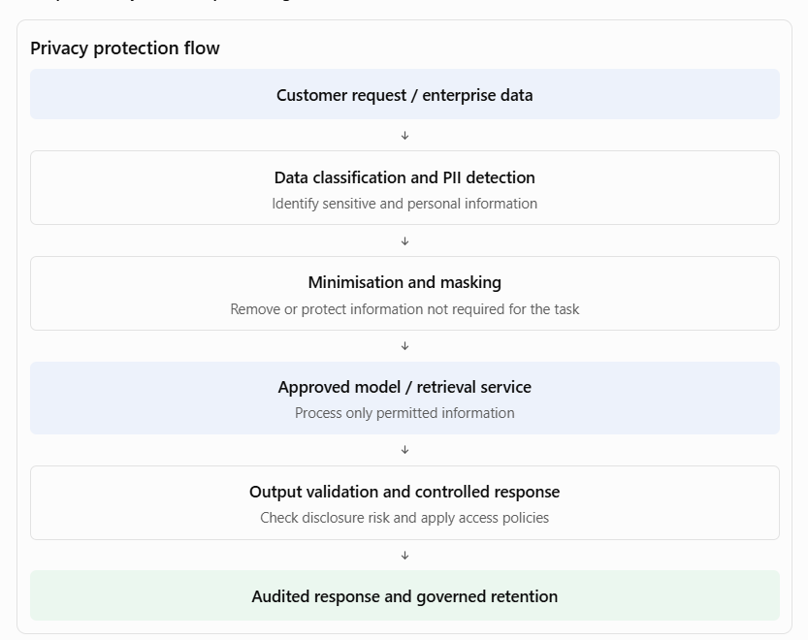Principal Architect perspective: I would ensure privacy controls are implemented in the data pipeline, retrieval layer, model gateway, application, and observability platform. Privacy should not depend on users remembering to avoid entering sensitive information into prompts.
C. Ensure regulatory and enterprise compliance
What this means
Compliance means ensuring that AI solutions operate within applicable laws, regulations, contractual obligations, industry standards, and internal enterprise policies.
The important distinction is that compliance cannot be achieved simply by adding a disclaimer to an AI-generated response. It must be supported by architecture controls, documented processes, evidence, accountability, and ongoing monitoring.
A Principal Architect should translate regulatory and enterprise obligations into technical requirements and ensure that those requirements are implemented consistently.
Key architectural responsibilities
1. Regulatory and policy mapping
- Identify the regulations and standards applicable to the business, geography, data, and use case.
- Map regulatory obligations to architecture controls.
- Maintain a traceability matrix connecting requirements, controls, evidence, and owners.
- Involve legal, compliance, risk, and security teams in interpreting obligations.
2. AI risk classification
- Classify AI use cases according to their potential impact.
- Apply stronger controls to high-impact or regulated use cases.
- Define approval requirements before production deployment.
- Reassess risk when the model, data, purpose, or degree of autonomy changes.
3. Auditability and explainability
- Record model and prompt versions.
- Maintain traceability of retrieved evidence and tool calls.
- Capture human approvals, overrides, and exception decisions.
- Provide sufficient evidence to reconstruct how an outcome was produced.
- Distinguish between an explanation of the system's process and proof that a model's internal reasoning is correct.
4. Records and evidence management
- Maintain AI system inventories and risk assessments.
- Preserve test results, approvals, model documentation, and change records.
- Define retention and deletion policies.
- Ensure audit records are protected from unauthorised modification.
5. Third-party and vendor compliance
- Assess model providers, cloud services, data processors, and external AI tools.
- Review data processing agreements and contractual restrictions.
- Understand model-provider retention, training, residency, and subprocessor arrangements.
- Establish ongoing supplier risk reviews.
6. Compliance lifecycle management
- Include compliance checkpoints in architecture reviews and release pipelines.
- Revalidate compliance after material model or workflow changes.
- Monitor control effectiveness in production.
- Manage policy exceptions through formal risk acceptance and remediation.
Industry examples
Industry | Compliance requirement | Architectural control
Banking | Financial regulations, model risk, auditability, fair lending | Model inventory, approval evidence, decision traceability
Insurance | Claims and underwriting obligations, customer fairness | Documented decision controls, human review, audit records
Healthcare | Patient privacy, clinical safety, health-data obligations | Clinical oversight, access controls, consent and retention policies
Telecommunications | Customer privacy, data protection, sector obligations | Purpose-based data access, consent and audit trails
Government | Public-sector accountability, transparency, records obligations | Traceable eligibility processes, documented rules and appeal mechanisms
Example: Compliance architecture for AI-supported loan underwriting
Assume a bank uses AI to extract information from financial documents and generate a recommendation for a loan officer.
The architecture should provide:
- A registered AI use case with an identified business owner.
- A documented risk classification and approved purpose.
- Approved models and version-controlled prompts.
- Controlled access to customer and credit information.
- Traceable source documents and extracted fields.
- A separate, governed credit-policy and decision service.
- Human approval where required by the bank's policy.
- An audit record of evidence, recommendation, approval, and final outcome.
- Periodic monitoring for accuracy, fairness, and policy compliance.
The key principle is that the model's recommendation must not silently become an unaudited credit decision.
Principal Architect perspective: I would establish a compliance-by-design approach in which every regulatory obligation is translated into a control, assigned an owner, tested, and supported by evidence. The exact requirements would be determined by the jurisdiction and the regulated activity rather than assuming one universal compliance checklist.
D. Design for resiliency and high availability
What this means
AI applications depend on multiple components: model providers, retrieval services, vector databases, orchestration engines, APIs, data stores, and enterprise systems. Failure of any one component can affect the entire AI workflow.
A Principal Architect must design AI systems to tolerate component failures, recover from interruptions, manage variable demand, and preserve business continuity.
Resiliency is particularly important for agentic systems because one user request may trigger several dependent operations.
Key architectural responsibilities
1. Availability architecture
- Define availability targets based on business criticality.
- Eliminate single points of failure in critical components.
- Use appropriate redundancy and multi-zone deployment.
- Define regional recovery strategies where justified.
- Design graceful degradation when optional AI capabilities are unavailable.
2. Model-provider resilience
- Support approved model fallback strategies.
- Use circuit breakers and bounded retries.
- Handle provider throttling and rate limits.
- Apply request timeouts and concurrency controls.
- Avoid uncontrolled fallback to a model with different privacy or security characteristics.
3. Workflow and agent resilience
- Persist workflow and agent state.
- Support resumable execution for long-running processes.
- Use idempotency keys to prevent duplicate business actions.
- Apply retry policies with backoff and dead-letter handling.
- Escalate unrecoverable failures to human operators.
4. Data resilience
- Back up critical data and configuration.
- Protect vector indexes and source-document metadata.
- Version prompts, evaluation datasets, and model configurations.
- Test recovery of the complete AI application, not just its database.
5. Capacity and performance resilience
- Test peak concurrent requests and token throughput.
- Manage queues and backpressure.
- Set token, context, and request limits.
- Scale retrieval and inference components appropriately.
- Protect the service against uncontrolled consumption.
6. Business continuity and disaster recovery
- Define Recovery Time Objectives (RTO) and Recovery Point Objectives (RPO).
- Identify critical business workflows and their acceptable downtime.
- Maintain documented recovery procedures.
- Test failover and restoration scenarios.
- Define manual or non-AI fallback processes for critical business operations.
Industry examples
Industry | Resilience scenario | Architectural approach
Banking | Loan-processing model provider becomes unavailable | Approved fallback, durable workflow state, manual processing route
Insurance | Claims surge after a natural disaster | Queue-based processing, autoscaling, prioritisation and retry handling
Healthcare | Clinical assistant retrieval service fails | Graceful degradation, approved alternative workflow, clinical fallback
Telecommunications | AI network operations platform receives an event spike | Event buffering, backpressure, workload prioritisation
Government | Citizen-service AI experiences a regional outage | Regional recovery, cached approved information where appropriate, alternative service channel
Example: Resilient AI loan-processing workflow
Consider a loan-processing agent that performs document extraction, credit checks, policy validation, and recommendation generation.
Potential failure scenarios and controls:
Failure scenario | Required control
LLM provider unavailable | Approved fallback model or manual processing
Vector database unavailable | Retry, recover service, or use approved alternative knowledge access
Credit API times out | Bounded retries and workflow suspension
Agent crashes midway | Persisted workflow state and resumable execution
Duplicate payment or transaction request | Idempotency and transaction validation
Model returns malformed output | Schema validation and controlled exception handling
Approval service unavailable | Persist pending approval; do not bypass the control
Principal Architect perspective: I would design for failure rather than assume that every AI dependency will remain available. I would define recovery objectives, identify critical dependencies, introduce fallback patterns, and regularly test failure scenarios through resilience and disaster-recovery exercises.
E. Establish end-to-end AI observability
What this means
Observability provides the ability to understand the internal behaviour and operational health of an AI solution from its outputs and execution telemetry.
Traditional application monitoring is not sufficient. An AI application may be technically available but still produce poor answers, retrieve irrelevant documents, repeatedly invoke tools, or generate excessive costs.
The architecture must provide visibility into both conventional system health and AI-specific behaviour.
Key architectural responsibilities
1. Distributed tracing
- Trace a request across applications, orchestration, model calls, retrieval, and enterprise APIs.
- Use correlation IDs and trace context.
- Identify slow or failing components.
- Reconstruct multi-step agent execution paths.
2. Model and inference monitoring
- Track model availability and error rates.
- Monitor response latency and throughput.
- Track token consumption and cost.
- Monitor model version and deployment changes.
3. RAG observability
- Track retrieved document identifiers and metadata.
- Measure retrieval quality and ranking behaviour.
- Monitor citation coverage and source freshness.
- Detect access-control filtering failures.
4. Agent observability
- Record tool invocation, input validation, and execution outcome.
- Monitor retries, loops, hand-offs, and escalation.
- Identify excessive or unnecessary tool usage.
- Track task completion and human intervention.
5. Quality and safety monitoring
- Monitor groundedness and answer relevance.
- Track output-policy violations.
- Monitor user feedback and correction rates.
- Detect quality degradation after model or prompt changes.
6. Operational monitoring
- Monitor availability, queue depth, error rate, and service latency.
- Define service-level indicators and objectives.
- Create alerts for service degradation and abnormal consumption.
- Integrate with enterprise incident-management processes.
Industry examples
Industry | Observability requirement | Example operational measure
Banking | Trace loan-agent execution and evidence | Successful workflow rate, exception rate, audit completeness
Insurance | Monitor claims extraction and assessment | Extraction accuracy, rework rate, processing time
Healthcare | Monitor clinical assistant quality and escalation | Source coverage, clinician override rate
Telecommunications | Monitor network-agent tool execution | Remediation success, failed tool calls, incident resolution time
Government | Trace citizen-service responses and application processing | Response quality, escalation rate, service availability
Example: AI observability architecture
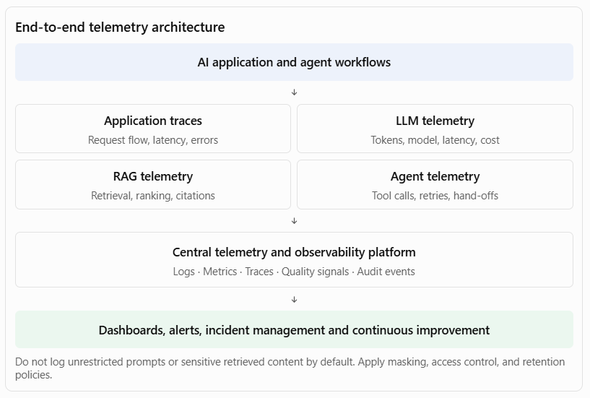A particularly important point for interviews: observability and auditability overlap, but they are not identical. Observability supports operational diagnosis; auditability provides controlled evidence of activities, decisions, and approvals.
Principal Architect perspective: I would define common telemetry standards and integrate AI observability into enterprise monitoring and incident-management platforms. Every production AI solution should provide sufficient visibility to diagnose failures, assess quality, understand cost, and demonstrate operational accountability.
F. Ensure maintainability and evolvability
What this means
AI solutions must be designed so that they can be modified, tested, upgraded, scaled, and operated over time without introducing unacceptable risk.
AI technology evolves rapidly. Models change, APIs are deprecated, prompts require refinement, retrieval strategies improve, and new security vulnerabilities emerge. Maintainability therefore requires architectural separation, version control, automation, documentation, and disciplined change management.
Key architectural responsibilities
1. Modular architecture
- Separate business logic, orchestration, model access, retrieval, and integration layers.
- Avoid hard-coding provider-specific model behaviour into business applications.
- Use well-defined interfaces and contracts.
- Keep deterministic business rules outside prompts wherever possible.
2. Model and provider independence
- Use a model gateway or abstraction layer where justified.
- Avoid unnecessary dependency on proprietary APIs.
- Maintain model configuration and capability metadata.
- Support controlled provider and model migration.
- Test behavioural differences before switching models.
3. Version management
- Version prompts, models, embeddings, indexes, tools, and orchestration workflows.
- Maintain deployment and rollback capability.
- Track changes to source data and retrieval configurations.
- Record evaluation results against each release.
4. Automated testing and CI/CD
- Introduce automated unit, integration, security, and regression testing.
- Test retrieval quality and model outputs.
- Validate agent tool contracts and workflow behaviour.
- Apply release gates based on evaluation and security results.
- Use controlled rollout, canary deployments, and rollback.
5. Documentation and architecture governance
- Maintain architecture decision records (ADRs).
- Document APIs, model dependencies, prompts, and data flows.
- Maintain operational runbooks.
- Define ownership for every production AI component.
- Review architecture when significant dependencies change.
6. Technical debt and lifecycle management
- Monitor deprecated models, libraries, and APIs.
- Review prompt complexity and orchestration sprawl.
- Remove obsolete components and unused AI services.
- Reassess cost and performance as usage grows.
- Plan model migration and platform upgrades.
Industry examples
Industry | Maintainability challenge | Architectural approach
Banking | Model provider changes its API or model version | Model abstraction, regression evaluation, controlled migration
Insurance | Claims extraction rules change frequently | Modular extraction services, versioned schemas and test datasets
Healthcare | Clinical knowledge sources and guidelines evolve | Versioned knowledge ingestion and source provenance
Telecommunications | New network APIs and orchestration patterns are introduced | API contracts, reusable tool adapters, automated integration tests
Government | Policy and eligibility rules change | Separate policy services, version-controlled rules and auditable releases
Example: Maintainable enterprise AI architecture
Consider a customer-service AI application.
A poorly designed solution might combine prompt instructions, business rules, API credentials, model-specific code, and customer-service workflow logic in one application.
A maintainable design separates these concerns:
- Application layer: Customer experience and channel integration.
- Business/domain layer: Customer-service policies and business capabilities.
- Orchestration layer: Coordinates agents, workflow steps, and approvals.
- AI service layer: Model gateway, prompt management, retrieval, and evaluation.
- Integration layer: CRM, billing, order management, and enterprise APIs.
- Infrastructure layer: Hosting, networking, secrets, monitoring, and scaling.
This separation allows the organisation to change the model provider without rewriting business logic, update the customer-service workflow without modifying the model gateway, or replace the retrieval technology without changing the user interface.
Principal Architect perspective: I would design AI applications around modular capabilities and stable contracts, with version-controlled artefacts, automated quality gates, and clear component ownership. The goal is to reduce vendor lock-in, limit change impact, and make AI systems safe to evolve.
2. How the six enterprise requirements fit together
These requirements should not be implemented as six independent checklists. They need to work together as a common set of architecture controls.
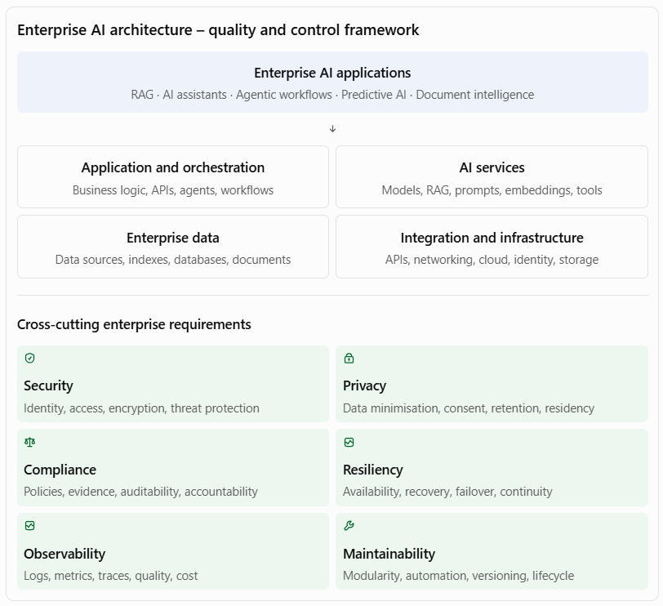
The architectural objective is to establish a common control framework that can be applied to different AI applications without requiring each product team to reinvent security, privacy, resilience, or operational practices.
For example, a banking customer-service assistant and a banking loan-processing agent may use the same identity, model gateway, telemetry, and governance services, but have different data permissions, approval controls, availability targets, and compliance requirements.
3. Practical interview case study: Enterprise AI architecture for a bank
Assume a large bank plans to introduce AI across customer service, loan processing, fraud investigation, and compliance operations.
As Principal Architect, I would approach this through the following steps.
Step 1 — Establish enterprise NFRs
First, conduct architecture and business workshops to identify the non-functional requirements for each use case.
Requirement | Questions to establish
Security | Who can access the AI application, models, tools, and retrieved information?
Privacy | What personal or confidential information is processed, stored, or sent to external services?
Compliance | Which regulations, internal policies, and audit obligations apply?
Resiliency | What availability, recovery, and business continuity targets are required?
Observability | What must operations, security, and business teams be able to monitor?
Maintainability | How will models, prompts, workflows, integrations, and infrastructure be updated?
Do not impose identical NFRs on all use cases. A customer-facing information assistant and a system supporting financial transactions have different business criticality and risk profiles.
Step 2 — Define the security and privacy architecture
Establish shared controls:
- Enterprise identity integration.
- Role- and attribute-based access control.
- Private network connectivity to sensitive services.
- Encryption and secrets management.
- Data classification and PII detection.
- Document-level retrieval authorisation.
- Prompt injection and output-handling protections.
- Agent tool allowlists and least-privilege access.
Step 3 — Establish compliance controls
Create an AI governance and compliance framework:
- AI use-case inventory.
- Risk classification.
- Approved model catalogue.
- Model and prompt version records.
- Data lineage and source provenance.
- Audit logging and retention policies.
- Human approval requirements.
- Compliance evidence and periodic assessments.
Step 4 — Define resiliency architecture
For critical AI workloads:
- Deploy critical services with appropriate redundancy.
- Introduce model fallback where permitted.
- Use asynchronous execution for long-running tasks.
- Persist workflow state.
- Apply retries, circuit breakers, and idempotency.
- Establish RTO and RPO.
- Define manual business continuity procedures.
Step 5 — Establish observability and operations
Create an enterprise AI operations capability:
- Distributed tracing across applications and models.
- Model latency and availability dashboards.
- Token consumption and cost monitoring.
- Retrieval and agent execution telemetry.
- Quality and safety indicators.
- Security events and audit trails.
- Incident alerts and operational runbooks.
Step 6 — Establish maintainability standards
Define reusable engineering standards:
- API contracts and modular architecture.
- Model abstraction and configuration management.
- Version-controlled prompts and retrieval configurations.
- Automated testing and evaluation.
- CI/CD and controlled deployment.
- Rollback and recovery procedures.
- Architecture decision records and technical documentation.
Step 7 — Introduce architecture governance
I would establish architecture review checkpoints covering:
- Business requirements and risk classification.
- Solution architecture and NFR compliance.
- Security and privacy assessment.
- AI evaluation and testing evidence.
- Production-readiness assessment.
- Operational handover and continuous review.
The result is an AI architecture that can scale across business units while maintaining consistent enterprise controls.
4. Architecture decision matrix: What would you prioritise?
In a Principal Architect interview, you may be asked how you balance competing requirements.
Scenario | Primary architectural decision | Trade-off to manage
Highly sensitive customer information | Private model deployment or approved protected model service | Cost versus data control
High-volume customer assistant | Autoscaling, caching, rate limiting | Latency versus cost
Critical loan-processing workflow | Durable orchestration and recovery | Complexity versus reliability
Multi-model AI platform | Model abstraction and version management | Flexibility versus abstraction overhead
Regulated AI decision support | Traceability, evidence, human oversight | Processing speed versus accountability
Rapidly evolving AI application | Modular architecture and automated testing | Initial engineering effort versus long-term maintainability
A strong answer should explain that architectural controls must be proportionate to business criticality, risk, and regulatory requirements.
5. Metrics you should discuss in the interview
These are examples of measurable enterprise architecture outcomes. Actual targets should be agreed through business and operational requirements.
Area | Metrics
Security | Critical vulnerabilities, unauthorised access incidents, security test pass rate
Privacy | PII exposure incidents, privacy control compliance, data deletion completion
Compliance | Control coverage, audit findings, unresolved exceptions, evidence completeness
Resiliency | Availability, MTTR, RTO/RPO achievement, recovery-test success
Observability | Trace coverage, alert detection time, incident resolution time
Maintainability | Deployment frequency, change failure rate, rollback time, regression-test coverage
Performance | P95/P99 latency, throughput, timeout rate
Cost | Cost per request, cost per successful task, infrastructure utilisation
I would also connect these technical measures to business outcomes:
- Reduced operational disruption.
- Faster production releases.
- Lower security and compliance exposure.
- Reduced maintenance costs.
- Increased reuse of enterprise AI capabilities.
- Improved business process continuity.
6. Preparation guide and recommended resources
These are the resources I would prioritise for interview preparation.
A. Enterprise security and AI security
Topic | What to study | Resource
AI application architecture | Security controls across AI components and layers | Microsoft: Architecture patterns for AI workloads
LLM security | Prompt injection, sensitive information disclosure, excessive agency, supply-chain risks | OWASP Top 10 for LLM Applications – 2026
AI threat modelling | Threat identification, security testing, agent permissions | AWS: Agentic AI security guidance
Cloud security architecture | Identity, encryption, network isolation, security design principles | Azure Well-Architected: AI design principles
The 2026 OWASP LLM list is especially relevant because it explicitly covers risks such as prompt injection, excessive agency, and vector and embedding weaknesses.
GitHub+1
B. Privacy and compliance
Topic | What to study | Resource
AI risk management | Risk identification, assessment, mitigation and monitoring | NIST AI Risk Management Framework
Generative AI risk | GenAI-specific risks and mitigations | NIST AI RMF and Generative AI Profile
Privacy engineering | Privacy risk management and organisational controls | NIST Privacy Framework
Security and privacy controls | Enterprise control catalogues and assessment | NIST Risk Management Framework
For interviews, be prepared to explain how you translate an obligation into an architectural control, how you test the control, and how you retain evidence that it is working.
C. Resiliency and reliability
Topic | What to study | Resource
Cloud reliability | Availability, recovery, redundancy and fault isolation | Azure Well-Architected Framework
AI workload reliability | Model and data-store dependencies, retries, fallback and failure analysis | Azure AI workload design principles
Generative AI reliability | Model availability, inference resilience, distributed processing | AWS Generative AI Well-Architected Lens
Resilience patterns | Circuit breakers, bulkheads, retry, failover | Azure AI reliability guidance
D. Observability and maintainability
Topic | What to study | Resource
AI workload architecture | Layered architecture, deployment and operations | Azure AI architecture patterns
Application telemetry | Logs, metrics, traces and standard attributes | OpenTelemetry semantic conventions
AI operations | Model lifecycle, evaluation, monitoring and safe deployment | Azure AI operational excellence
Generative AI operations | Model quality, traceability, lifecycle and cost optimisation | AWS Generative AI Lens
Microsoft's AI workload architecture guidance is particularly useful because it connects layered AI design with identity, security, monitoring, lifecycle management, and deployment practices.
Microsoft Learn+1
7. Interview questions you should prepare
Security
- How would you secure an enterprise RAG application that accesses confidential documents?
- How would you protect an agent from prompt injection and unauthorised tool invocation?
- How would you design identity propagation from a user to an AI agent and its enterprise tools?
Privacy and compliance
4. How would you prevent personal information from being exposed through prompts, embeddings, or logs?
5. How would you ensure that an AI solution complies with different regulatory requirements across geographies?
6. How would you make an AI-supported decision auditable?
Resiliency
7. What happens if the foundation model provider becomes unavailable?
8. How would you design a long-running agentic workflow that must recover after a failure?
9. How would you define RTO and RPO for an AI application?
Observability
10. How would you troubleshoot an AI application that is available but producing poor-quality responses?
11. What should be included in an end-to-end AI execution trace?
12. How would you monitor agent behaviour, model quality, latency, and cost?
Maintainability
13. How would you prevent vendor lock-in in an enterprise AI platform?
14. How would you safely introduce a new model version into production?
15. How would you design AI applications to support independent evolution of business logic, orchestration, and model services?
8. A suggested 7-day preparation plan
Day | Focus | Practical exercise
1 | Enterprise security | Design security architecture for a banking RAG application
2 | Privacy and compliance | Create a privacy and compliance control matrix
3 | Resiliency | Design failure-handling patterns for a loan-processing agent
4 | Observability | Design an AI monitoring and distributed-tracing architecture
5 | Maintainability | Design a modular, model-independent AI application architecture
6 | Enterprise NFRs | Create an NFR checklist and architecture review template
7 | Interview simulation | Present and defend the complete architecture
9. Your interview-ready closing statement
I believe enterprise AI architecture must meet the same quality, security, reliability, and operational standards expected of any mission-critical enterprise application, with additional controls to address the risks introduced by AI models, retrieval, and autonomous agents.
My approach is to translate enterprise requirements into measurable non-functional requirements and implement them through reusable architecture patterns and enforceable controls.
For security and privacy, I would focus on identity, least-privilege access, data protection, secure model integration, and controlled retrieval. For compliance, I would establish risk classification, traceability, auditability, and lifecycle governance. For resiliency, I would design for failure through redundancy, fallback, durable workflows, and tested recovery mechanisms.
I would also establish end-to-end observability covering application performance, model behaviour, retrieval quality, agent execution, and cost. Finally, I would ensure maintainability through modular architecture, standard interfaces, version management, automated testing, and controlled deployment.
My objective would be to ensure that AI solutions are not only functionally successful but also secure, compliant, resilient, observable, and sustainable throughout their operational lifecycle.
10. How to position your existing architecture experience
Your application architecture and Appian/BPM experience is directly relevant to this expectation.
You can connect your experience to these requirements through four architectural strengths:
Your architecture background | How it translates to AI architecture
Enterprise application architecture | Security boundaries, application decomposition, integration contracts and NFRs
BPM and workflow architecture | Durable process execution, human approvals, exception handling and recovery
Architecture governance | Standards, design reviews, control ownership and compliance evidence
Reusable enterprise capabilities | Shared APIs, integration services, common platform components and maintainable architecture
One particularly strong interview point is the separation of business logic from infrastructure and technology implementations.
For example, loan eligibility rules should remain in an authoritative business or decision service rather than being embedded in an LLM prompt. The AI component can interpret documents and assist with recommendations, while the enterprise application architecture controls identity, business rules, transactions, and approvals.
That demonstrates the architectural discipline needed to introduce AI into complex enterprise environments without compromising established controls.

Expectation: Help engineering teams leverage AI-powered PDLC capabilities across coding, testing, documentation, analysis, and delivery workflows
This expectation is about transforming the traditional Product Development Life Cycle (PDLC) into an AI-enabled engineering lifecycle. A Principal Architect is expected to help engineering teams use AI to improve productivity, software quality, delivery speed, engineering consistency, and operational effectiveness across the entire development lifecycle—not just introduce coding assistants.
My approach would be to define an enterprise AI-powered engineering strategy that integrates AI capabilities into requirements analysis, solution design, coding, testing, documentation, code reviews, DevSecOps, deployment, and production support. I would establish reusable engineering patterns, approved AI tools, secure development practices, integration standards, and measurable productivity metrics. I would also ensure that AI-generated code and engineering artefacts remain subject to human review, automated quality gates, security validation, and architecture governance.
The objective is to make AI a practical engineering capability embedded in everyday workflows, while retaining developer accountability, software quality, architectural integrity, and enterprise security.
1. Understand AI-powered PDLC
Traditional PDLC follows a sequence of activities from business requirements through software development, testing, deployment, and maintenance.
AI-powered PDLC introduces AI assistants, agents, and automation into these activities to augment engineering teams.
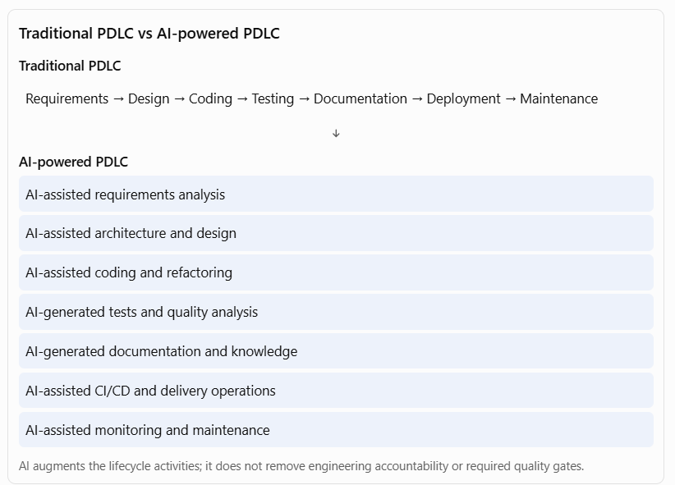
The Principal Architect's responsibility is to determine where AI provides genuine value, which activities can be automated, which require human judgement, and how these capabilities can be adopted consistently across engineering teams.
2. Expand the key responsibilities
A. Enable AI-powered requirements analysis and business analysis
What this means
AI can help engineering and product teams convert business requirements into structured, traceable, implementation-ready engineering artefacts.
Traditionally, business analysts and product owners manually analyse requirements, identify gaps, create user stories, define acceptance criteria, and prepare functional specifications.
AI can accelerate these activities by analysing documents, meeting transcripts, business processes, existing application behaviour, and historical requirements.
Key architectural responsibilities
- Requirements interpretation
  - Analyse business requirement documents.
  - Summarise stakeholder discussions and workshops.
  - Identify ambiguous, conflicting, or incomplete requirements.
  - Extract business rules and functional requirements.
  - Identify dependencies and assumptions.
- User story generation
  - Convert requirements into epics and user stories.
  - Generate acceptance criteria.
  - Identify functional and non-functional requirements.
  - Suggest edge cases and exception scenarios.
  - Map stories to business capabilities.
- Impact analysis
  - Analyse existing application components.
  - Identify impacted APIs, databases, services, and workflows.
  - Identify upstream and downstream dependencies.
  - Assess potential changes to existing business processes.
  - Generate initial impact assessments for engineering review.
- Requirements traceability
  - Link business requirements to user stories.
  - Link stories to design components and implementation artefacts.
  - Link requirements to test cases.
  - Identify requirements without corresponding test coverage.
  - Highlight changes that may affect existing functionality.
Industry examples
Industry | AI-assisted analysis | Example output
Banking | Analyse loan-processing requirements | User stories, credit-check rules, exception scenarios
Insurance | Analyse claims-processing requirements | Claims workflow, document requirements, validation rules
Healthcare | Analyse patient-registration requirements | Patient journeys, data requirements, acceptance criteria
Telecommunications | Analyse service-provisioning requirements | Network dependencies, activation workflows, failure cases
Government | Analyse citizen-service requirements | Eligibility requirements, application journeys, policy constraints
Example: Banking loan application
Suppose a product owner provides the following requirement:
"Customers should be able to apply for a personal loan online, upload supporting documents, and receive an eligibility decision."
An AI-assisted requirements analysis capability could generate:
- Epic: Digital Personal Loan Application.
- User story: As a customer, I want to submit a loan application online.
- Acceptance criteria:
  - Customer identity must be verified.
  - Mandatory documents must be submitted.
  - Income information must be validated.
  - Credit checks must be performed through an authorised service.
  - Incomplete applications must be routed for additional information.
- Exception scenarios:
  - Missing documentation.
  - Invalid identity information.
  - Credit API unavailable.
  - Customer fails eligibility rules.
- NFRs:
  - Secure customer authentication.
  - Data encryption.
  - Auditability.
  - Response-time requirements.
  - Accessibility.
The product owner and business analyst must validate these outputs before they become approved requirements.
Principal Architect perspective: I would encourage the use of AI to accelerate requirement decomposition, impact analysis, and traceability, while ensuring that business owners remain accountable for requirements and acceptance criteria.
B. Enable AI-assisted architecture and solution design
What this means
AI can assist architects and engineers in exploring solution alternatives, analysing existing architectures, generating design artefacts, and identifying potential design risks.
However, architecture decisions involving security, scalability, integration, resilience, and technology standards must remain subject to qualified architectural judgement.
Key architectural responsibilities
- Architecture discovery
  - Analyse existing application architecture documents.
  - Understand legacy systems, APIs, databases, and integrations.
  - Identify application dependencies and technology constraints.
  - Summarise architecture decision records.
  - Discover reusable enterprise components.
- Solution design assistance
  - Generate initial component diagrams.
  - Propose service boundaries and API contracts.
  - Suggest integration patterns.
  - Generate sequence diagrams and data-flow diagrams.
  - Identify potential non-functional requirements.
- Architecture alternatives
  - Compare synchronous and asynchronous integration.
  - Evaluate monolithic versus microservices designs.
  - Compare cloud deployment options.
  - Assess build-versus-buy alternatives.
  - Identify scalability and maintainability trade-offs.
- Architecture governance
  - Check designs against enterprise reference architectures.
  - Identify deviations from technology standards.
  - Analyse security and compliance requirements.
  - Generate architecture review checklists.
  - Maintain architecture decision records.
Industry examples
Industry | AI-assisted architecture activity | Example
Banking | Loan-processing architecture | Generate service decomposition and integration options
Insurance | Claims automation architecture | Identify document intelligence and workflow components
Healthcare | Patient engagement platform | Analyse privacy, integration, and scalability requirements
Telecommunications | Network operations platform | Evaluate event-driven architecture and AI integration
Government | Digital citizen-services platform | Generate API and application integration designs
Example: Architecture copilot
An engineering team provides an architecture document for an existing banking application.
The AI architecture assistant can:
- Summarise the existing architecture.
- Identify system dependencies.
- Analyse API integration patterns.
- Identify potential single points of failure.
- Compare proposed modernisation options.
- Generate an initial target-state architecture.
- Prepare an architecture decision record for review.
The architect validates the recommendations and makes the final decisions.
Principal Architect perspective: I would introduce AI architecture assistants connected to approved enterprise architecture knowledge, technology standards, and reusable design patterns. This helps teams make consistent decisions and reduces the effort required for architecture discovery and documentation.
C. Enable AI-powered software coding and development
What this means
AI-powered coding assists developers in writing, understanding, debugging, refactoring, and maintaining application code.
This is one of the most visible applications of AI in software engineering, but the Principal Architect's responsibility extends beyond providing developers with coding assistants. It includes establishing approved tools, integration patterns, secure coding practices, reusable prompts, coding standards, and governance mechanisms.
Key architectural responsibilities
- Code generation
  - Generate code from approved requirements and design specifications.
  - Create API endpoints, service classes, data models, and integration components.
  - Generate boilerplate code and configuration.
  - Create database queries and data transformation logic.
  - Generate infrastructure-as-code templates.
- Code understanding
  - Explain complex or unfamiliar code.
  - Summarise legacy application functionality.
  - Identify dependencies between modules.
  - Explain API behaviour and business logic.
  - Support developers onboarding to existing codebases.
- Code refactoring
  - Identify duplicated code.
  - Suggest improvements to code structure.
  - Improve readability and modularity.
  - Identify opportunities to apply design patterns.
  - Support migration from legacy frameworks and languages.
- Debugging assistance
  - Analyse stack traces and error messages.
  - Identify potential root causes.
  - Suggest code corrections.
  - Analyse application logs.
  - Recommend performance improvements.
- Secure coding
  - Identify common security weaknesses.
  - Detect insecure coding patterns.
  - Suggest input validation and output encoding.
  - Identify hard-coded secrets and credentials.
  - Recommend remediation for vulnerabilities.
- Developer productivity
  - Provide contextual code completion.
  - Generate unit-test scaffolding.
  - Assist with API client development.
  - Generate comments and code explanations.
  - Reduce repetitive development work.
Industry examples
Industry | AI-powered coding use case | Example
Banking | Digital banking development | Generate REST API implementations for customer and account services
Insurance | Claims application development | Generate document-processing and validation components
Healthcare | Patient management systems | Generate API integration and data transformation logic
Telecommunications | Network service applications | Generate event-processing and monitoring components
Government | Citizen-service applications | Generate form validation, application APIs, and workflow components
Example: Building a loan-processing API
A developer receives an approved requirement to create an API that retrieves a loan application's status.
An AI coding assistant can help generate:
- FastAPI endpoint structure.
- Request and response schemas.
- Service-layer implementation.
- Database repository interface.
- Input validation.
- Error-handling logic.
- Unit-test scaffolding.
- API documentation.
For example, an initial endpoint might look like:
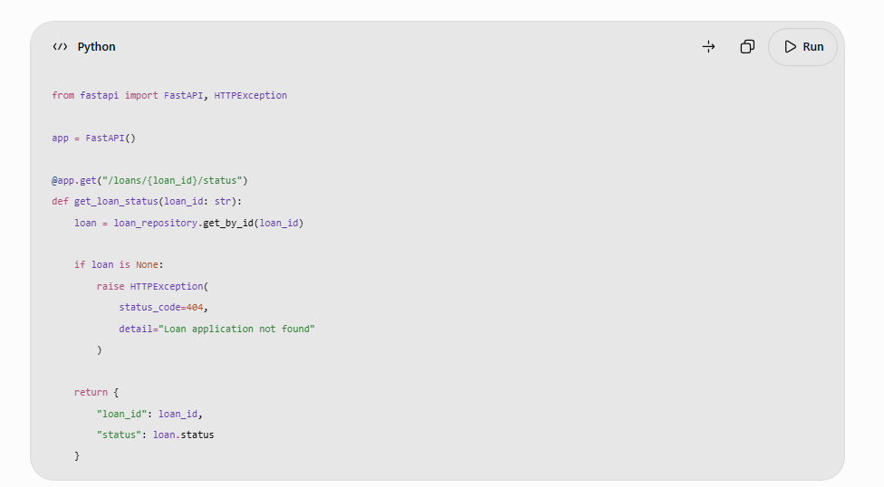The generated implementation is only a starting point. Developers must validate the repository implementation, authentication and authorisation, error handling, logging, data exposure, and test coverage before merging it.
Principal Architect perspective: I would introduce approved AI coding assistants integrated with the engineering toolchain and enterprise coding standards. I would focus on increasing developer productivity without compromising clean architecture, code quality, security, and maintainability.
D. Enable AI-powered software testing and quality engineering
What this means
AI can improve software testing by generating test cases, analysing requirements, identifying edge cases, creating test data, detecting defects, and helping engineering teams investigate failures.
The objective is to shift testing earlier in the development lifecycle and increase test coverage without relying entirely on manual test design.
Key architectural responsibilities
- Test case generation
  - Generate test scenarios from user stories.
  - Create positive and negative test cases.
  - Identify boundary conditions.
  - Generate exception and failure scenarios.
  - Map test cases to acceptance criteria.
- Unit testing
  - Generate unit-test scaffolding.
  - Suggest test inputs and expected outcomes.
  - Identify untested code paths.
  - Generate mocks and test fixtures.
  - Help improve branch and statement coverage.
- Integration testing
  - Generate API integration test cases.
  - Identify dependency failures.
  - Test authentication and authorisation.
  - Validate message and event contracts.
  - Test database and external service interactions.
- Regression testing
  - Analyse code changes and identify impacted components.
  - Recommend relevant regression tests.
  - Identify potential breaking changes.
  - Support automated regression suite optimisation.
  - Compare application behaviour across releases.
- Performance and reliability testing
  - Generate workload scenarios.
  - Identify potential performance bottlenecks.
  - Analyse latency and throughput.
  - Help interpret load-test results.
  - Suggest capacity and scaling improvements.
- AI-specific testing
  - Evaluate LLM output quality.
  - Test RAG retrieval and citation accuracy.
  - Test prompt-injection resistance.
  - Validate agent tool selection and execution.
  - Test hallucination, unsafe output, and guardrail behaviour.
Industry examples
Industry | AI-assisted testing | Example
Banking | Loan application testing | Generate eligibility, validation, and exception test cases
Insurance | Claims testing | Generate tests for missing documents, duplicate claims, and policy exceptions
Healthcare | Patient management testing | Test access controls, data validation, and patient record handling
Telecommunications | Network service testing | Generate tests for API failures, event processing, and network outages
Government | Citizen application testing | Test eligibility rules, missing documents, and application rejection scenarios
Example: AI-generated testing for a loan application
Consider this user story:
"As a customer, I want to submit a loan application with supporting documents."
An AI testing assistant could generate the following scenarios:
Test scenario | Expected result
Submit a valid application | Application successfully registered
Submit without mandatory documents | Application rejected or marked incomplete
Submit invalid income information | Validation error returned
Submit duplicate application | Duplicate detection applied
Credit API unavailable | Controlled retry or exception handling
Unauthorised customer accesses application | Access denied
Application exceeds allowed loan amount | Business validation triggered
It can also generate initial automated test scripts, but the test team must validate the scenarios and expected results against approved business rules.
Principal Architect perspective: I would embed AI-assisted testing into the CI/CD pipeline, making automated test generation, security scanning, regression testing, and AI-specific evaluation part of the engineering quality gates.
E. Enable AI-powered technical documentation and knowledge management
What this means
Software documentation is often incomplete, outdated, or disconnected from the actual implementation. AI can help engineering teams generate, update, search, and maintain technical documentation using approved source code, architecture artefacts, APIs, and engineering knowledge.
This is particularly valuable in organisations with large legacy application estates, multiple engineering teams, and distributed knowledge.
Key architectural responsibilities
- Code documentation
  - Generate code comments and method descriptions.
  - Explain complex functions and classes.
  - Document configuration and dependencies.
  - Generate module-level documentation.
  - Identify missing or outdated documentation.
- API documentation
  - Generate API descriptions and examples.
  - Explain request and response schemas.
  - Generate OpenAPI documentation.
  - Document error codes and integration behaviour.
  - Identify API contract changes.
- Architecture documentation
  - Generate initial component descriptions.
  - Create sequence and data-flow diagrams.
  - Summarise architecture decisions.
  - Maintain system dependency documentation.
  - Generate technical design summaries.
- Operational documentation
  - Generate deployment instructions.
  - Create operational runbooks.
  - Document common failure scenarios.
  - Generate incident troubleshooting guides.
  - Summarise recovery procedures.
- Engineering knowledge assistants
  - Build RAG-based assistants over engineering documentation.
  - Enable developers to query architecture standards.
  - Retrieve API specifications and design decisions.
  - Search historical incident records.
  - Support onboarding of new developers.
- Documentation lifecycle
  - Link documentation to source-code repositories.
  - Update documentation when implementation changes.
  - Maintain version history.
  - Assign documentation ownership.
  - Introduce review and approval workflows.
Industry examples
Industry | AI documentation use case | Example
Banking | Core banking documentation | Generate service descriptions, integration specifications, and operational runbooks
Insurance | Claims platform documentation | Document claims rules, APIs, and workflow configurations
Healthcare | Clinical application documentation | Generate interface and integration specifications
Telecommunications | Network management documentation | Document event flows, APIs, and operational procedures
Government | Public-service application documentation | Maintain service specifications, data flows, and audit documentation
Example: Enterprise engineering knowledge assistant
An organisation has hundreds of applications, APIs, architecture documents, and operational runbooks.
A developer wants to understand how the customer onboarding application integrates with the identity verification service.
An AI knowledge assistant can:
- Retrieve the relevant architecture documents.
- Identify the application and integration components.
- Retrieve the API specifications.
- Explain the authentication mechanism.
- Identify downstream dependencies.
- Provide links to the original source documents.
The response should be grounded in approved documentation, respect access permissions, and identify when information is missing or outdated.
Principal Architect perspective: I would establish an enterprise engineering knowledge platform using governed retrieval and AI-assisted documentation. This would reduce dependency on individual knowledge holders, improve onboarding, and increase reuse of existing architecture assets.
F. Enable AI-powered code analysis and engineering intelligence
What this means
AI can analyse source code, architecture repositories, test results, application logs, and development activity to identify risks and provide engineering insights.
This is broader than code generation. It helps architects and engineering leaders understand the health, complexity, dependencies, and maintainability of software estates.
Key architectural responsibilities
- Static code analysis assistance
  - Identify code smells and design weaknesses.
  - Detect duplicated code and complexity.
  - Identify potential security vulnerabilities.
  - Highlight outdated dependencies.
  - Suggest refactoring opportunities.
- Architecture analysis
  - Analyse dependencies across applications and services.
  - Identify tight coupling and circular dependencies.
  - Detect deviations from reference architecture.
  - Identify technology obsolescence.
  - Support modernisation assessments.
- Change impact analysis
  - Analyse the impact of proposed code changes.
  - Identify dependent services and APIs.
  - Highlight affected test cases.
  - Assess database schema impact.
  - Generate change-risk summaries.
- Defect analysis
  - Analyse logs and stack traces.
  - Correlate related production errors.
  - Identify probable root causes.
  - Summarise recurring defects.
  - Recommend corrective actions for engineering review.
- Technical debt analysis
  - Identify obsolete libraries and frameworks.
  - Detect repeated workarounds and architectural anti-patterns.
  - Prioritise refactoring opportunities.
  - Estimate potential maintenance impact.
  - Track technical debt reduction.
- Engineering intelligence
  - Analyse delivery bottlenecks.
  - Identify test failure patterns.
  - Monitor code-review turnaround.
  - Analyse build and deployment failures.
  - Provide team-level improvement insights without treating individual activity metrics as simplistic productivity scores.
Industry examples
Industry | AI-powered analysis | Example
Banking | Legacy banking modernisation | Identify dependencies and modernisation risks
Insurance | Claims application analysis | Detect duplicated business logic and workflow complexity
Healthcare | Patient platform analysis | Identify privacy and security weaknesses
Telecommunications | Network application analysis | Analyse service dependencies and failure patterns
Government | Legacy public-service systems | Identify obsolete technology and technical debt
Example: Legacy application modernisation
Assume a bank wants to modernise an application developed using an older technology stack.
An AI-assisted engineering analysis solution can:
- Analyse source-code repositories.
- Identify application modules and dependencies.
- Identify database interactions.
- Detect duplicated business functionality.
- Identify obsolete libraries.
- Generate an initial application dependency map.
- Recommend potential modularisation options.
- Identify candidate services for modernisation.
The output should be treated as an initial assessment. Architects must validate dependencies, hidden business rules, performance characteristics, and migration risks before finalising the target architecture.
Principal Architect perspective: I would use AI-assisted engineering intelligence to make architecture and modernisation decisions more evidence-based. This can help engineering leaders prioritise technical debt, reduce change risk, and improve the long-term health of the application portfolio.
G. Enable AI-powered delivery, DevOps, and release management
What this means
AI can support the delivery lifecycle by analysing build pipelines, identifying deployment risks, generating release documentation, investigating failures, and assisting production operations.
The goal is to improve delivery predictability and reduce the manual effort associated with software releases.
Key architectural responsibilities
- CI/CD pipeline assistance
  - Generate pipeline configuration templates.
  - Analyse pipeline failures.
  - Recommend corrections for build errors.
  - Identify dependency and configuration issues.
  - Improve deployment automation.
- Release management
  - Generate release notes from code and work-item changes.
  - Summarise features, fixes, and known issues.
  - Identify impacted applications.
  - Analyse release risks.
  - Prepare deployment checklists.
- Deployment risk analysis
  - Analyse code changes and affected components.
  - Review test results and security findings.
  - Identify database migration risks.
  - Recommend deployment strategies.
  - Support canary and progressive rollout decisions.
- Infrastructure automation
  - Generate infrastructure-as-code templates.
  - Explain cloud configuration.
  - Identify insecure infrastructure settings.
  - Suggest resource-sizing improvements.
  - Validate infrastructure configuration against standards.
- Incident management
  - Summarise application incidents.
  - Correlate logs and monitoring alerts.
  - Suggest potential root causes.
  - Retrieve relevant operational runbooks.
  - Prepare incident reports and post-incident summaries.
- Production support
  - Provide AI-assisted operational knowledge search.
  - Identify recurring failures.
  - Recommend remediation steps.
  - Automate low-risk operational actions under controlled permissions.
  - Escalate high-impact or uncertain actions to human operators.
Industry examples
Industry | AI-powered delivery use case | Example
Banking | Digital banking release management | Identify release dependencies and deployment risks
Insurance | Claims platform DevOps | Analyse failed deployments and generate release summaries
Healthcare | Clinical application delivery | Check release artefacts against security and validation requirements
Telecommunications | Network service delivery | Analyse pipeline failures and deployment telemetry
Government | Citizen-service releases | Generate compliance evidence and release documentation
Example: AI-assisted production incident management
A banking application experiences a sudden increase in loan application failures.
An AI operations assistant can:
- Retrieve relevant monitoring alerts.
- Correlate application logs and traces.
- Identify the affected service.
- Analyse recent deployments.
- Retrieve the relevant runbook.
- Suggest possible root causes.
- Prepare an incident summary.
- Recommend remediation for operator approval.
For critical systems, the assistant should not independently execute high-impact remediation unless explicitly authorised under a tested and governed operational policy.
Principal Architect perspective: I would introduce AI into delivery and operations through controlled engineering workflows, integrating it with CI/CD, observability, incident management, and release governance. The focus would be faster and more predictable delivery, not uncontrolled automation.
3. How to architect an enterprise AI-powered PDLC
The Principal Architect should not approach this as a collection of independent developer tools. The objective is to establish an integrated AI engineering platform that connects requirements, architecture, code, tests, documentation, and delivery artefacts.
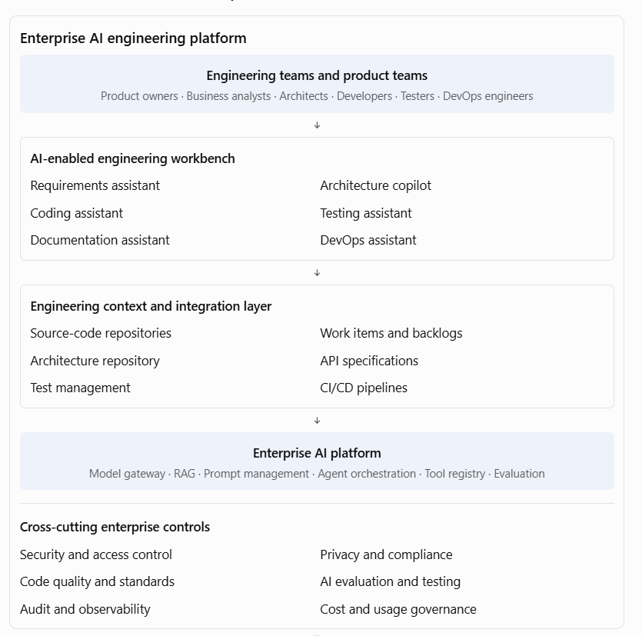
Important architectural components
Component | Responsibility
AI engineering workbench | Provides a consistent experience for engineering roles
Model gateway | Provides controlled access to approved models
Engineering knowledge RAG | Retrieves relevant code, architecture standards, APIs, and documentation
Agent orchestration | Coordinates multi-step engineering tasks
Tool registry | Exposes approved repository, build, test, and deployment operations
Evaluation framework | Evaluates generated code, tests, documentation, and agent outcomes
Engineering integration layer | Connects work-item management, source control, CI/CD, and test systems
Governance and telemetry | Controls access, captures activity, and measures performance
The importance of engineering context
An AI coding assistant without sufficient context may generate technically valid code that does not comply with the organisation's architecture.
For example, a developer asks an AI assistant to create a new customer API. The assistant should ideally have access to approved information about:
- Enterprise API standards.
- Existing customer-service APIs.
- Authentication and authorisation patterns.
- Naming conventions.
- Domain models.
- Error-handling standards.
- Logging and monitoring standards.
- Approved technology stacks.
This is where enterprise RAG, repository context, reusable agent instructions, and tool integrations become important.
The objective is to make AI recommendations consistent with the organisation's engineering practices rather than relying on generic model knowledge.
4. Introduce an AI-assisted engineering workflow
One particularly useful approach is spec-driven development.
Instead of asking an AI coding assistant to generate an application directly from a loosely defined business request, first create a validated specification. The specification becomes the basis for design, coding, testing, and validation.
AI-assisted spec-driven engineering
- Define intent
Product owner provides the business objective and requirements.
- Specify
AI helps produce user stories, acceptance criteria, and business rules.
- Clarify
AI identifies ambiguities, dependencies, assumptions, and edge cases.
- Plan
Architect and engineering team approve the solution design, constraints, and implementation approach.
- Create tasks
AI helps decompose the approved design into implementation tasks.
- Implement
Coding assistants and agents help generate code, tests, and documentation.
- Validate
Automated tests, security checks, code review, and human approval validate the implementation against the specification.
This approach is particularly useful because it creates a traceable connection between business intent and implementation. Microsoft's GitHub Spec Kit describes a similar specification-first workflow.
Microsoft for Developers
Example: Implementing a customer onboarding feature
PDLC stage | AI-assisted activity | Engineering artefact
Requirements | Analyse onboarding requirements | User stories and acceptance criteria
Analysis | Identify impacted systems | Dependency and impact report
Architecture | Generate design alternatives | Component and sequence diagrams
Development | Generate API and service code | Source code and configuration
Testing | Generate test scenarios | Unit and integration tests
Documentation | Generate API and technical documentation | OpenAPI specification and design notes
Delivery | Analyse release changes | Release notes and deployment checklist
Operations | Analyse logs and incidents | Incident summary and remediation suggestions
A key control is that the artefacts must pass through appropriate engineering reviews. AI-generated specifications are not automatically approved requirements, and AI-generated code is not automatically production-ready software.
5. Governance model for AI-powered engineering
At enterprise scale, engineering teams need freedom to use AI productively, but within common guardrails.
I would establish the following governance model.
Governance area | Enterprise standard
Approved AI tools | Maintain an approved catalogue of coding assistants, models, and agents
Source-code protection | Define which repositories and code classifications may be shared with AI services
Developer identity | Ensure AI tools operate under authenticated user or approved service identities
Agent permissions | Apply least privilege and restrict write, merge, and deployment operations
Code quality | Require peer review, automated testing, and static analysis
Security | Scan generated code and dependencies; protect secrets and credentials
Architecture | Validate generated solutions against enterprise standards
IP and licensing | Apply policies for provenance, third-party code, and licence compliance
Auditability | Record relevant AI-assisted changes and agent actions
Human accountability | Keep developers and designated approvers accountable for changes
An important design distinction:
AI assistants and AI agents should not necessarily have the same permissions.
- An assistant may suggest code to a developer.
- A coding agent may create a branch and submit a pull request.
- A deployment agent may prepare a release but require approval before production deployment.
- A production operations agent may execute a narrowly defined, reversible action under an approved policy.
Permissions should be based on the task, environment, business risk, and identity—not simply on the capabilities of the AI tool.
NIST's DevSecOps reference model discusses controlled AI integration across software development, security, deployment, and operations, including human oversight and verification of AI-generated outputs.
NIST Pages+2
6. Practical enterprise case study: AI-powered PDLC transformation
Assume a large bank has 20 engineering teams developing and maintaining digital banking, loan processing, payments, and customer-service applications.
The organisation wants to improve engineering productivity and reduce delivery timelines through AI adoption.
As Principal Architect, I would propose a phased transformation.
Phase 1 — Assess the current engineering lifecycle
Assess the current development process across:
- Requirements gathering and analysis.
- Architecture and design.
- Development and code reviews.
- Testing and defect management.
- Documentation.
- CI/CD and release management.
- Production support.
Identify bottlenecks such as:
- Excessive manual documentation.
- Repetitive code development.
- Slow test-case creation.
- Long code-review cycles.
- Poor understanding of legacy applications.
- Manual impact analysis.
- Repeated production incidents.
Phase 2 — Establish the AI engineering platform
Introduce a standard platform with:
- Enterprise-approved AI coding assistants.
- AI-powered engineering knowledge assistant.
- AI architecture and requirements assistant.
- AI testing and code-review capabilities.
- AI-powered documentation generation.
- AI-assisted DevOps and incident analysis.
- Centralised AI governance and usage monitoring.
Phase 3 — Run controlled pilots
Start with three use cases.
Pilot | Scope | Expected benefit
AI coding assistant | Code generation, debugging, refactoring | Reduced repetitive development effort
AI testing assistant | Test-case generation and unit-test scaffolding | Faster test preparation and improved coverage
Engineering knowledge assistant | Search architecture, APIs, and code documentation | Reduced onboarding and investigation time
Establish baseline measurements before the pilots.
Phase 4 — Integrate AI into engineering workflows
Integrate AI capabilities with:
- Work-item and backlog management.
- Git repositories.
- IDEs.
- Pull-request workflows.
- Automated testing.
- CI/CD pipelines.
- Monitoring and incident-management systems.
The aim is to avoid isolated AI tools that require developers to constantly switch between applications and manually transfer information.
Phase 5 — Establish engineering quality gates
AI-generated code and engineering artefacts must pass the same enterprise controls as manually generated work.
A sample pipeline:
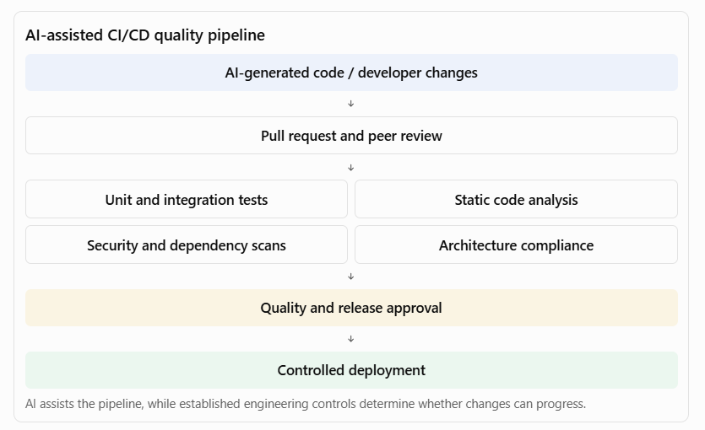
Phase 6 — Scale adoption across engineering teams
Once pilots demonstrate measurable improvements:
- Establish reusable AI engineering patterns.
- Create shared prompts, instructions, and agent templates.
- Introduce AI engineering champions.
- Provide training for developers, architects, testers, and DevOps engineers.
- Establish platform onboarding standards.
- Monitor adoption and engineering outcomes.
- Continuously improve based on feedback.
7. Metrics to measure AI-powered PDLC success
One of the most important Principal Architect responsibilities is demonstrating that AI adoption improves engineering outcomes rather than simply increasing the number of AI tools being used.
I would measure performance across five dimensions.
Dimension | Metrics
Developer productivity | Time to implement a story, coding cycle time, time spent on repetitive tasks
Software quality | Defect density, escaped defects, test coverage, change failure rate
Delivery efficiency | Lead time for changes, deployment frequency, pull-request turnaround
Engineering effectiveness | Rework rate, onboarding time, documentation completeness, build success
AI adoption and value | Active usage, accepted suggestions, AI-assisted task completion, cost per successful task
Example of a transformation scorecard
Illustrative targets for a pilot programme, not industry benchmarks.
Metric | Baseline | Illustrative target
Unit-test preparation time | 8 hours | 4 hours
API documentation effort | 5 hours | 2 hours
Initial code implementation | 3 days | 2 days
Pull-request review time | 12 hours | 8 hours
Developer onboarding | 4 weeks | 3 weeks
Escaped defect rate | 5% | 3%
Do not interpret faster coding as equivalent to faster delivery. If AI increases code output but also increases rework, security findings, or review effort, the overall transformation may not be successful.
The DORA research is particularly useful here: it emphasises that AI amplifies the organisation's existing engineering capabilities and weaknesses, so successful adoption requires improvements to the engineering system, not just new tools.
Google Cloud+2
8. Preparation guide and recommended resources
These are the resources I would prioritise for this expectation.
A. AI-powered software development
Topic | What to study | Resource
AI-assisted development | Coding, code explanation, debugging, code review | GitHub Copilot documentation
AI in software engineering | AI adoption across the SDLC | Microsoft Learn: Developer use cases for AI
Agentic coding | Coding agents, repository context, pull requests | GitHub Copilot usage across workflows
AI-native engineering | Specification-first development and validation | Microsoft: Spec-driven development
B. AI-powered testing and quality engineering
Topic | What to study | Resource
Automated software testing | Unit, integration, regression and test automation | Microsoft developer AI training
AI code review | Reviewing AI-generated code and pull requests | GitHub Copilot capabilities
Secure development | Security automation and DevSecOps | NIST DevSecOps practices
AI-generated software security | Secure development practices for AI-related systems | NIST SP 800-218A
C. AI engineering transformation and productivity
Topic | What to study | Resource
AI engineering transformation | Organisational adoption and engineering effectiveness | 2025 DORA State of AI-assisted Software Development
AI capabilities model | Organisational practices that enable AI-assisted engineering | DORA AI Capabilities Model
Enterprise AI engineering | Embedding AI across engineering workflows | Microsoft: AI-led engineering transformation
Agentic software delivery | AI across planning, coding, review, security and delivery | Microsoft: Agentic software development platform
D. Enterprise AI engineering governance
Topic | What to study | Resource
Secure AI development | Human oversight, secure design, deployment and operations | NCSC: Guidelines for secure AI system development
AI in DevSecOps | Governance, security checks, and controlled AI adoption | NIST DevSecOps reference model
Enterprise AI coding standards | Consistent instructions, plugins, reusable agent configurations | Microsoft: Consistent AI-assisted engineering
9. Interview questions you should prepare
AI-powered development
- How would you introduce AI coding assistants across a large engineering organisation?
- How would you ensure that AI-generated code complies with enterprise architecture standards?
- How would you manage AI coding agents that can modify source-code repositories?
Testing and quality
4. How can AI improve test coverage and reduce testing effort?
5. How would you introduce AI-generated test cases into CI/CD pipelines?
6. How would you validate the quality of AI-generated code?
Architecture and documentation
7. How can AI help architects with architecture discovery and impact analysis?
8. How would you build an enterprise engineering knowledge assistant?
9. How would you keep AI-generated documentation synchronised with source code?
Delivery and transformation
10. How would you integrate AI into DevOps and release management?
11. How would you measure the success of an AI-powered engineering transformation?
12. How would you scale AI engineering capabilities across multiple development teams?
10. Suggested 10-day preparation plan
Day | Preparation area | Practical exercise
1 | AI-powered PDLC fundamentals | Map AI capabilities to each PDLC phase
2 | AI requirements analysis | Convert a banking requirement into user stories and acceptance criteria
3 | AI architecture assistance | Generate and review a solution design
4 | AI coding | Build a FastAPI service with an AI coding assistant
5 | AI testing | Generate unit and integration tests
6 | AI documentation | Generate API documentation and an engineering knowledge assistant
7 | AI code analysis | Analyse a legacy application and identify technical debt
8 | AI-powered DevOps | Design an AI-assisted CI/CD workflow
9 | Governance | Create an enterprise AI engineering governance framework
10 | Principal Architect interview | Present an enterprise AI-powered PDLC transformation proposal
11. Your interview-ready closing statement

My approach would be to transform the traditional software development lifecycle into an AI-enabled engineering lifecycle, embedding AI capabilities across requirements analysis, architecture, coding, testing, documentation, delivery, and production support.
I would start by identifying the engineering bottlenecks and establishing an enterprise AI engineering strategy. This would include approved coding assistants, architecture and requirements copilots, AI-powered testing, engineering knowledge assistants, and AI-enabled DevOps capabilities.
From an architecture perspective, I would focus on integrating these capabilities with existing engineering platforms, source-code repositories, work-item management, test automation, and CI/CD pipelines. I would also establish reusable engineering patterns, secure coding guidelines, agent permissions, and quality gates to ensure that AI-generated artefacts comply with enterprise standards.
I would work with engineering leaders to introduce these capabilities through controlled pilots, measure their impact on productivity, quality, and delivery performance, and then scale successful patterns across teams.
My objective would be to improve engineering effectiveness and delivery speed while maintaining architectural consistency, software quality, security, and long-term maintainability.
12. How to position your existing application architecture and Appian experience
There is a useful connection between your application architecture background and this expectation.
You can position your experience around three capabilities:
Existing architecture strength | How to extend it into AI-powered PDLC
Reusable architecture patterns | Create reusable AI engineering templates, prompts, coding standards, and agent configurations
BPM and workflow automation | Automate engineering workflows such as approvals, defect management, testing, and release processes
Enterprise architecture governance | Establish AI coding standards, architecture compliance checks, security controls, and engineering quality gates
Application integration | Integrate AI assistants with APIs, repositories, test platforms, and delivery systems
Technology leadership | Drive adoption, develop engineering capabilities, and measure transformation outcomes
A particularly useful distinction to explain in the interview is:
Traditional automation executes predefined development and delivery steps. AI-assisted engineering helps developers and architects understand context, generate solutions, analyse problems, and make recommendations. Agentic engineering goes further by allowing authorised agents to execute multi-step engineering tasks, subject to permissions and review controls.
Your architectural role is to bring these three approaches together into a governed engineering ecosystem.

Guide architecture decisions across application, data, integration, platform, and operational concerns to avoid fragmented or duplicative solutions
This is a key responsibility for an AI Principal Architect because enterprise AI initiatives often begin independently across business units. Different teams may select different LLM providers, build separate RAG pipelines, create overlapping APIs, maintain duplicate data stores, and introduce inconsistent security and operational practices. The result is an expensive and difficult-to-maintain technology landscape.
As an AI Principal Architect, I would establish an enterprise-wide architectural decision framework that considers application, data, integration, platform, and operational architecture together. My objective would be to maximise reuse, enforce appropriate standards, reduce duplication, and preserve business-unit flexibility where it is justified. I would guide teams toward shared capabilities and interoperable patterns while ensuring that each solution meets its business requirements for scalability, security, performance, resilience, cost, and maintainability.
1. What this responsibility means
This responsibility is about making sure that individual AI solutions fit into a coherent enterprise architecture rather than becoming isolated technology implementations.
Consider a large bank implementing five AI initiatives:
- Customer service virtual assistant.
- Loan underwriting copilot.
- Fraud investigation assistant.
- Regulatory compliance assistant.
- Employee knowledge assistant.
Without architectural direction, each team might independently procure an LLM, create a vector database, build document ingestion pipelines, implement authentication, and develop its own monitoring solution.
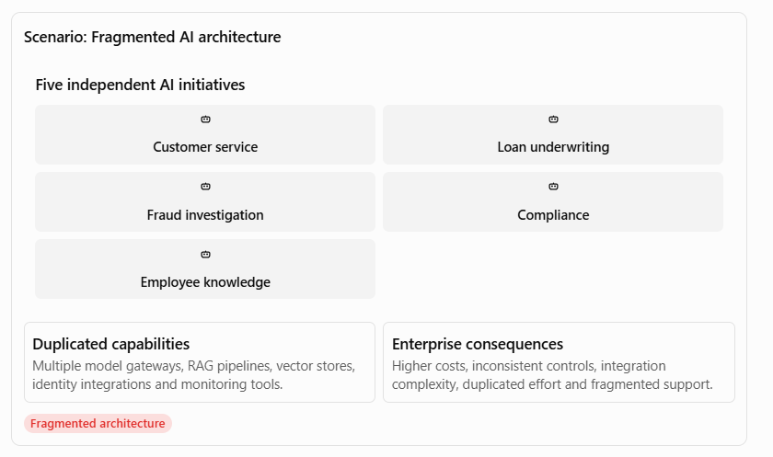
The Principal Architect should guide the organisation toward shared enterprise capabilities without forcing every business solution into an identical design.
2. Five architectural dimensions to govern
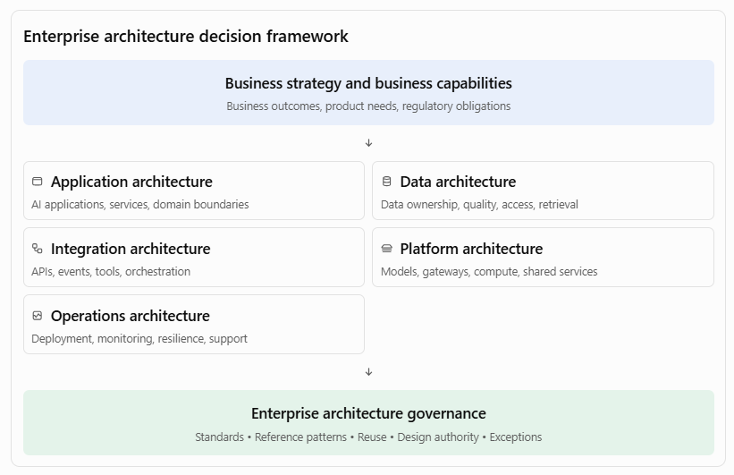
The five dimensions are interdependent. For example, choosing an agent framework affects application design, integration patterns, state management, observability, deployment, and operational support. A decision about vector storage affects data governance, retrieval performance, access control, and infrastructure costs.
3. Application architecture decisions
3.1 What should be decided?
The objective is to prevent every team from independently building similar AI applications and business capabilities.
As Principal Architect, I would guide teams on:
A. Application and domain boundaries
- Define clear business-domain ownership.
- Separate business logic from AI-specific orchestration.
- Avoid embedding business rules inside prompts.
- Define boundaries between user-facing applications, domain services, AI services, and enterprise systems.
- Use modular architecture and well-defined interfaces.
B. Shared versus business-specific capabilities
Identify which capabilities should be enterprise-wide and which should remain specific to a business domain.
Shared enterprise capabilities | Business-specific capabilities
Model access service | Loan underwriting rules
Prompt management | Claims assessment logic
RAG framework | Fraud investigation workflow
AI evaluation service | Customer retention decisions
Agent/tool registry | Regulatory interpretation workflow
AI audit service | Product-specific recommendations
C. Architecture patterns
Standardise appropriate patterns for:
- AI-enabled application architecture.
- RAG-based knowledge assistants.
- Agentic workflow applications.
- Human-in-the-loop decision workflows.
- AI-assisted decision support.
- AI-enabled legacy modernisation.
3.2 Industry examples
Industry | Application architecture decision
Banking | Reuse a common AI document-processing capability across loan applications, KYC and compliance rather than developing separate extraction applications.
Insurance | Create reusable claims document assessment services while keeping policy-specific claims rules within individual product domains.
Healthcare | Share clinical document summarisation services but maintain separate workflows and access boundaries for clinical and administrative applications.
Telecom | Reuse customer interaction and knowledge-assistant capabilities across service channels while maintaining domain-specific billing and network workflows.
Government | Establish common citizen-service AI capabilities while keeping departmental case-management and statutory decision logic separate.
Principal Architect perspective: Reuse the capability, not necessarily the entire application. Domain ownership, business rules, and accountability must remain clear.
4. Data architecture decisions
Data architecture is particularly important in AI programmes because AI solutions depend on reliable, governed, accessible, and appropriately protected enterprise data.
A common source of duplication is that every AI team independently creates its own document repository, data ingestion pipeline, embedding process, vector database, and retrieval mechanism.
4.1 What should be decided?
A. Enterprise data ownership and data domains
Define authoritative sources for enterprise data.
For example:
Data domain | Potential authoritative source
Customer information | Customer master / CRM
Account information | Core banking system
Loan information | Loan management system
Policy information | Policy administration system
Claims information | Claims management system
Employee information | HR system
Regulatory documents | Approved regulatory content repository
AI applications should retrieve information from authorised sources rather than creating competing versions of enterprise data.
B. Data ingestion and processing standards
Establish reusable patterns for:
- Structured data ingestion.
- Unstructured document ingestion.
- Data validation and cleansing.
- Metadata extraction and enrichment.
- Document classification.
- Chunking and embedding generation.
- Data lineage and version management.
- Data retention and deletion.
C. Enterprise RAG architecture
A common RAG capability can support multiple business applications.
For example, a banking enterprise may have separate knowledge assistants for customer service, loan processing, and compliance. They may share document ingestion, embedding generation, retrieval infrastructure, and evaluation services while maintaining separate knowledge collections, access policies, and domain-specific retrieval configurations.
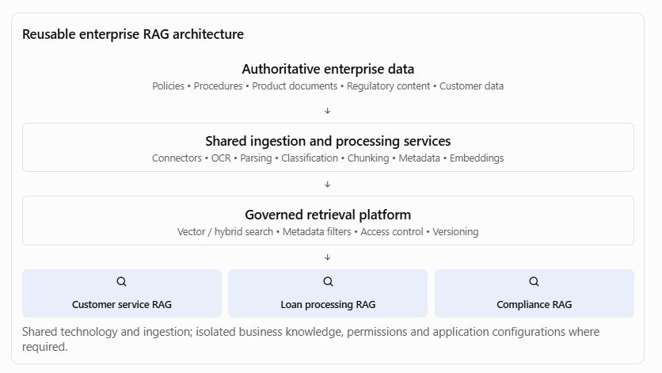
D. Data security and access control
The retrieval architecture must enforce the source system's access permissions. A user who cannot access a confidential document in the original repository must not be able to retrieve it through an AI assistant.
Key controls include:
- Role-based and attribute-based access control.
- Document-level and, where required, chunk-level permissions.
- Tenant and business-unit isolation.
- Data classification and encryption.
- PII detection and masking where appropriate.
- Data residency and retention controls.
- Source attribution and lineage.
4.2 Industry examples
Industry | Data architecture decision
Banking | Reuse customer and account data products across lending, customer service and relationship-management AI applications, subject to purpose-based access.
Insurance | Establish a governed policy and claims document ingestion capability rather than creating separate document pipelines for every claims application.
Healthcare | Use governed clinical data services with patient-level access restrictions and appropriate consent controls.
Telecom | Reuse customer, network and usage data products while maintaining separate access policies for customer-facing and network operations use cases.
Government | Establish common data cataloguing and metadata standards across departments while respecting statutory data-sharing restrictions.
Principal Architect perspective: Data reuse does not mean unrestricted data sharing. Reuse must be governed by ownership, purpose, consent, access, quality, and regulatory requirements.
5. Integration architecture decisions
Integration architecture determines how AI applications communicate with enterprise systems, consume business capabilities, and execute actions.
This is particularly important in agentic AI, where an AI agent may need to retrieve customer information, create a service request, initiate a payment, or trigger an approval workflow.
5.1 What should be decided?
A. API strategy
Define standard approaches for:
- Synchronous REST APIs.
- Asynchronous APIs.
- API gateways.
- API versioning.
- Authentication and authorisation.
- Rate limiting and throttling.
- API lifecycle management.
- Service contracts and error handling.
Avoid creating new APIs when an existing, governed enterprise API already provides the required business capability.
B. Event-driven integration
Use events when business processes require asynchronous communication, loose coupling, and independent processing.
Examples:
- Loan application submitted.
- Insurance claim received.
- Customer complaint raised.
- Payment flagged for investigation.
- Regulatory document updated.
AI services can subscribe to relevant events, process them, and publish results without tightly coupling the AI application to the originating system.
C. Agent and tool integration
Define an enterprise approach for AI agents to interact with business systems.
A tool should have:
- A clearly defined business purpose.
- A versioned interface and input/output schema.
- Identity and permission controls.
- Validation and business-rule enforcement.
- Timeout, retry, and error-handling behaviour.
- Audit logging.
- Approval requirements for high-impact actions.
For example, a loan-processing agent should not directly update the core banking database. It should invoke an approved loan-management API, which enforces the business rules and authorisation controls.
D. Workflow integration
This is where BPM and workflow architecture become particularly valuable.
An AI agent can analyse a loan application, extract relevant information, identify missing documents, and recommend a decision. A workflow engine should manage task assignment, approval, exception handling, escalation, and final business-process state.
The agent should not become an uncontrolled replacement for the enterprise workflow engine.
5.2 Industry examples
Industry | Integration architecture decision
Banking | Reuse customer, account and payment APIs for multiple AI applications rather than creating direct database integrations.
Insurance | Integrate claims AI with policy and claims systems through governed APIs and workflow events.
Healthcare | Integrate clinical AI with authorised healthcare systems using standards-based interfaces such as FHIR where applicable.
Telecom | Use event-driven integration between network monitoring, incident management and AI-based fault analysis.
Government | Establish API standards and shared integration services for citizen identity, case management and departmental workflows.
5.3 Worked example: AI-enabled loan processing
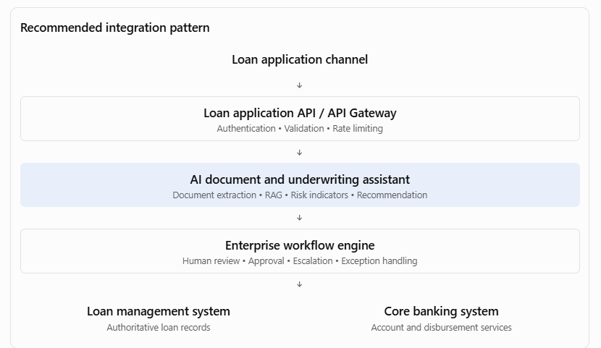
This design separates AI reasoning, business process execution, and authoritative transaction processing. It also allows the bank to replace the AI model or orchestration framework without redesigning the core loan-management integration.
Principal Architect perspective: AI agents should consume governed business capabilities, not bypass enterprise integration and transaction controls.

6. Platform architecture decisions
Platform architecture is where the organisation establishes the reusable technical foundation for building, deploying, and operating AI applications.
The objective is to avoid every project selecting its own model provider, embedding service, vector database, orchestration framework, deployment infrastructure, and monitoring stack.
6.1 What should be decided?
A. Enterprise AI platform strategy
Establish which platform capabilities should be centrally provided.
Platform capability | Architectural decision
Model access | Approved model providers and model gateway
Model lifecycle | Model onboarding, evaluation, versioning and retirement
Prompt management | Central prompt repository and version control
Embeddings | Approved embedding models and service patterns
Vector search | Approved vector database and hybrid retrieval options
Agent orchestration | Approved orchestration patterns and frameworks
Tool registry | Governed enterprise tools and API contracts
Evaluation | Shared evaluation framework and test datasets
Observability | Common tracing, logging, metrics and dashboards
Security | Identity, secrets, encryption and policy enforcement
B. Model and provider abstraction
Avoid unnecessary dependence on a single model provider.
Establish a model gateway or abstraction layer to manage:
- Provider-specific connectivity.
- Model selection and routing.
- Authentication and secrets.
- Token usage and cost tracking.
- Rate limits.
- Model versioning.
- Fallback and availability policies.
- Safety and content filtering.
However, abstraction should not hide important model-specific capabilities. The architecture should retain the ability to use provider-specific features where there is a justified business or technical benefit.
C. Compute and deployment strategy
Define appropriate infrastructure patterns for:
- Managed AI services.
- Container-based AI applications.
- Kubernetes-based deployments.
- Serverless workloads.
- GPU-intensive workloads.
- Private networking and hybrid connectivity.
- Development, testing, staging and production environments.
D. Platform standardisation versus flexibility
Not every workload requires the same technology.
For example, a simple knowledge assistant may use a managed RAG service, whereas a complex multi-agent workflow may require a dedicated orchestration service with durable state management.
The Principal Architect should standardise interfaces, controls, and operational expectations without unnecessarily standardising every implementation detail.
6.2 Industry examples
Industry | Platform architecture decision
Banking | Establish an enterprise AI platform with approved models, private connectivity, model gateway, RAG and audit capabilities.
Insurance | Provide reusable document intelligence, OCR, embedding and model evaluation services across claims and underwriting.
Healthcare | Use a controlled AI platform with appropriate data isolation, identity controls, model validation and clinical safety oversight.
Telecom | Provide shared AI infrastructure for network operations, customer support and predictive maintenance while supporting different performance requirements.
Government | Establish approved hosting, identity, model access and audit patterns for departments with different data classifications.
Principal Architect perspective: Build an enterprise AI platform as a product with defined service ownership, service-level objectives, onboarding processes, support models, and measurable adoption—not merely as a collection of cloud services.
7. Operational architecture decisions
A solution is not enterprise-ready simply because it works in development. The architecture must also address how it will be deployed, monitored, supported, recovered, secured, and evolved.
7.1 What should be decided?
A. Production operating model
Define:
- Application ownership.
- Platform ownership.
- Model and AI service ownership.
- L1, L2 and L3 support responsibilities.
- Incident and problem management.
- Change and release management.
- Service-level objectives and service-level agreements.
B. AI-specific observability
Traditional application monitoring is not sufficient for AI workloads.
The architecture should monitor:
- API latency and availability.
- Model response latency.
- Token consumption and cost.
- Prompt and completion failures.
- Retrieval quality.
- Groundedness and citation accuracy.
- Agent task completion.
- Tool invocation failures.
- Safety-policy violations.
- Model quality drift.
C. Resilience and recovery
Define patterns for:
- Model-provider failure.
- API failures.
- Vector database unavailability.
- Queue backlogs.
- Retry and timeout handling.
- Circuit breakers.
- Graceful degradation.
- Disaster recovery.
- Backup and restore.
For example, a customer-service assistant should be able to fall back to a conventional search experience or transfer the interaction to a human agent if the model service becomes unavailable.
D. AI lifecycle and change management
A change to a prompt, model, embedding model, retrieval configuration, or agent tool can affect application behaviour.
Therefore, production changes should be controlled through:
- Versioned prompts and model configurations.
- Regression evaluation.
- Security and safety testing.
- Controlled rollout and rollback.
- Shadow or canary deployment where appropriate.
- Production feedback and continuous improvement.
E. Cost and capacity management
Establish cost visibility at application, business-unit, model, and platform levels.
Use appropriate strategies such as model routing, caching, token optimisation, batching, workload scheduling, and quotas.
7.2 Industry examples
Industry | Operational architecture decision
Banking | Define high availability, transaction auditability, fallback and operational controls for customer-facing AI services.
Insurance | Monitor claims-processing AI accuracy, processing delays, exception volumes and model drift.
Healthcare | Establish clinical safety escalation, human oversight and service continuity for clinical AI applications.
Telecom | Monitor AI-based network incident detection and ensure fallback to existing network operations procedures.
Government | Maintain service continuity, audit records, controlled releases and support accountability for citizen-facing AI services.
Principal Architect perspective: A shared platform without a defined operating model can become another enterprise bottleneck. Every shared capability needs an owner, support model, service level, lifecycle policy, and cost model.
8. How to prevent fragmented and duplicative solutions
The Principal Architect should establish mechanisms that influence architecture decisions before teams commit to technology and implementation choices.
8.1 Establish an enterprise capability map
Create an inventory of existing and planned capabilities across business units.
For example:
Capability | Existing implementation | Proposed direction
LLM access | Three separate provider integrations | Shared model gateway
Document ingestion | Four independent pipelines | Reusable ingestion service
Embedding generation | Multiple implementations | Approved embedding service
Vector search | Separate databases per project | Governed shared or domain-isolated service
Prompt management | Prompts stored in source code | Versioned prompt management
AI evaluation | Manual testing | Shared evaluation framework
AI observability | Different monitoring tools | Common telemetry standards
Agent tools | Duplicated API wrappers | Governed tool registry
The objective is not necessarily to consolidate every technology into one instance. It is to identify duplicated capabilities and determine whether they should be shared, federated, or retained independently.
8.2 Introduce architecture decision records
For significant architectural choices, require a documented decision.
An Architecture Decision Record (ADR) should capture:
- Business and technical context.
- Problem being addressed.
- Options considered.
- Evaluation criteria.
- Selected decision.
- Reasons for selecting it.
- Trade-offs and consequences.
- Security, privacy and compliance implications.
- Reuse opportunities.
- Review date and conditions for revisiting the decision.
Example: Should we build another vector database?
Evaluation question | What the architect should establish
Is there an existing enterprise service? | Identify the current approved vector-search capability.
Does it meet the requirement? | Assess scale, latency, filtering, isolation and availability.
Is a new technology justified? | Identify concrete functional or non-functional gaps.
Can it integrate with existing controls? | Assess identity, encryption, monitoring and backup.
What is the total cost? | Include licensing, infrastructure, support and skills.
What is the long-term impact? | Assess portability, vendor lock-in and operational complexity.
A new technology should be introduced only when the business or technical justification outweighs the additional complexity.
8.3 Establish architecture governance forums
Governance mechanism | Purpose
Enterprise Architecture Review Board | Review strategic architecture decisions and alignment with target architecture.
AI Architecture Review Board | Review AI-specific architecture, model, RAG and agent patterns.
Security and Responsible AI Review | Review security, privacy, risk, fairness and responsible AI controls.
Technology Standards Forum | Approve technologies, reference architectures and standards.
Design Authority | Review solution designs, exceptions and material architectural deviations.
Governance should be risk-based. A low-risk internal productivity assistant should not necessarily go through the same approval process as an AI system influencing credit decisions or clinical care.
8.4 Use architecture principles
I would establish a set of enterprise principles such as:
- Reuse before building.
- Buy or consume managed services where justified; build only where differentiation or control requires it.
- API-first integration.
- Data ownership remains with authoritative systems.
- Security and privacy by design.
- Human accountability for consequential business decisions.
- Model and provider portability where economically justified.
- Observability and auditability by design.
- Automate compliance and quality controls.
- Design for resilience and graceful degradation.
9. Worked enterprise case study: Banking AI transformation
Consider a bank that wants to implement six AI initiatives across Retail Banking, Corporate Banking, Risk, Compliance and Operations.
9.1 Initial situation
Different business units have started AI pilots independently.
Business unit | Initiative | Duplicated architecture
Retail Banking | Customer service assistant | LLM integration, RAG, knowledge store
Lending | Loan underwriting assistant | Document processing, RAG, model integration
Risk | Fraud investigation assistant | LLM integration, APIs, monitoring
Compliance | Regulatory knowledge assistant | Document ingestion, vector search
Operations | Employee knowledge assistant | RAG, prompt management
Corporate Banking | Relationship manager copilot | Customer APIs, LLM integration
The bank is facing:
- Multiple model-provider contracts.
- Duplicated document processing.
- Inconsistent security controls.
- Separate vector databases.
- Different evaluation approaches.
- High operational support costs.
- Limited visibility into AI usage and expenditure.
9.2 Target-state architecture
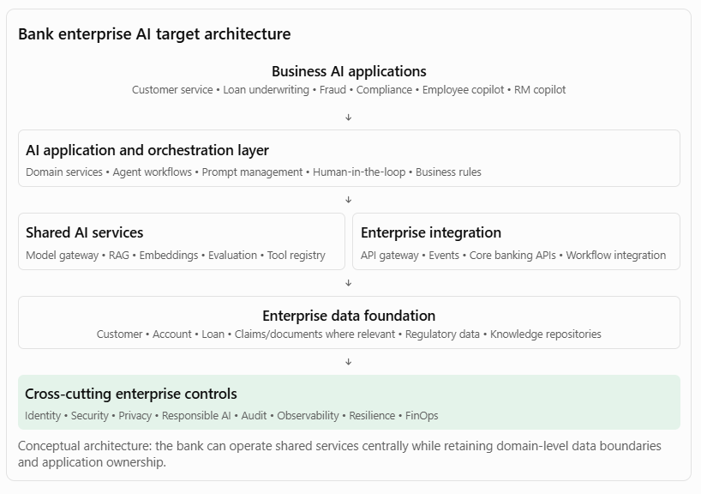
9.3 Implementation approach
Phase 1 — Discover and assess
- Inventory existing AI initiatives.
- Identify duplicated technology and capabilities.
- Review current enterprise application, data and integration architecture.
- Assess security, regulatory and operational constraints.
- Identify opportunities for reuse.
Phase 2 — Define target architecture
- Establish enterprise AI reference architecture.
- Define shared versus domain-specific capabilities.
- Select approved model access and retrieval patterns.
- Define integration standards and tool contracts.
- Establish architecture principles and decision rights.
Phase 3 — Build shared foundations
- Implement model gateway.
- Establish common document ingestion services.
- Provide governed RAG and retrieval services.
- Implement evaluation and observability capabilities.
- Establish identity, security and audit controls.
Phase 4 — Migrate and onboard applications
- Prioritise initiatives based on business value and reuse potential.
- Onboard suitable pilots to shared services.
- Retire redundant components where appropriate.
- Retain specialised services where justified.
- Measure adoption and business outcomes.
Phase 5 — Operate and continuously evolve
- Monitor platform adoption, reliability and cost.
- Review exceptions and technology changes.
- Improve shared capabilities based on application feedback.
- Update reference architectures and standards.
9.4 How to measure success
The objective is not simply to reduce the number of technologies. It is to improve business delivery and enterprise technology effectiveness.
Dimension | Example KPI
Reuse | Percentage of AI solutions using approved shared capabilities
Duplication | Number of redundant services and technology implementations retired
Delivery | Time required to onboard a new AI application
Cost | Cost per AI transaction or completed task
Integration | Percentage of integrations using approved enterprise APIs and events
Security | Percentage of AI applications meeting mandatory security controls
Reliability | Availability and recovery performance against agreed SLOs
Quality | Groundedness, task success and evaluation pass rates
Governance | Percentage of material architecture decisions documented and approved
Targets should be set after measuring the current baseline. For instance, the bank might target a reduction in new application onboarding time by reusing the enterprise AI platform, but should not claim that benefit without measuring it.
10. Key architectural trade-offs a Principal Architect must understand
A strong architect does not simply mandate centralisation. The role is to choose the right level of standardisation and autonomy.
Architectural choice | When to prefer it | Main trade-off
Centralised AI platform | Common enterprise capabilities and consistent controls are needed | Can become a bottleneck
Federated AI platform | Business units have distinct needs or regulatory boundaries | Greater governance complexity
Shared vector database | Similar workloads and manageable isolation requirements | Shared capacity and failure-domain risks
Separate domain vector stores | Strong isolation, residency or workload requirements | More operational overhead
Central model gateway | Common security, routing and cost controls are required | Potential latency and dependency
Multiple model providers | Resilience, capability diversity or negotiation leverage matters | More integration and operational complexity
Synchronous API integration | Immediate response is required | Tighter runtime dependency
Event-driven integration | Loose coupling and asynchronous processing are suitable | Eventual consistency and more complex tracing
Workflow-led execution | Predictable processes, approvals and auditability are essential | Less flexibility for open-ended reasoning
Agent-led execution | Dynamic reasoning and tool selection provide genuine value | Less predictable execution and greater control requirements
Important distinction: Standardise the enterprise contracts, controls, and engineering practices. Allow implementation choices to vary when measurable requirements justify the variation.
11. How this connects to your application architecture and Appian background
Your application architecture and BPM experience provides a strong foundation for explaining this responsibility.
You can connect your experience to AI architecture in five ways:
Your existing architecture experience | Application in enterprise AI architecture
Enterprise application architecture | Define boundaries between AI applications, domain services and enterprise systems.
Appian Technology Center of Excellence | Establish reusable AI capabilities, reference patterns and architecture standards.
BPM and workflow architecture | Govern agent execution, human approvals, exception handling and long-running business processes.
Enterprise integration | Establish API, event-driven and service integration standards for AI agents.
Architecture governance | Manage design reviews, technology decisions, exceptions and architecture compliance.
For example, in an Appian-led enterprise transformation, you would not allow every project team to independently create customer management, document processing, workflow, and integration capabilities. You would establish reusable services and common standards while retaining business-specific process logic.
The same architectural philosophy applies to AI: shared model access, retrieval, evaluation, orchestration and observability capabilities, with domain-specific applications and business workflows.
12. Interview questions to prepare
- How would you prevent different business units from building duplicate AI capabilities?
- How would you decide whether an AI capability should be centralised or owned by an individual business unit?
- How would you establish an enterprise AI reference architecture?
- How would you decide whether to reuse an existing vector database or introduce a new one?
- How would you ensure AI agents integrate securely with enterprise applications?
- How would you separate AI reasoning from business rules and workflow execution?
- How would you manage different model providers across enterprise AI applications?
- How would you balance architecture standardisation with delivery-team autonomy?
- How would you identify and manage architectural exceptions?
- How would you measure whether enterprise architecture governance is delivering value?
13. Suggested preparation resources
These are useful resources for strengthening your architecture decision-making approach:
Resource | What to study
Microsoft Azure Architecture Center | Reference architectures, integration patterns, cloud design decisions
Azure Well-Architected Framework | Reliability, security, cost, operational excellence and performance
Azure AI architecture | Enterprise AI and machine-learning architecture patterns
Microsoft architecture styles | Microservices, event-driven and other architectural styles
NIST AI Risk Management Framework | AI risk management and governance
TOGAF | Architecture governance, principles and enterprise architecture development
14. Seven-day interview preparation plan
Day | Preparation topic | Practical exercise
1 | Enterprise architecture principles | Define 10 principles for enterprise AI architecture.
2 | Application architecture | Design a reusable AI application architecture for a bank.
3 | Data architecture | Design a shared enterprise RAG architecture with domain-level access control.
4 | Integration architecture | Design secure API and event integration for an AI agent.
5 | Platform architecture | Design an enterprise AI platform supporting multiple model providers.
6 | Operational architecture | Define observability, resilience, deployment and cost-management standards.
7 | Architecture governance | Present the banking case study and defend your architectural decisions.
15. Final interview-ready answer
I believe one of the most important responsibilities of a Principal Architect is to ensure that individual technology initiatives contribute to a coherent enterprise architecture rather than creating fragmented and duplicated solutions.
My approach is to evaluate architecture decisions across five dimensions: application, data, integration, platform and operations. At the application level, I establish clear domain boundaries and identify reusable business and AI capabilities. At the data level, I focus on authoritative sources, data ownership, governance, security and reusable ingestion and retrieval services. At the integration level, I promote API-first and event-driven patterns, ensuring AI agents interact with enterprise systems through governed business capabilities rather than bypassing existing controls.
At the platform level, I identify opportunities to establish shared capabilities such as model gateways, RAG services, prompt management, agent orchestration, evaluation and observability. Operationally, I ensure that every solution addresses production readiness, resilience, security, monitoring, cost management and lifecycle management.
I also establish architecture principles, reference architectures, technology standards, architecture decision records and governance forums to guide delivery teams. However, I do not believe in standardisation for its own sake. I balance enterprise consistency with business-unit autonomy, allowing exceptions when there is a clear business or technical justification.
Ultimately, my objective is to maximise reuse, reduce technology duplication, accelerate solution delivery, improve operational consistency and ensure that AI investments contribute to measurable enterprise business outcomes.

Participate in architecture reviews, technical strategy discussions, and investment decisions related to AI and platform modernization
The important difference between a Solution Architect and a Principal Architect is that the latter must be able to defend decisions at three levels:
- Technical: Why is this the right architecture?
- Strategic: Why is this the right technology direction for the enterprise?
- Financial: Why should the organisation invest in this rather than another opportunity?
Below are five realistic scenarios, the decision frameworks you should use, and examples of how to defend your recommendations.
1. Scenario: Architecture review of an enterprise AI agent
Architecture review simulation
Situation
A bank's Retail Banking team proposes an AI-powered customer service agent.
The proposed solution:
- Uses an external LLM.
- Uses RAG to retrieve customer and product information.
- Connects to core banking APIs.
- Can initiate service requests and payment-related actions.
- Uses a separate vector database.
- Has its own monitoring and logging infrastructure.
The project team wants architecture approval to begin implementation.
1.1 What should you investigate?
As Principal Architect, I would not immediately approve the design. I would challenge the architecture across the following dimensions.
Area | Questions you should ask
Business | What business problem is being solved? What is the expected benefit?
Application | Why is a separate application required? Can existing customer-service capabilities be reused?
AI | Why an agent rather than a conventional workflow with LLM assistance?
Data | What customer data can the agent access? How is access controlled?
Integration | Are existing banking APIs being reused?
Security | How are agent permissions and sensitive transactions controlled?
Platform | Why is a separate vector database required?
Operations | How will model failures, incorrect responses and tool failures be handled?
Financial | What is the five-year TCO?
1.2 Identify architectural risks
Suppose the team provides these answers:
Team's proposal | Your architectural concern
We will use the latest LLM. | Has it been evaluated against the business requirements?
We will build a new vector database. | Does an approved enterprise retrieval service already exist?
The agent can call banking APIs. | What permissions will it have?
The agent will handle customer transactions. | Where are business validation and authorisation performed?
We will create our own monitoring. | Can the enterprise observability platform be reused?
We will store prompts in application code. | How will prompt versioning and regression testing work?
1.3 Your recommended architecture
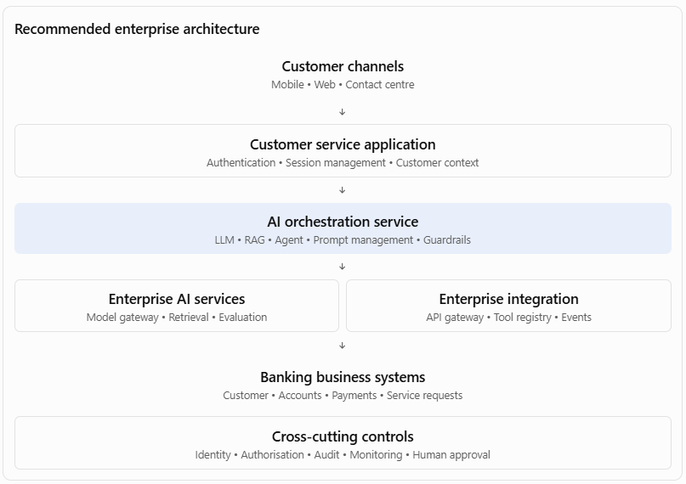
Key architectural decisions:
- Use an approved enterprise model gateway.
- Reuse enterprise retrieval services where suitable.
- Enforce customer permissions at retrieval time.
- Allow the agent to invoke only approved business tools.
- Keep financial transaction authorisation within existing banking services.
- Use workflow management for approvals and exceptions.
- Implement end-to-end AI observability.
1.4 How you defend this decision before the architecture board
Your response:
"I would support the business objective, but I would recommend some architectural changes before approval.
My primary concern is that the proposed design introduces several capabilities that may already exist at enterprise level. I would first establish whether the model gateway, document retrieval, API integration and observability capabilities can be reused.
I would also separate AI reasoning from transactional business execution. The agent can understand customer intent, retrieve relevant information and propose an action, but the actual transaction must go through an authorised banking service that validates permissions, business rules and transaction limits.
This approach gives us the flexibility to evolve the AI implementation without compromising the bank's existing transaction controls. It also reduces duplication and creates reusable capabilities for future AI applications."
2. Scenario: Two business units want different AI platforms
Enterprise technology strategy
Situation
Two business units approach the CTO with different proposals.
- Retail Banking wants Microsoft Azure AI services.
- Corporate Banking wants AWS Bedrock and its associated AI services.
Both business units have valid requirements. The CTO asks you:
"Should we standardise on one AI platform, or allow different platforms across the enterprise?"
This is a typical Principal Architect strategic decision.
2.1 Understand the requirements before deciding
I would compare the requirements across several dimensions.
Dimension | Retail Banking | Corporate Banking
Main use cases | Customer service, personal banking | Relationship management, document intelligence
Data sensitivity | High | High
Existing cloud footprint | Azure-heavy | AWS-heavy
Integration | Core banking, CRM | Corporate banking, document systems
AI workloads | Customer-facing assistants | Complex document and workflow processing
Regulatory requirements | Banking controls | Banking controls
Platform skills | Azure engineering | AWS engineering
2.2 Evaluate three strategic options
Option A — Standardise on one cloud AI platform
Best when requirements are substantially common
- Consistent governance.
- Easier central platform management.
- Potential economies of scale.
- Less technology fragmentation.
Risks: Migration costs, unsuitable fit for some workloads, concentration risk and potential lock-in.
Option B — Allow each business unit to choose independently
- Maximum business-unit flexibility.
- Can leverage existing cloud investments.
- Potentially faster delivery.
Risks: Duplicate capabilities, inconsistent governance, fragmented skills and increased operating costs.
Option C — Federated enterprise AI architecture
Often a strong candidate
- Common enterprise architecture standards.
- Common security and responsible AI controls.
- Shared interfaces and governance.
- Multiple approved cloud AI platforms where justified.
Risks: More complex governance, integration and platform operations.
2.3 My recommended approach
I would generally evaluate a federated architecture before enforcing a single-provider strategy.
The enterprise should standardise:
- Model access governance.
- Security and identity standards.
- AI evaluation requirements.
- Prompt and model lifecycle management.
- Observability.
- Auditability.
- API and agent tool contracts.
- Data protection and responsible AI controls.
However, the underlying model provider or cloud service can differ where there is a defensible business, regulatory or technical requirement.
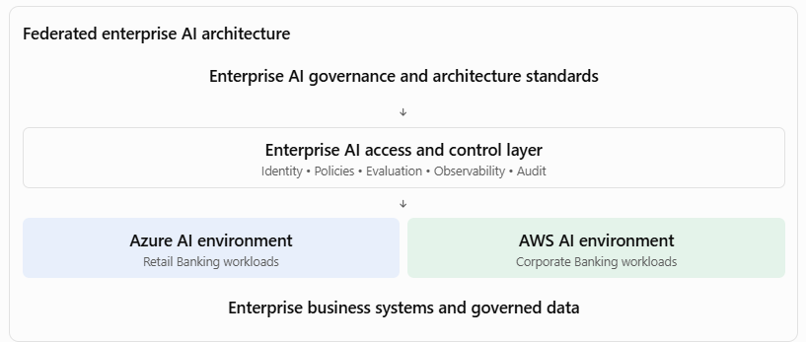
2.4 How to defend this decision before the CTO
"I would avoid making a cloud-provider decision purely on standardisation grounds.
I would first evaluate the existing cloud footprint, data residency requirements, security architecture, AI service capabilities, operational maturity, cost and vendor dependency.
My preference would be to standardise enterprise governance, security, model access contracts and operational controls, while allowing multiple approved platforms where justified.
This provides a balance between enterprise consistency and business-unit flexibility. I would also establish clear criteria for introducing an additional platform, so that multi-cloud does not become an excuse for uncontrolled technology proliferation."
Principal-level insight: Multi-cloud is not automatically a good strategy. It must have a clear business or architectural justification and an operating model capable of managing the resulting complexity.
3. Scenario: The CTO asks you to define a three-year AI and platform modernisation roadmap
Technical strategy
Situation
The CTO says:
"We have several legacy applications, fragmented integration platforms, growing AI demand and increasing technology costs. What should our technology roadmap look like for the next three years?"
You need to move beyond individual solution recommendations and articulate an enterprise transformation strategy.
3.1 Begin with a current-state assessment
I would evaluate five dimensions.
Dimension | Typical problem
Applications | Legacy monoliths, duplicated functionality and technical debt
Data | Silos, inconsistent quality and limited data accessibility
Integration | Point-to-point interfaces and inconsistent APIs
AI | Isolated pilots, inconsistent model selection and no shared AI platform
Operations | Limited observability, manual deployments and high operational effort
I would also evaluate business impact, technical risk, regulatory exposure and the cost of maintaining the existing landscape.
3.2 Define the target-state vision
A possible vision could be:
"Create a modern, secure and AI-enabled enterprise technology platform that allows business units to deliver digital capabilities faster through reusable services, governed data, intelligent automation and scalable cloud infrastructure."
3.3 Create a three-year roadmap
Three-year AI and platform modernisation roadmap
Year 1 — Foundation
Stabilise and standardise
- Current-state assessment.
- Enterprise architecture principles.
- API and integration standards.
- AI platform foundation.
- Identity and security modernisation.
- Priority legacy platform stabilisation.
- AI governance and evaluation framework.
Year 2 — Modernisation
Transform and integrate
- Legacy application modularisation.
- Enterprise data products.
- Shared RAG and agent services.
- Event-driven integration.
- AI-powered PDLC.
- Workflow automation.
- Common observability and FinOps.
Year 3 — Scale and optimise
Industrialise and evolve
- Enterprise AI adoption at scale.
- Agentic workflow expansion.
- Predictive and intelligent operations.
- Legacy platform retirement.
- Continuous architecture optimisation.
- Cost and performance optimisation.
- Benefits realisation.
3.4 How would you prioritise?
Not all modernisation initiatives should start at the same time.
I would use a prioritisation model based on:
- Business value.
- Regulatory and security risk.
- Technology obsolescence.
- Dependency on other initiatives.
- Reuse potential.
- Cost and implementation complexity.
For example, API modernisation may need to precede AI agent adoption because agents require reliable and governed enterprise interfaces.
3.5 How to defend the roadmap before the CTO
"I would not recommend treating AI adoption and platform modernisation as separate programmes.
The success of enterprise AI depends on the quality of the underlying application, data, integration, security and operational architecture.
My recommendation would be to establish the enterprise foundations first, modernise the highest-priority platforms in parallel, and then scale AI use cases on top of those foundations.
I would use a phased roadmap with measurable milestones. This allows us to demonstrate early value without creating additional technical debt or making large irreversible technology commitments prematurely."
4. Scenario: The investment committee asks whether to build or buy an enterprise AI platform
Technology investment decision
Situation
The CIO has received three proposals:
- Proposal A: Build an enterprise AI platform internally.
- Proposal B: Purchase a commercial AI platform.
- Proposal C: Use managed AI services from the existing cloud provider and develop only the required enterprise integration and governance layers.
The investment committee asks you to recommend one.
4.1 Build an investment assessment
I would evaluate the proposals against the following dimensions.
Criteria | Weight
Business and strategic alignment | 20%
Functional and technical capability | 15%
Security and compliance | 15%
Five-year TCO | 15%
Integration and interoperability | 10%
Scalability and performance | 10%
Vendor dependency and portability | 5%
Operational maturity | 5%
Time to value | 5%
Total | 100%
4.2 Illustrative weighted assessment
Scores are out of 5. Higher is better.
Criterion | Build | Buy | Managed services
Strategic alignment | 5 | 3 | 4
Functional capability | 3 | 5 | 4
Security/compliance | 4 | 4 | 4
Five-year TCO | 2 | 3 | 4
Integration | 4 | 3 | 4
Scalability | 4 | 4 | 5
Portability | 5 | 2 | 3
Operational maturity | 2 | 4 | 4
Time to value | 2 | 5 | 4
Weighted score / 100 | 71 | 73 | 81
Illustrative scoring, not a market assessment. Actual scores require vendor demonstrations, security assessment, pricing, reference checks and workload testing.
Illustrative weighted evaluation scores for three AI platform investment options.
0/10025/10050/10075/100100/100BuildBuyManaged services
4.3 Understand the TCO
A common mistake is comparing only the initial implementation cost.
A proper five-year TCO should include:
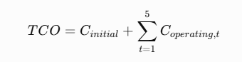
Where initial and operating costs include:
- Platform development or licensing.
- Cloud compute and storage.
- LLM inference and embeddings.
- Vector database.
- Integration development.
- Security and compliance.
- Engineering and support teams.
- Monitoring and observability.
- Upgrades and maintenance.
- Migration and eventual exit costs.
I would also assess opportunity cost: how much time and money would internal engineering spend building capabilities already available as managed services?
4.4 How to defend your recommendation
"My recommendation would be based on strategic differentiation and the economics of ownership.
I would not build an entire AI platform from scratch if the majority of capabilities are already available through mature managed services.
I would evaluate a managed-services-led approach with an enterprise-controlled architecture layer. This would allow us to use mature model and infrastructure services while retaining control over enterprise identity, governance, data access, orchestration contracts, evaluation and observability.
However, if the organisation has specialised requirements around data residency, model control, latency or proprietary intellectual property, I would consider self-hosted or custom-built components selectively.
The objective is to invest engineering effort where it creates genuine enterprise value rather than recreating commodity technology."
5. Scenario: A project team wants to use multi-agent AI, but you believe it is unnecessarily complex
Technical challenge and architectural judgement
Situation
An engineering team proposes a multi-agent solution for insurance claims assessment.
They want:
- A document agent.
- A policy agent.
- A fraud agent.
- A decision agent.
- A workflow agent.
- A supervisor agent.
The team claims that this is an advanced, future-ready architecture.
The business problem is relatively straightforward: process claims documents, verify policy conditions, identify potential fraud indicators, and send claims for assessment.
5.1 Challenge the proposed design
I would ask:
- Does each agent have a genuinely distinct responsibility?
- Are the agents independently reasoning or simply calling APIs?
- Does the problem require autonomous planning?
- Can the workflow be represented through deterministic business processes?
- What is the additional latency and token cost?
- How will we trace decisions across agents?
- How will we manage failures and inconsistent agent outputs?
- Can we demonstrate better business outcomes than a simpler architecture?
5.2 Compare architectural alternatives
Option | Description | Suitability
Conventional workflow | Deterministic workflow with API and rules integration | Good for predictable processes
LLM-assisted workflow | LLM extracts information and supports specific decisions; workflow controls execution | Strong candidate for structured claims processes
Single agent | One agent invokes approved tools and reasons across tasks | Useful for moderate complexity
Multi-agent | Multiple specialised agents collaborate | Appropriate where independent capabilities and coordination justify the complexity
5.3 My recommended approach
I would initially recommend an LLM-assisted workflow rather than immediately adopting a multi-agent architecture.
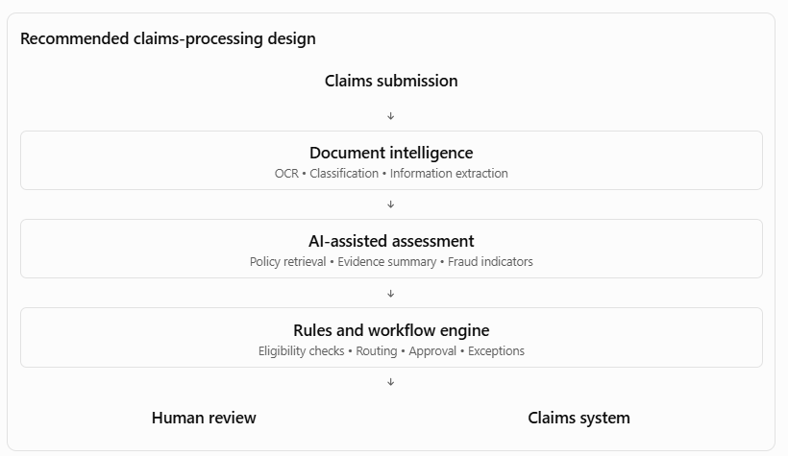
This approach offers predictable execution, clear accountability and easier auditability. We can introduce specialised agents later if measurable evidence demonstrates that they improve performance.
5.4 How to defend this decision
"I would not equate architectural sophistication with architectural quality.
My responsibility is to select the simplest architecture that adequately addresses the business requirements and non-functional constraints.
For this claims process, many activities are deterministic: policy validation, approval thresholds, task routing and claims status updates. These should remain within governed business services and workflow engines.
AI can add significant value in document interpretation, unstructured information extraction and evidence summarisation. I would introduce autonomous agent collaboration only where the use case demonstrates a genuine need for dynamic reasoning and where we can control its permissions, execution and failure behaviour."
6. Your Principal Architect decision-making framework
You should internalise one consistent approach that you can use across architecture reviews, technology strategy and investment discussions.
I recommend the following seven-step framework.
The Principal Architect decision framework
- Understand the business problem
Identify business outcomes, stakeholders, constraints and success measures.
- Assess the current architecture
Identify existing platforms, reusable capabilities, dependencies, risks and technology debt.
- Define architectural options
Develop realistic alternatives, including reuse, managed services, custom build and phased modernisation.
- Evaluate technical and business trade-offs
Assess NFRs, security, scalability, resilience, complexity, TCO and strategic flexibility.
- Make a recommendation
Explain the selected option and why alternatives are less suitable.
- Obtain governance and investment decisions
Document decisions, risks, exceptions, funding and accountable owners.
- Measure implementation and business outcomes
Validate that the decision delivered the expected benefits and revise the architecture when evidence warrants it.
7. A reusable architecture decision template
Use this structure when preparing to present a recommendation to an architecture board or technology investment committee.
Architecture decision brief
1. Business problem
Introduce an enterprise AI platform for multiple business units
2. Recommended architectural option
Federated platform using approved managed AI services
3. Expected business and technical benefits
Reuse common capabilities, reduce duplication and accelerate onboarding
4. Key risks and trade-offs
Platform complexity, provider dependency and operating-model maturity
5. Decision requested
Approve a phased platform foundation, subject to security, cost and operational validation
8. Mock CIO/CTO interview: Test your decision-making
Let's test whether you can defend your decisions at Principal Architect level.
I'll act as the CTO. You respond as the AI Principal Architect.
Scenario: Enterprise AI investment
Executive challenge
CTO:
"We have six business units asking for AI funding. Each unit wants to use a different LLM provider and build its own AI application platform.
The business leaders argue that centralising AI will slow them down. The CFO is concerned about duplicated expenditure, and the CISO is concerned about inconsistent security and data governance.
I want you to recommend an enterprise architecture and investment strategy.
You have five minutes to present your recommendation."
Your response should address:
- What architecture strategy would you recommend?
- What would you centralise and what would remain with business units?
- How would you balance speed of delivery with enterprise governance?
- How would you prioritise investments?
- How would you demonstrate the financial and business benefits?
- What risks and trade-offs would you highlight?

